**logo.png**

**DEPARTMENT OF AGRICULTURAL TECHNOLOGISTS**

**UNIVERSITY OF FOOD TECHNOLOGIES (PLOVDIV)**

**INTERSTATE POSTGRADUATE STUDIES  
"ANALYSIS AND FOOD QUALITY CONTROL "**

**Water holding capacity and Water binding capacity of meat**

as part of the requirements of the class Food Chemistry and Biochemistry that has submitted from

**Papadopoulos Argyrios**

CONTENTS

CHAPTER 1 INTRODUCTION 2

1.1 WATER CAPACITY OF MEAT 2

1.2 FORCES OF WATER INSTARACTIONS IN MEAT 2

*1.2.1 ELECTROSTATIC FORCES* 3

*1.2.2 OSMOTIC FORCES* 3

*1.2.3 CAPILLARY FORCES* 3

1.3 TYPES OF WATER IN THE MEAT TISSUE 4

*1.3.1 STRUCTURAL WATER* 4

*1.3.2 IMMOBILIZED WATER* 5

*1.3.3 FREE WATER* 5

CHAPTER 2 VARIABLES THAT EFFECT THE WATER HOLDING AND WATER BINDING CAPASITY OF MEAT 6

2.1 THE STRUCTURAL CONDITION OF THE MYOFIBRILS 6

2.2 THE pH VALUE AND THE QUANTITY OF ATP 6

2.3 THE CONDITION OF THE ANIMAL BEFORE THE SLAUGHTER 7

2.4 THE ANIMAL KIND 8

2.5 THE TYPE OF THE MUSCLE 8

2.6 THE AGE OF THE ANIMAL 8

2.7 THE QUANTITY OF THE CONNECTIVE TISUES 8

2.8 THE QUANTITY OF FAT 9

2.9 THE USE OF HEATING 9

2.10 THE USE OF NaCl 9

2.11 THE USE OF PHOSPHORIC SALTS 10

2.12 THE USE OF ACIDS 10

CHAPTER 3 SUMMARY 11

BIBLIOGRAPHY 12

# CHAPTER 1 INTRODUCTION

The water content that a piece of meat possesses and also can absorve is a crucial factor for the meat industry. The main reasons for this importance are that water effects the quality of the meat, the chemical and the biochemical changes that will occur to the meat during storage, production etc. and also has an economical value for the company.

From quantity point of view water is the basic ingredient of the meat (especially at the lean meat). Water can be found at bigger quantity at the lean meat tissue and in very small quantity in the fat tissue. Lean meat can posses water at a percentage of 75% and it can even absorve and hold even more. (Ραμαντάνης. 2006)

## 1.1 WATER CAPACITY OF MEAT

As it was previously mentioned water can be found in two ways in the meat industry, bound to the meat and as an additive. So there are two definition for the water capacity of meat:

Water - holding capacity (WHC) is the ability of the meat to retain the tissue water present within its structure.

Water - binding capacity (WBC) is the ability of the meat to bind added water during the process of the meat. (Ranken. 2000)

The connection of water - holding capacity and the water - binding capacity is directly proportional. Every factor that influences the water - holding capacity influences also the water - binding capacity. (Γεωργάκης. 2005)

## 1.2 FORCES OF WATER INSTARACTIONS IN MEAT

There are three types of forces mentioned in literature that effect the water - holding and the water - binding capacity of meat. These forces are: a) electrostatic forces, b) osmotic forces and c) capillary forces.

### *1.2.1 ELECTROSTATIC FORCES*

Water holding is caused by electrostatic repulsion between the myofibrillar proteins (myofilaments) and has a result the swelling of the myofibrils and in some cases with the use of salts or very low pH a partial solubilisation of the filaments because of the repulsion between the individual molecules.

Polar groups of the side chain of the aminoacids bind the water molecules on their surface by Van der Waals forces. Non polar side chains of the amino acids push the polar water molecules and cause an arched-like structure around the non polar group. These combined effects create tension and force the water molecules to adopt an ice-like form in the protein network of filaments and transverse elements. (Puolanne and Halonen. 2010)

### *1.2.2 OSMOTIC FORCES*

Because the structural proteins in meat are solid and cannot move electrical forces pull the counter ions (sodium ions) very close to the filament surface and create an uneven distribution of the ions in the water phase. The differences in the concentration establish an osmosis-like force (pressure) inside the filament lattice which pulls the water molecules into the system. The pressure could cause unlimited swelling but the cross - bridges because of an opposite force that is called elastic pressure. Increasing the osmotic force from the interaction between proteins and the solution and eliminating the elastic pressure by disrupting or decreasing the strength of cross-bridges will lead to an increases water binding and the opposite. (Puolanne and Halonen. 2010)

### *1.2.3 CAPILLARY FORCES*

Surface tension in a capillary with a diameter equal to the interfilamental spacing would support a water column of 300m in height. So it seems reasonable that water is held in meat by capillarity with the majority being in the interfilamental space within the myofibrils and a substantial part in the extracellular space and also the spaces between the myofibrils.

Structural aspects like actomyosin cross-bridges or denaturation which usually lead to a shortening of filaments or cross-bridges also have an influence on capillarity. (Puolanne and Halonen. 2010)

## 1.3 TYPES OF WATER IN THE MEAT TISSUE

We can find three types of water in the meat tissue: a) structural water, b) immobilized water and c) free water. (Ραμαντάνης. 2006)

The distribution of water in the lean meat can be found in the table below. The water is distributed in fibrils, the sarcoplasm, at the extracellular space and the connective tissues.

|  |  |  |  |  |
| --- | --- | --- | --- | --- |
| **Distribution of water (%) in the lean meat** | | | | |
|  | Fibres or cells | | Extracellular space and connective tissues | Total |
| Fibrils | Sarcoplasm |
| Water | 45 | 19 | 11 | 75 |
| Protein | 10 | 6 | 2 | 18 |
| Other substances | 5 | - | 2 | 7 |
| Totals | 60 | 25 | 15 | 100 |

Source: Ranken. 2000

### *1.3.1 STRUCTURAL WATER*

As structural water we can consider the quantity of water that is toughly bound with the proteins in such an organized way with a single water molecule layer or with two water molecule layer around the protein molecules.

This water display deferent physicochemical properties from the normal water. It is so toughly bound with the proteins that even at very low temperature it doesn't form ice crystals. Structural water also doesn't get effected by the changes of the protein structure or their charge. Finally changes that will affect the meat tissue like heating, or by changing the pH, or NaCl addition and changes during rigor mortis has not effect in the structural water. (Ραμαντάνης. 2006)

### *1.3.2 IMMOBILIZED WATER*

The quantity of water that is being held between the filaments molecules in a less organized way is called immobilized water. This water is connected with the proteins and it is being formed after the second water layer in the protein molecule. The physicochemical properties of this water are very close to the normal water, it can be frozen at the same temperature, it can be effected by changes in the pH, from heating etc. (Ραμαντάνης. 2006)

### *1.3.3 FREE WATER*

The water of the sarcoplasm can move more freely and is called free water. In this type of water we can add also the extracellular water that exists in the capillaries of the tissue and is being held by capillary forces. (Ραμαντάνης. 2006)

# CHAPTER 2 VARIABLES THAT EFFECT THE WATER HOLDING AND WATER BINDING CAPASITY OF MEAT

The variables that affect the water - holding and the water - binding capacity of water are: a) the structural condition of the myofibrils, b) the pH value and the quantity of ATP, c) the condition of the animal before the slaughter, d) the animal kind. e) the type of the muscle, f) the age of the animal, g) the quantity of the connective tissues and h) the quantity of fat, i) the use of heating, j) the use of NaCl, k) the use of phosphoric salts and l) the use of acids.

## 2.1 THE STRUCTURAL CONDITION OF THE MYOFIBRILS

At the myofibrils is being held the bigger quantity of water of the muscle tissue mainly because of the lattice structure of the thin and fat filaments. When the free space between the filaments are big the water holding capacity is also big and when the free space is small the water holding capacity is also small. During rigor mortis the free space between the filaments is small, the bound water is less and the free water is at higher concentration. In this stage if we apply some pressure to the meat the free water will get out. (Ελευθεριάδου, 2008)

Among the aminoacids of the myofibrillar proteins glutamic acid and lysine have charged groups to which water is strongly attracted and bond. Also glutamine and tyrosine contain nitrogen and oxygen atoms in side groups that have sufficient polarity to attract and bind water. (Kerth. 2013)

## 2.2 THE pH VALUE AND THE QUANTITY OF ATP

The swelling capacity of water and the weight gain of meat are being reduced when the pH falls from 7 to 5-5.2 and rises again when the pH goes below 5. The minimum value of swelling capacity of meat at pH 5 coincides more or less with the isoelecrtic point of myosin. At the isoelectric point myosin has the same number of positive and negative charges and they are strongly attracted by the protein molecules that are close and have the opposite charge. The meat at this point has the lowest swelling capacity and water holding capacity. If the pH goes to higher values this forces will be smaller and the swelling capacity and water holding capacity will be higher. (Ελευθεριάδου, 2008)

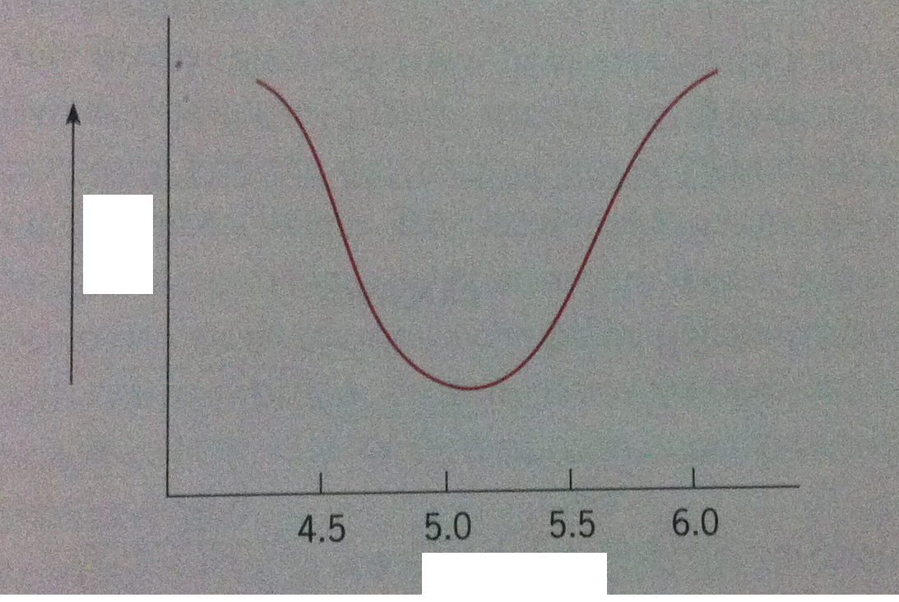

**PH**

**WHC**

Source: Μπλούκας. 2007

The large quantity of ATP is responsible for the big water holding capacity of the meat after slaughter. When ATP starts to disrupt a sudden decrease of water holding capacity is being observed. (Ελευθεριάδου, 2008)

## 2.3 THE CONDITION OF THE ANIMAL BEFORE THE SLAUGHTER

The health of the animal, the diet, the treatment of the animals during transportation and before the slaughter are crucial for the water holding capacity of the meat. Animals that are hungry have low amounts of glycogen in their muscles. So when the after death glycolysis occurs the fall of the pH is very small and the water holding capacity is very high. The meat though doesn't taste and smell the same. Also it gets corrupted by bacteria because the high pH favors their growth. (Ελευθεριάδου, 2008)

## 2.4 THE ANIMAL KIND

Big variation of the water holding capacity has been observed between meat from different types of animals. Pork meat has bigger water holding capacity from calf. Horse meat has the same water capacity with calf and poultry much less. (Ελευθεριάδου, 2008)

## 2.5 THE TYPE OF THE MUSCLE

Difference in the water holding capacity has been observed between different muscles from the same animal. White muscles in poultry and calf have bigger water - holding capacity than the dark ones. This difference is because of the different pH value between the muscles as an effect of different glycogen levels in the muscles. Also some other reasons are: a) the metabolism of the muscle (aerobic or anaerobic), b) the speed of the after death biochemical reactions (faster on the white muscles), c) the ion difference and the osmosis (white muscles have more intense osmosis than the dark ones), d) to the interstitial water (white muscles have less interstitial water than the dark ones). (Ελευθεριάδου, 2008)

## 2.6 THE AGE OF THE ANIMAL

The age of the animal seems to effect more the calf meat than the pork meat. Usually meat from young animals has better water holding capacity than the meat from old animals. (Ελευθεριάδου, 2008)

## 2.7 THE QUANTITY OF THE CONNECTIVE TISUES

The connective tissue is being found at all the muscles. The quantity though differs a lot between the muscles of the animal. The connective tissue is being formed by many chemical substances but the collagen seems to effect more the water holding capacity. Also the connective tissue has polysaccharides that can hold large amount of water. (Ελευθεριάδου, 2008)

## 2.8 THE QUANTITY OF FAT

The quantity of intracellular and intercellular fat seems to have a big effect to the water holding capacity. Meat that has big quantity of intracellular fat has bigger water holding capacity that meat with small quantity of fat. (Ελευθεριάδου, 2008)

## 2.9 THE USE OF HEATING

Boiling (or heating) of the meat weaken the water holding capacity because it denaturizes the meat proteins, liquefy the fat and changes the structure of the tissue and the pH. Heating of meat at 50 lowers the water holding capacity and temperature above 50 completely destroys it. (Γεωργάκης. 2005)

## 2.10 THE USE OF NaCl

The use of NaCl at small quantities swells the muscle fibrils and raises the water holding capacity of water. After the use Nacl it breaks into ions of sodium (Na+) and chlorine (Cl-). (Μπλούκας. 2007) Chloride ions tend to penetrate into the myofilaments causing them to swell. On the other side sodium ions form an ionic "cloud" around the filaments. All the above result to differences in local concentration and lead to an increased osmotic pressure within the myofibrils which causes the filament lattice to swell. (Puolanne *et al*. 2000)

At pH values below the isoelectric point the pure charge of the proteins is positive and the chlorine ions have the ability to bound easily from the positive charged proteins. At this point the isoelectric point is being shifted to lower pH values.

At higher pH values from the isoelectric point the pure charge of the proteins is negative. To this negative charge the negative charge of chlorine is being added to the total negative charge because the sodium ions don't tent to bound with the negative charged proteins. From this increase of the negative charge of the meat is the growth of even bigger repulsion forces between the peptide chains of the proteins and an increase of the water holding capacity of the meat. (Μπλούκας. 2007)

The water holding capacity of pre-rigor meat can be increased with increasing amounts of added salt from 1.8% to 2.0%. Also there is a rapid muscle swelling when 5.0% to 10.0% of salt is added to the meat products and the increase of the water holding capacity is a result of an increase in the ionic strength which causes the dissociation of actomyosin complexes. (Kerth. 2013)

Cooking loss of water is at minimum when the salt contained is in a range of 5-8%. At this concentration the increase in yield and the cooking loss is because of the structural changes within the muscle fibres as some proteins are solubilized or extracted. (Ranken. 2000)

## 2.11 THE USE OF PHOSPHORIC SALTS

The use of phosphoric and polyphosphoric acids increase the water holding capacity and the swelling of the meat. The reasons for this increase are: a) they raise the pH, b) the break of actomyosin to actin and myosin and the increase of the space between the fat and the thin filaments and c) they have the ability to react with the calcium ions and the magnesium ions and break the bonds of the peptide chains. (Μπλούκας. 2007)

When phosphates are being used alone they have a salt type of yield: 0.3% tripolyphosphate has a similar effect as 0.7% NaCl. Pyrophosphates and tripolyphosphates act in the presence of salt and greatly increase the effect of salt at cooking loss of water, on meat binding and act catalytically accelerating the salts effect (allowing same results in shorter time). (Ranken. 2000)

## 2.12 THE USE OF ACIDS

The use of strong acids in the meat procedure weaken the water holding capacity because the push the proteins isoelectic point to lower pH. Weak acids when they are used in meat production increase hydration of the proteins. (Γεωργάκης. 2005)

# CHAPTER 3 SUMMARY

The water holding and the water binding capacity is a major industrial concern for the meat industry. Unwanted moisture loss during processing of meat or cooking must be minimized in order for the consumers to have faith that the meat products they buy fulfill their requirements.

Knowledge of the forces that interact in the meat tissue, the types of water that can be found at the meat tissue and the principles that effect the water - holding and the water binding capacity that are analyzed in the previous chapters can help to diminish the chance of delivering not acceptable meat products to the consumers, to create more stable products and also maintain the economical benefits that the use of water to the meat production has.

# BIBLIOGRAPHY

Γεωργάκης, Α. Σ., 2005. Το κρέας και τα προϊόντα του. Σύγχρονη παιδεία

Ελευθεριάδου, Η. Α., 2008. Τεχνολογία κρέατος. Τμήμα εκδόσεων Α.Τ.Ε.Ι Θεσσαλονίκης

Μπλούκας, Γ. Ι., 2007. Τεχνολογία κρέατος. Εκδόσεις Σταμούλη Α.Ε.

Ραμαντάνης, Β. Σ., 2006. Τεχνολογία κρέατος και Προϊόντων του. Εκδόσεις "Σύγχρονη Παιδεία"

Kerth, R. C., 2013. The science of meat quality. Wiley - B;ackwell

Puolanne, E. and Halonen, M., 2010. Theoretical aspects of water - holding in meat. Meat science: 86 (2010) 151-165

Puolanne, J. E., Ruusunen, H. M. and Vainiopaa, I. J., 2000. Compined effects of NaCl and raw meat pH on water - holding in cooked sausage with and without added phosphate. Meat science 58 (2001) 1-7

Ranken, D. M., 2000. Handbook of meat product technology. Blackwell Science Ltd