MSc ..............................
Course: Food Physical Chemistry
Name:...............................
MF .......................
« Glass transition and Freezing of foods »

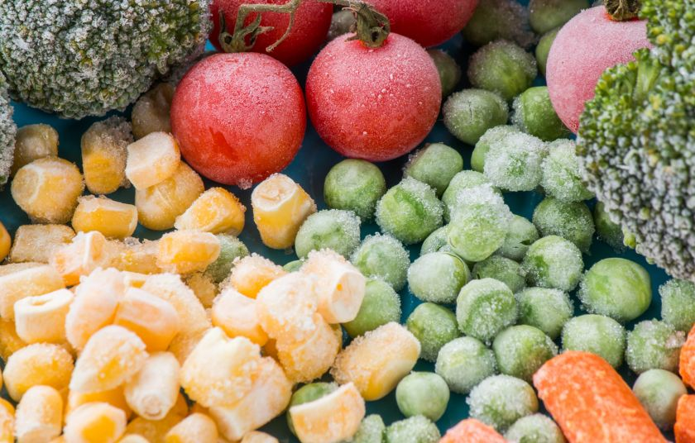

ABSTRACT
At the first part of this assignment will be described the meaning of the glassy state and phase transitions of materials but extensively will be described the glass transition and its relation with food products. Also will be analyzed the glass transition temperature, which is very important characteristic as well as the correlation of glass transition temperature with viscosity and crystallization. The second part of the essay is about the freezing of foods. The meaning, the advantages and disadvantages of the method. In addition will be analyzed the way that ice crystals are formed and finally in summary the methods of freezing that are used nowadays in food industry.

CONTENTS
PART 1: The glassy state and glass transition
  - Phases of a food
  - The glassy state
  - Phases transition
  - Glass transition
  - Glass transition in food products
  - Glass transition temperature
  - Viscosity and glass transition temperature
  - Crystallization
PART 2: Freezing of foods
  - What is the meaning of freezing on foods?
  - Phases of freezing of foods
  - Formation of ice crystals
  - Methods of freezing
  - Negative changes in frozen foods

PART 1
  - The phases of a food
The phases of a food that contains water in relation to the temperature may be:
- Glassy
- Elastic
- Very viscous
Indicators of the self-life of the food are the water activity (aw) that it’s use as a life time indicator for foods with low water content is limited, and the phase transition of foods that takes into account the change of physical properties of food at the contact of water with hydrophilic components.

  - The glassy state

The physical state of materials is often determined by their thermodynamic properties and their balance. Simple one-component systems may exist as crystalline solids, liquids or gases and these equilibrium states are controlled by pressure and temperature.
In most foods and other organic systems, the water content is high and the natural state of the water determines if the systems are frozen or liquid. In the food science and characterization of food systems, it is necessary to understand the physical state of solids and their interactions with water. Balance situations are not typical for foods so foods should be considered as non-equilibrium systems with time-dependent features. Foods, like the polymers, are constructed from several heterogeneous ingredients (monomers). As mentioned above, are metastable (unbalanced) systems and a mechanism by which they can stabilize is the formation of glass.
This view is very important in storage of foods, in order to preserve their safety and stability, as well as during freezing in which the foods reach in a state of immobilization of their liquid state, and so the physicochemical changes that lead to deterioration of the food, are blocked (glass transition). In the glassy state the food is in a rigid state which organoleptically is characterized as crispy/hard in opposition to the elastic state in which the food is organoleptically characterized as soft. Many foods with low water content are wholly or partly in glassy condition that is very important for the mechanical properties and stability of the food.

  - Phase transition

Phase transition are changes in the state of matter that happens at specific temperatures. These are:
- Meltdown (from solid to liquid)
- Crystallization (from liquid to solid)
- Vaporization (from liquid to gas)
- Condensation (from gas to liquid)

  - Glass transition

Glass transition is a gradual and reversible change that occurs in amorphous materials as temperature increases. It is the transition from the glassy condition (hard/brittle) to the elastic. The amorphous solid that appears glass transition is called glass while the opposite transition that occurs by supercooling of a viscous liquid in the state of a glass, is called vitrification. Under the temperature that glass transition takes place, the chains in the polymer molecule remain braided and immobile while increasing temperature becomes free and slid one over the other. At this temperature the material begins to appear as a solid mass. During the glass transition, the physical properties of the material change, but it is not considered as a phase transition (i.e. a transition between solid, liquid and gas). As a system moves from the glass to the elastic phase, the viscosity is dramatically reduced and this leads to great mobility of polymer chains and of the reactants.

  - Glass transition in food products

Many solid foods, and especially those with brittle, hard or crispy texture, are largely in the glassy state. The stability of these foods depends on how they are protected from temperature and humidity. In the various operations of food processing, the low glass transition temperature can limit the processing capacity of the food. On foods that glass transition takes place, undesirable changes in their quality may appear.

  - Glass transition temperature Tg

The glass transition temperature Tg separates the glassy from the elastic behavior and depends on the content of the food in water. The content in water and the temperature above which the crispness is lost, corresponds to Tg. When the foods are stored in Tg, the speed of chemical and enzymatic reaction as well as the speed of natural processes, are almost zero. This has the effect of increasing the storage time of the food. Increasing of Tg also increases the food storage time by one of the following ways:
- Removing of water by drying
- Immobilizing of water by freezing
- Immobilizing of water with help of polysaccharides
The phase transition temperature Tg is affected by
- The experimental conditions
- The presence of impurities
- Residuals of solvent
- The history of the sample
- The molecular weight
Because foods considered to be polymers, the glass transition temperature of a mixture of different material is a non-linear function of the glass transition temperature Tg of each of its particular constituents
Such an equation was proposed by Gordon & Taylor for the determination of Tg of an ideal mixture : 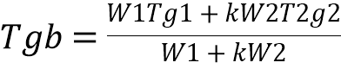
Where: Tgb: glass transition temperature of the mixture
W1: mass fraction of component 1
W2: mass fraction of component 2
Tg1: glass transition temperature of component 1
Tg2: glass transition temperature of component 2
The above equation is used to predict either the influence of the moisture content on Tg, either for the estimation of Tg in a binary polymer mixture (e.g. low and high molecular weight carbohydrates).

  - Viscosity and glass transition temperature Tg

At the phase transition temperature, the viscosity is extremely high while the temperature increases as the viscosity decreases. This has as effect the speeding up of the processes that lead to downgradation of food quality. During the glassy transition happens a dramatic reduction of the viscosity which leads to a flow of product.

  - Crystallization

Crystallization is called the removal of a component from a solution with the form of solid crystalline particle. Its object is to be received a relatively pure product from the original solution that contains various other substances. Several foods contain carbohydrates that can crystallize during storage (e.g. lactose on ice cream, lactose in milk powder, starch in bread). Crystallization depends on time and often occurs over the Tg, and crystallization rate is determined by the difference T-Tg. The crystallization process is based on the change in the solubility of a substance as determined by its phase diagram. For the crystal’s appearance, has either the temperature of the solution to be reduced under the phase change point, or to evaporated a part of the solvent.
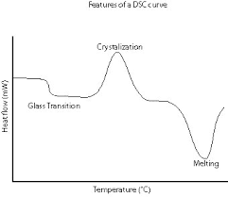

PART 2
2.1 What is the meaning of freezing on foods? 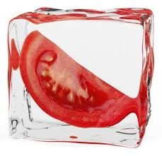
Food freezing is defined as the reducing of the temperature of a food and its retention at temperatures usually below -18 º C. Freezing is a process that its target is to preserve a food, retain its quality, its lifetime, its nutritional value and ensure public health from microbiological, enzymatic, chemical and physical changes. During the freezing of foods, takes place the conversion of water into ice crystals. This has as a result the:
- Reducing of water activity aw (which in combination with low temperatures, contributes to the maintenance of the food)
- Slowing down of enzyme and enzymatic and chemical reactions (but not always because some enzyme reactions are still continued at -30 º C, for this reason many times a pre-process, the blancing is done to achieve the enzyme inactivation.)
- Growth inhibition of microorganisms (pathogenic microorganisms and microorganisms that because deterioration is inactivated at -10 º C).

By summarizing, food freezing that leads to water removal, temperature reducing and limited molecular mobility, entails to deceleration of degradation of food quality. Freezing is the most effective way to conserve food for a long time. Frozen foods maintain their organoleptic characteristics and nutritional value almost perfectly

2.2 Phases of freezing of foods
The freezing of foods contains:
- Converted to ice crystals and the temperature of the product is reduced to the refrigerated storage temperature.
- The refrigeration phase of the product usually at temperatures under -18 º C.
- The defrosting phase, during which because of receiving of heat, returns to the product, melting of ice crystals and it returns to the original state.
The advantages of freezing as a method of preserving foods are the minimal changes in nutritional value and the organoleptic characteristics of frozen foods compared to other preservation methods such as canning and dehydration. However, in order to be achieved the good condition of frozen foods, appropriate circumstances must be followed in all three stages.

2.3 Formation of ice crystals
As mentioned above, during the freezing process the liquid phase is crystallized i.e. the formation of an organized solid phase (crystals) in a solution happens. The way that ice crystals form during the freezing of a food, is of great importance due to the influence of crystal size, on the quality of the product.
Includes:
- Nucleation (initial crystal formation) that may be heterogeneous or homogeneous.
In the homogeneous creation of ice crystals happens instantaneously below the freezing point while in heterogeneous very small particles which are in the liquid, act like nuclear to start the formation of crystals. Nucleation starts after a characteristic decrease in temperature, below the freezing point and its rate increases rapidly as the temperature decreases. Therefore, the rapid rate of nucleation is directly related to the rapid rate of temperature decrease and the rapid rate of freezing

- Increasing the size of the crystal.

2.4 Methods of freezing
Nowadays various food freezing methods are used, such as freezing in air which is the most widely used in industry, by contacting cold surfaces, by dipping in a refrigerant and by cryogenic two-phase means.

2.5 Negative changes in frozen foods
The main changes that are detrimental to the quality of frozen foods are:
- Recrystallization: changes in the shape and size of ice crystals or union of adjacent ice crystals, which occurs largely when the product is kept at non-stable temperatures.
- Denaturation of proteins: due to recrystallization, the concentration of salts increases and this leads to destabilization of hydrogen bonds in protein molecules (denaturation)
- Fat oxidation: the presence of oxygen causes rancidification of the fat and consequently the unpleasant odor and savory.
- Dehydration of food: the cold air that is circulated inside the freezer compartment is condensed due to ice formation. The effect is the reduce of the cold water vapor pressure that exerted on the surface of the product causing loss of moisture from the surface of the product because of sublimation. Therefore, the surface of the product becomes more hard and causes freeze burns (in the form of color change stigmas)
- Breakdown of pigments: mainly noticed in vegetables and fruits where their prolonged stay in freezing causes a change in their color.
- Vitamin loss: mainly observed in water-soluble vitamins that are removed from the food during defrosting.
- Continuation of enzyme activity: observed in fruits and vegetables that have not be blancing before their freezing.

