Food Physical Chemistry
Part I
1 Physical Chemistry in Food Science and Technology
Slaid 4
Physical Chemistry in Food science and technology
Food science and technology are concerned with a wide variety of problems and questions, and some will be exemplified below. For instance, food scientists want to understand and predict changes occurring in a food during processing, storage, and handling, since such changes affect food quality.
Slaid 5
Physical Chemistry in Food science and technology
Examples are
The rates of chemical reactions in a food can depend on many variables, notably on temperature and water content. The relations between reaction rates and the magnitude of these variables vary widely. Moreover, the composition of the mixture of reaction products may change significantly with temperature.
How is this explained and how can this knowledge be exploited?
How is it possible that of two nonsterilized intermediate-moisture foods of about the same type, of the same water activity, and at the same temperature, one shows bacterial spoilage and the other does not?
Two plastic fats are stored at room temperature. The firmness of the one increases, that of the other decreases during storage. How is this possible?
Slaid 6
Physical Chemistry in Food science and technology
Food technologists have to design and improve processes to make foods having specific qualities in an efficient way. Examples of problems are:
Many foods can spoil by enzyme action, and the enzymes involved should be inactivated, which is generally achieved by heat denaturation. For several enzymes the dependence of the extent of inactivation on heating time and temperature is simple, but for others it is intricate. Understanding of the effects involved is needed to optimize processing: there must be sufficient inactivation of the enzymes without causing undesirable heat damage.
It is often needed to make liquid foods with specific rheological properties, such as a given viscosity or yield stress, to ensure physical stability or a desirable eating quality. This can be achieved in several ways, by adding polysaccharides, or proteins, or small particles.
Slaid 7
Physical Chemistry in Food science and technology
How can denaturation and loss of solubility of proteins during industrial isolation be prevented? This is of great importance for the retention of the protein’s functional properties and for the economy of the process.
How can one manufacture or modify a powdered food, spraydried milk or dry soup, in such a manner that it is readily dispersable in cold water?
Slaid 8
Physical Chemistry in Food science and technology
How does one make an oil-in-water emulsion that is stable during storage but that can be whipped into a topping? The first question then is: what happens during a whipping process that results in a suitable topping? Several product and process variables affect the result.
Slaid 9
Physical Chemistry in Food science and technology
All of these examples have in common that knowledge of physical chemistry is needed to understand what happens and to solve the problem.
Physical chemistry provides quantitative relations for a great number of phenomena encountered in chemistry, based on well-defined and measurable properties. Its theories are for the most part of a physical nature and comprise little true chemistry, since electron transfer is generally not involved. Experience has shown that physicochemical aspects are also of great importance in foods and food processing. This does not mean that all of the phenomena involved are of a physical nature: it is seen from the examples given that food chemistry, engineering, and even microbiology can be involved as well.
Slaid 10
Physical Chemistry in Food science and technology
The problems encountered in food science and technology are generally quite complex, and this also holds for physicochemical problems.
In the first place, nearly all foods have a very wide and complex composition; a chemist might call them dirty systems. Anyway, they are far removed from the much purer and dilute systems discussed in elementary textbooks. This means that the food is not in thermodynamic equilibrium and tends to change in composition. Several changes may occur simultaneously, often influencing each other. Application of physicochemical theory may also be difficult, since many food systems do not comply with the basic assumptions underlying the theory needed.
Slaid 11
Physical Chemistry in Food science and technology
In the second place, most foods are inhomogeneous systems.
Consequently, various components can be in different compartments, greatly enhancing complexity. This means that the system is even farther removed from thermodynamic equilibrium than are most homogeneous systems. Several new phenomena come into play, especially involving colloidal interactions and surface forces. These occur on a larger than molecular scale. Fortunately, the study of mesoscopic physics—Which involves phenomena occurring on a scale that is larger than that of molecules but (far) smaller than can be seen with the naked eye—has made great progress in recent times.
In the third place, a student of the physical chemistry of foods has to become acquainted with theories derived from a range of disciplines, as a look at the table of contents will show. Knowledge of the system studied is essential: although basic theory should have universal validity, the particulars of the system determine the boundary conditions for application of a theory and thereby the final result.
2 Aspects of Thermodynamics
Slaid 12
Aspects of Thermodynamics
Chemical thermodynamics can provide the food scientist with important quantitative knowledge. It treats—despite its name—equilibrium situations. Three components of thermodynamic equilibrium can be distinguished: (a) mechanical, implying that there are no unbalanced forces; (b) thermal, no temperature gradients; and (c) chemical, implying that no chemical reactions and no net transport of components occur. Thermodynamics may tell us whether there is equilibrium and, if not, in what direction the change will be, but nothing about the rate at which any reaction or other change may occur.
Slaid 13
Aspects of Thermodynamics
Thermodynamic theory does not involve molecular explanations and is this model independent. Physical chemists mostly combine thermodynamic concepts with molecular theories and have developed powerful tools for studying matter.
Some of the theory will be briefly recalled in this chapter, and applications to foods will be illustrated. It is by no means an attempt to treat the rudiments of thermodynamics.
Slaid 14
Consepts
Physical chemists call the part of the universe that they want to consider the system and the remainder the surroundings. The system may be a collection of water molecules, an emulsion droplet, a beaker containing a solution, a loaf of bread, a yeast cell, etc. An open system can exchange mass and energy with its surroundings, a closed system can exchange no mass, and an isolated system neither mass nor energy. If the system is large enough, it has measurable properties, which are conveniently separated in two classes.
Intensive parameters are independent of the amount of matter and thus include temperature, pressure, refractive index, mass density, dielectric constant, heat conductivity, pH, and other compositional properties, viscosity and so on.
Extensive parameters depend on (and often are proportional to) the amount of matter and thus include mass, volume, energy, electric charge, heat capacity, etc.
Slaid 15
Consepts
Most systems that food scientists consider are heterogeneous, and this is further discussed in Chapter 9. As mentioned, thermodynamics is model independent, but it is necessary to consider the existence of more than one phase. A phase is defined as a (part of a) system that is (a) uniform throughout and (b) bounded by a closed surface, at which surface at least some of the intensive parameters change abruptly.
Another criterion is that the boundary or interface between the two phases contain energy, and that enlargement of the interfacial area costs energy, the amount of which can in many cases be measured.
Slaid 16
Consepts
Thermodynamics is primarily concerned with energy and entropy.
Energy, also called internal energy (U), comprises heat and work; it is measured in joules (J). Work may be mechanical, electrical, chemical, interfacial. It may be recalled that work generally equals force times distance (in N m = J) and that force equals mass times acceleration (in kg m s⁻² = N).
According to the first law of thermodynamics, the quantity of energy, heat + work + potential energy, is always preserved.
Slaid 17
Consepts
Entropy (S) is a measure of disorder; it is given by
S = k_{B} ln Ω
where k_{B} is the Boltzmann constant (1.38 10⁻²³ J K⁻¹) and Ω is the number of ways in which the system can be arranged, also called the number of degrees of freedom. If the system consists of perfect spheres of equal size, this only relates to the positions that the spheres can attain in the volume available (translational entropy). This is illustrated in a simplified way in Figure 2.1 for a two-dimensional case, where spherical particles or molecules can be arranged in various ways over the area available. If the interparticle energy = 0, which means in this case that there is no mutual attraction or repulsion between the particles, the entropy is at maximum: the particles can attain any position available and are thus randomly distributed (and they will do so because of their thermal or Brownian motion). If there is net attraction (U is negative), they tend to be arranged in clusters, and S is much lower.
Slaid 18
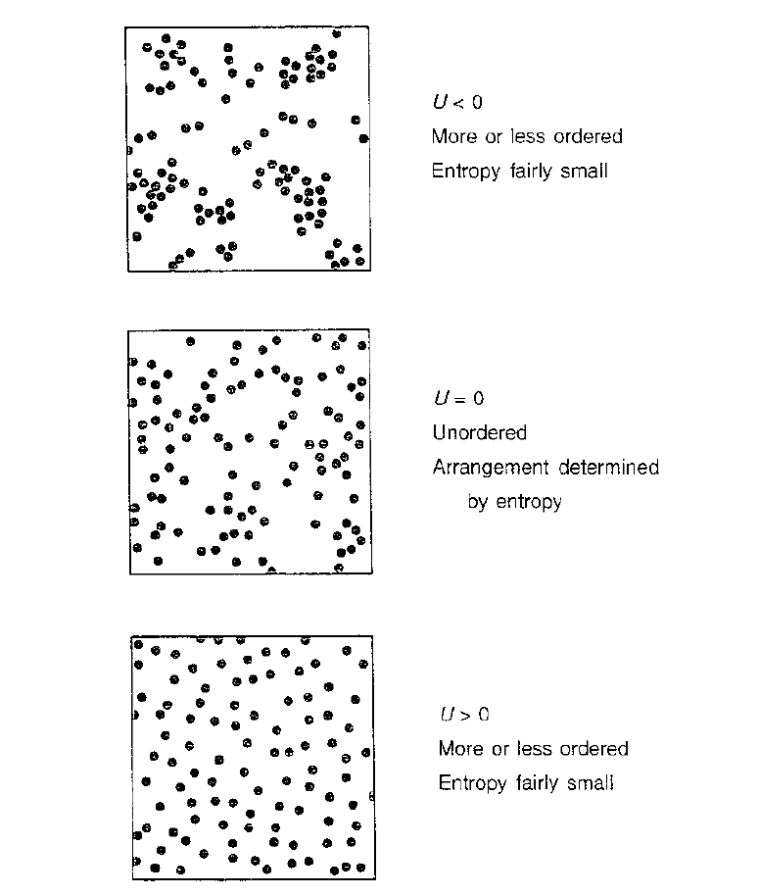
FIGURE 2.1 Energy (U) and entropy. Depicted for a given number of molecules or particles in a given two-dimensional space.
Slaid 19
Consepts
The paramount thermodynamic property is the free energy. Two kinds are distinguished. The Helmholtz (free) energy is given by
A = U - TS (2.1)
Note that entropy is thus expressed in J K ; T is the absolute temperature (in K). At constant volume, every system will always change until it has obtained the lowest Helmholtz energy possible. This may be due to lowering of U or increase of S. Since we mostly have to do with constant pressure rather than constant volume, it is more convenient to use the Gibbs (free) energy. To that end we must introduce the enthalpy (H), defined as
H = U - pV (2.2)
where p is pressure (in Pa) and V volume (in m³). For condensed (solid or liquid) phases at ambient conditions, any change in pV mostly is very small compared to the change in U. At constant pressure, every system will change until it has obtained the lowest Gibbs energy:
G = H - TS (2.3)
Unless mentioned otherwise, we will always mean the Gibbs energy when speaking about free energy.
Slaid 20
Consepts
Example
The free energy is the property determining what will happen. If we add some sugar to water, it will dissolve and the sugar molecules will distribute themselves evenly throughout the liquid, because that gives the lowest free energy. In this case the increase in entropy has a greater effect than the increase in enthalpy (in crystalline sugar, the molecules attract each other and the enthalpy is thus lower than in solution).
All this applies, only to macroscopic amounts of matter.
Thermodynamics is valid only for large numbers of molecules. If small numbers are considered, say less than a few times 100, exceptions to the rule stated above may occur; even at 10 ºC, a few water molecules may temporarily become oriented as in an ice crystal, just by chance, but macroscopically ice will never form at that temperature.
Slaid 21
Consepts
Another remark to be made is that the absolute values of enthalpy and entropy are generally unknown. (Only a perfect crystal of one component at zero absolute temperature has zero entropy.) Quantitative results therefore mostly refer to some standard state (usually 0 ºC and 1 bar), where these parameters are taken to be zero. One always considers the change in thermodynamic properties, and that is quite sufficient. At constant pressure and temperature, the basic equation thus is
ΔG = ΔH - TΔS (2.4)
The change may be from one state to another, say water plus crystalline sugar to a sugar solution, etc. If the change considered is reversible, we have at equilibrium ΔG = 0 and thus
ΔH = Te ΔS (2.5).
For example, at 273.15 K (0 ºC) and 1 bar there is equilibrium between (pure) water and ice. ΔH is here the enthalpy of fusion, which can readily be measured by calorimetry and which equals 6020 J mol⁻¹. Consequently, the change in entropy of water molecules going from the solid to the liquid state equals
ΔH/Te = 22 J mol⁻¹ K⁻¹. (2.6)
This signifies that the molecules gain entropy on melting, in agreement with the nature of entropy.
Slaid 22
Consepts
It is often tacitly assumed that ΔH and ΔS are independent of conditions like temperature, and this is indeed often true, as long as the temperature range is small. Note that the effect of a change in entropy will be larger at a higher temperature. If the system does not work, a change in enthalpy can be measured as a change in heat, by calorimetry. Changes in entropy mostly cannot be measured directly.
According to thermodynamic theory, any system will spontaneously change until it has attained the state of lowest free energy. In an isolated system (no exchange of energy with the environment) this means that the entropy will increase until it has attained the highest possible value. Consequently, a system is stable if it is in a state of lowest free energy. In any other state the system would be unstable. This does not mean that we observe every unstable system to change. First, the system may be metastable. This means that it is in a local state of minimum free energy; at least one other state of still lower free energy does exist, but the system cannot reach it, because it then has to pass through a state of higher free energy.
Slaid 23
Solutions
Almost all foods are or contain solutions, and solution properties are paramount. In this section we will briefly discuss some properties of simple solutions of nonelectrolytes.
The Chemical Potential
In a homogeneous mixture each component i has a chemical potential μ_{i}, defined as the partial molar free energy of that component (the change in Gibbs energy per mole of component n₁ added, for addition of an infinitesimally small amount). It is given by
Slaid 24
$μ={\left(\frac{∂G}{∂n}\right)}_{P,T}$$2\text{.}7$Chemical potential
$2\text{.}8$
${\left(μ_{i}\right)}_{}=μ_{i}^{0}\left(P,T\right)+\text{RT}\text{ln}a_{i}$
where μ_{i} is the standard chemical potential of the pure substance i and the subscript j refers to all other components. R is the universal gas constant, given by
Slaid 25
Chemical potential
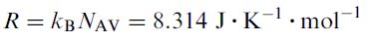$2\text{.}9$
where Avogadro’s number N_{AV} = the number of molecules in a mole (6.02 10²³). It should be noted that only applies at standard pressure.
Note: If the pressure is raised, this increases the chemical potential, in first approximation by an amount pv_{i}, where v_{i} is the molar volume of the component.
Slaid 26
Chemical potential
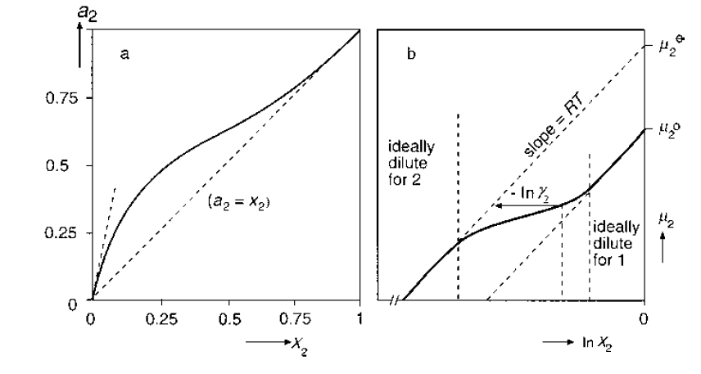
FIGURE 2.2 Thermodynamic aspects of mixtures. (a) Activity (a₂) of ethanol as a function of its mole fraction in an aqueous mixture (x₂). (b) Example of the chemical potential (μ₂) of a substance as a function of its mole fraction (x₂) in a mixture of substances 1 (solvent) and 2 (solute).
Slaid 27
Chemical potential
a_{i} is the activity of i; it is sometimes called the thermodynamic or the effective concentration. The activity is directly related to concentration: for zero concentration a = 0; for the pure substance a = 1. For solutions called ideal, the activity equals concentration, if the latter is expressed as mole fraction (x). Ideality is not often observed, except for a mixture of very similar compounds. Figure 2.2a gives an example for the mixture ethanol (2) and water (1), and it is seen that the deviation from ideality is large.
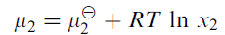$2\text{.}\text{10}$
Note: in Figure 2.2a that at high concentration of ethanol the activity of the solvent (water) is proportional to its mole fraction, hence to 1 - x₂; here the solution is ideally dilute for the solvent.
For those cases where x does not equal a, one arbitrarily introduces an activity coefficient γ, defined by
Slaid 28
Chemical potential
$2\text{.}\text{11}$
The chemical potential determines the reactivity of a component, the composition of a mixture at chemical equilibrium and the driving force for a reaction, though not its rate. Transfer of a component from one phase or position to another one will always proceed in the direction of the lowest chemical potential, whether the transfer is by diffusion, evaporation, crystallization, dissolution, or some other process. If temperature and pressure are constant, it is convenient to use the activity. The activity rather than the concentration enters in relations on the solubility, the distribution of a component over various phases, the adsorption of a component onto a surface, and so on. If for some reason—say, the addition of another component—the activity coefficient becomes smaller without the concentration altering, the reactivity of the solute has become smaller and its solubility increased.
Slaid 29
Solubility and partitioning
For a mixture of components that behaves ideally, it can be derived that there is no change in enthalpy when the components are mixed, no heat is released nor consumed. The decrease in free energy due to mixing then is purely due to an increase in entropy. Such a situation may occur for two components of very similar properties, for instance for a mixture of closely related triglycerides. If one of the components is a solid at the temperature of mixing, it has to melt, and this means an increase in enthalpy, equal to the enthalpy of fusion ΔH_{f} (the enthalpy of mixing is still assumed to be zero). This implies that there is a limited solubility (x_{s}), given by the Hildebrand equation,
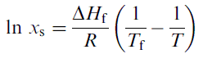$2\text{.}\text{12}$
where the solubility is expressed as a mole fraction and where the subscript f refers to fusion. Most solutions are far from ideal, and especially at high concentrations the activity coefficient may differ greatly from unity (often being larger).
Slaid 30
Solubility and partitioning
It may further be noted that the volume of a mixture of two components is generally not equal to the sum of the volumes of each. For many aqueous mixtures, the volume is decreased; one then speaks of contraction. For example, when mixing 10 ml (15.8 g) of ethanol with 90 ml of water, the mixture has a volume of 98.3 ml, which implies a contraction by 1.7%.
Partitioning.
A substance may have limited solubility in two mutually immiscible solvents, for instance water and oil. This often happens in foods, for example with many flavoring and bactericidal substances. It then is important to know the concentration (or rather activity) in each phase. For low concentration, the partitioning or distribution law of Nernst usually holds:
Slaid 31
Solubility and partitioning
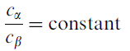$2\text{.}\text{13}$
where c is concentration and α and β refer to the two phases.
This law is readily derived from thermodynamics, assuming both solutions to be ideally dilute. At equilibrium we must have for the solute (2) that μ_{2,α} = μ_{2,β}. Although the standard chemical potential of the pure solute μ⁰ is, of course, the same, the apparent standard chemical potential μ⁻ (see Fig. 2.2) will generally be different. We thus have
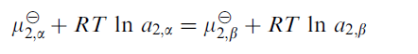
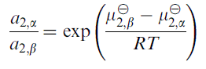$2\text{.}\text{14}$
which is constant at constant temperature. Since for dilute solutions the (apparent) activities mostly are proportional to the concentrations, Eq. (2.14) comes down to Nernst’s law. Note that the partition ratio (c_{α}/c_{β}) will decrease with increasing temperature if the ratio is larger than unity.
Slaid 32
Determination of activity
When preparing a solution, one usually knows the concentration of the solute. Most analytical methods also yield concentrations rather than activities. Often, the solute is allowed to react in some way, and although the reaction rate will be determined by the activity rather than the concentration, these reactions are generally chosen such that the reacting solute will be completely consumed, and a concentration results. Generally, spectroscopic methods give concentrations as well. Equilibrium methods, on the other hand, yield activities. A good example is measurement of an electric potential by means of an ion-selective electrode, as in pH measurement. Also a partition equilibrium between two phases yields activity.
Slaid 33
Determination of activity
This provides an easy way of determining the activity of a substance if it is volatile. It will then have the same activity in the gas phase as in the solution, and at ambient conditions a gas generally shows ideal behavior.
The latter is true as long as the so-called ideal gas law,
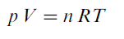$2\text{.}\text{15}$
holds, where n is the number of moles in the system. The prime example is determination of the water activity of a solution. Because of the ideality in the gas phase, a₁ = x₁, the a₁ in the solution, mostly designated a_{w}, is equal to the relative humidity of the air with which the solution is in equilibrium, which can readily be measured. If the solute is also volatile, it is often possible to determine its activity in the gas phase, hence in the solution.
Slaid 34
Determination of activity
For a solution of one (nonvolatile) solute in water, whose water activity is known over a concentration range, the activity of the solute can be derived from the Gibbs–Duhem relation, which can for this case be written as
$2\text{.}\text{16}$
By (numerical or graphical) integration, a₂ can now be derived. Figure 2.3 gives as an example the activities of sucrose solutions. It is seen that the activities greatly deviate from the mole fractions at higher concentration.
For example, at x₂ = 0.1, the activity coefficient of water ≈ 0.85/0.90 = 0.94, that of sucrose ≈ 0.26/0.1 = 2.6. For mixtures of more than two components, the activities cannot be derived in this way.
Slaid 35
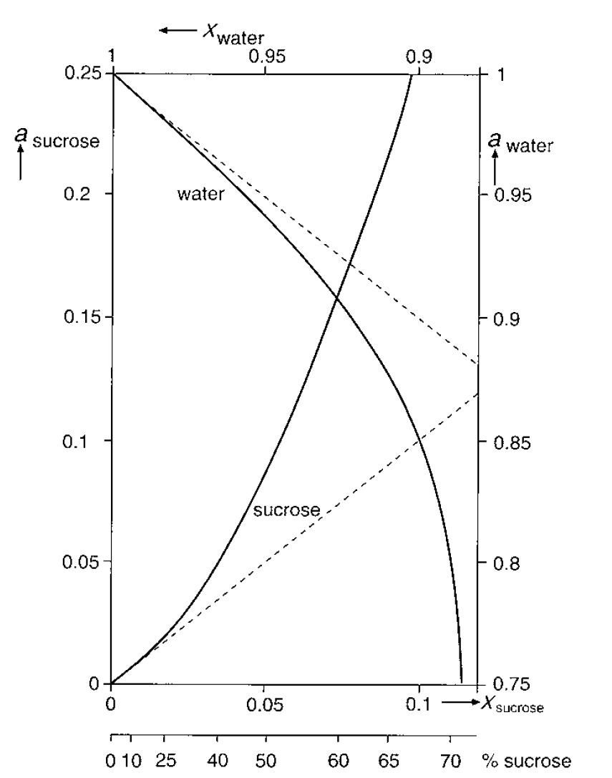
FIGURE 2.3 Activities (a) of sucrose and water in binary mixtures as a function of the mole fraction (x). The broken lines give the hypothetical activities for ideally dilute systems.
Slaid 36
Colligative properties
The lowering of the chemical potential of a solvent by the presence of a solute causes changes in a number of physical properties: vapor pressure, boiling point, freezing point, osmotic pressure, etc. In an ideally dilute solution the magnitudes of these changes all are proportional to the mole fraction of solute; they follow from the same cause and are called colligative solution properties. In Section 2.3, electrolyte solutions will be discussed, but it is convenient to recall here that solutes that largely dissociate into two species—commonly ions—have an effective molarity that is about twice the nominal one; this effective concentration is called the osmolarity. We will here only consider water as the solvent and assume the solution to be ideally dilute. Subscript 1 refers to the solvent (water), 2 to the solute.

Slaid 37
Colligative properties
The lowering of vapor pressure at any temperature then follows from Raoult’s law,
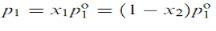$2\text{.}\text{17}$
where p is vapor pressure and p₁⁰ is that of pure water.
The change in boiling point at standard pressure (1 bar) is given by
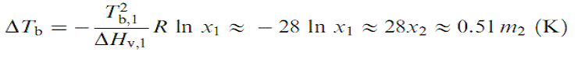$2\text{.}\text{18}$
where T_{b,1} is the boiling point of the pure solvent, ΔHv is the enthalpy of vaporization (40.6 kJ mol⁻¹ for water at 100 ºC), and m is the solute concentration in moles per liter. The approximations successively made, when going from the first to the last righthand term in the equation, all apply at infinite dilution. The boiling point elevation is often given as K_{b} m², where for water K_{b} = 0.51K L mol⁻¹. It should be noted that its magnitude significantly depends on ambient pressure.
Slaid 38
Colligative properties
The change in freezing point is similarly given by
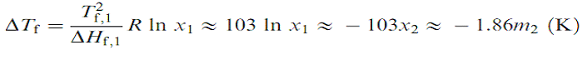$2\text{.}\text{19}$
where ΔH_{f} is the enthalpy of fusion, 6020 J mol⁻¹ for water.
Note: the freezing point depression is considerably greater than the boiling point elevation, because the molar enthalpy of fusion is far smaller than the enthalpy of vaporization.
Slaid 39
Colligative properties
The osmotic pressure (П) of a solution can be interpreted as the pressure that has to be applied to the solution to increase the chemical potential of the solvent to the value of the pure solvent at standard pressure. П is thus higher for a higher solute concentration. If local differences in concentration exist, solvent (liquid) will move to the regions where П is highest, to even out concentration gradients; this means that osmotic pressure is in fact a negative pressure.
The osmotic pressure becomes manifest and can be measured in a situation as depicted in Figure 2.4, where solvent and solution are separated by a semipermeable membrane that lets the solvent pass but not the solute(s).
Solvent now moves to the solution compartment until the osmotic pressure is compensated by the difference in height of, hence in gravitational pressure in, both compartments. Incidentally, this implies that by application of a pressure to a solution that is higher than its osmotic pressure, solvent can be removed from the solution, thereby increasing the concentration of the solute; this is called reversed osmosis.
Slaid 40
Colligative properties
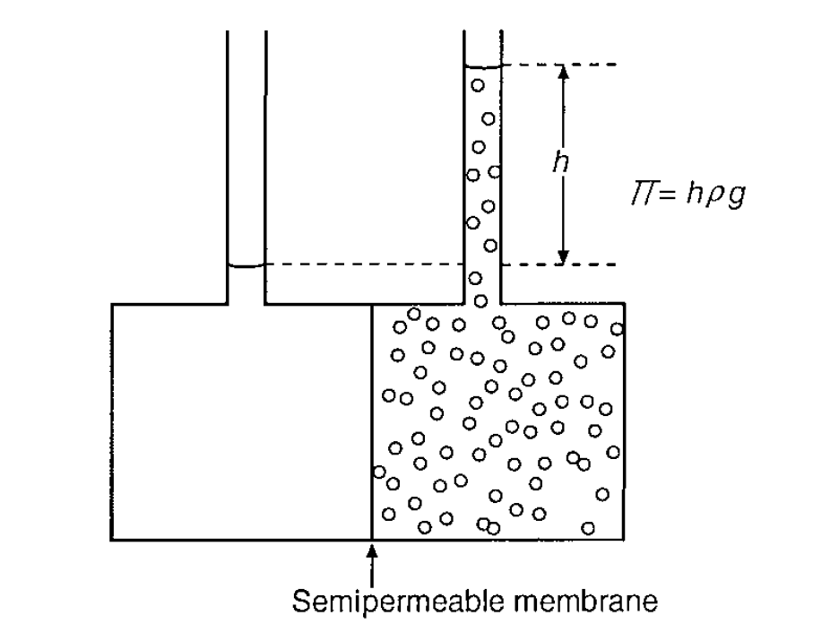
FIGURE 2.4 Measurement of osmotic pressure (П). Solvent and solution are separated by a membrane that lets the solvent pass but not the solute. The small circles denote the solute molecules (or particles). h = height (m), ρ = mass density (10³ kg m⁻³ for water) and g = acceleration due to gravity (9.81m s⁻²).
Slaid 41
Colligative properties
The osmotic pressure of an ideally dilute aqueous solution is given by
$2\text{.}\text{20}$
where the factor 55,510 represents the number of moles of water in a m³.
Since m² = n/V, where n = the number of moles in the volume V, Eq. (2.20) can also be written as ПV ≈ nRT
It is seen that the agreement is reasonable, especially if the equations are used in their most rigid form. Nevertheless, deviations remain, which implies that at the concentration considered the solutions are not ideally dilute anymore.
Comparison with Figure 2.3 shows that, for sucrose, deviations become large for concentrations over 20%. Actually, Eqs. (2.17–2.20) are all based on the assumption that x₁ = a₁, i.e., = the water activity a_{w}. By inserting a_{w}—which can often be measured—for x₁, a much better agreement will be obtained.
Slaid 42
Colligative properties
The colligative properties are of importance by themselves, but they can also be used to determine the molar mass of a solute, since they all depend on the molar concentration and since the mass concentration generally is known. To this end, the determination of the freezing point often is most convenient. Because of nonideality, determinations should be made at several concentrations and the results extrapolated to zero. For determination of the molar mass of macromolecules, osmotic pressure measurement is to be preferred, since membranes exist that are not permeable for macromolecules, while they are for small-molecule solutes, and even small quantities of the latter have a relatively large effect on the colligative properties. Actually, a difference in osmotic pressure is determined, the difference being due to the macromolecules only.
Slaid 43
Deviations from ideality
In foods, we often have situations in which concentrations are markedly different from activities, or in other words, the activity coefficients may be far from unity. This may have important consequences for partition equilibria, for reaction equilibria, and often also for reaction rates. Below some important causes for deviations from ideality are listed.
1. Not all species are reactive. This is theoretically fairly trivial, but the practical implications may be considerable. An example is the presence of a reducing sugar, for instance D-glucose, in various forms. Here we have
and only in the open-chain form, which may be less than 1% of the glucose present, can the sugar participate in Maillard reactions or other reactions involving the aldehyde group. Another example is an organic acid, here denoted by HAc, which dissociates according to
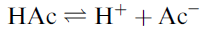
Slaid 44
Deviations from ideality
The dissociated form Ac⁻ can react with cations, whereas the undissociated form HAc may be active as an antimicrobial agent. The activities of each depend not only on the overall concentration but also on the dissociation constant (which depends on temperature), the pH, the presence and concentration of various cations. It may be argued in these cases not that the activity coefficient is (much) smaller than unity but that we should take the concentration of the species involved in the reaction only. The result is, of course, the same, and we may speak of an apparent activity coefficient.
Slaid 45
Deviations from ideality
2. High concentration. At high concentrations of a solute, its activity coefficient nearly always deviates from unity. This may be for two reasons. First, the solvent quality affects the activity coefficient, and the effect increases with increasing solute concentration. Solvent quality depends on the interaction energy between solute and solvent molecules. A poor solvent tends to increase and a good solvent to decrease the activity coefficient of the solute (and thereby, for instance, to increase its solubility).
Second, volume exclusion occurs, which always causes an increase in the activity of a solute if the solute molecules are larger than the solvent molecules. At high concentration the amount of solvent available to the solute is effectively less than the nominal amount, which means that the solute concentration is effectively higher. This is easiest envisaged for spherical molecules of radius r; such a molecule takes up a volume equal to (4/3)πr³.
Slaid 46
Deviations from ideality
Nevertheless volume exclusion is a very real and important source for deviations from ideality at high concentration, especially if the solute molecules are large.
The effect of concentration is often expressed in a virial expansion. For the osmotic pressure it reads
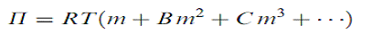$2\text{.}\text{21}$
where m is in mol m⁻³. B is called the second virial coefficient, C the third virial coefficient, and so on. In first approximation, B is due to both solvent quality and volume exclusion effects and it can either be negative or, more likely, positive; C is only caused by volume exclusion and would be zero if solvent and solute molecules have equal size. Figure 2.5 illustrates some trends. It is seen that for a not too high concentration the second virial coefficient may suffice (P = m is linear with m), but this is rarely true for macromolecular solutes.
Slaid 47
Deviations from ideality
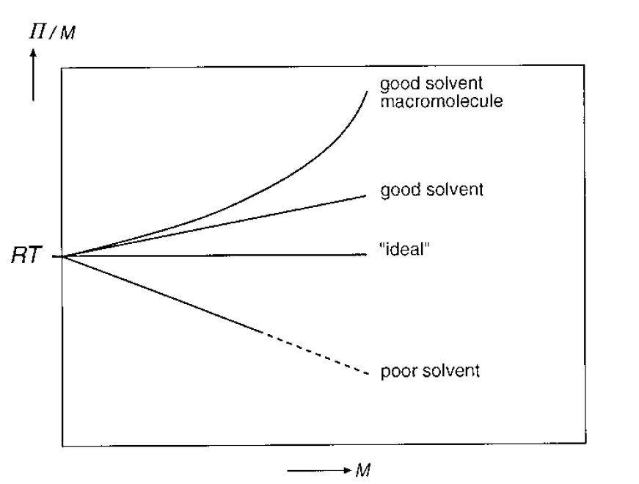
FIGURE 2.5 Hypothetical examples of the dependence of osmotic pressure (П) divided by concentration against molar concentration (m).
Slaid 48
Deviations from ideality
The same relation can be used for the chemical potential of the solvent (more precisely for μº₁ - μ₁, which equals zero for m = 0) and for all colligative properties. From the results depicted in Figure 2.3, it can be derived that for sucrose solutions a second virial coefficient suffices up to a mole fraction of about 0.015 (about 25% w/w sucrose). If we have more than one solute, the situation becomes far more complicated. For two solutes (subscripts 2 and 3) we have in principle
$2\text{.}\text{22}$
We now must also take into account a second virial coefficient for the interaction between both solutes B₂₃. If both solutes are very similar in chemical nature, B₂₃ may be negligible. As an example we take the effect of sucrose on lactose. Figure 2.6 show that high concentrations of sucrose considerably lower the solubility of lactose. This is to be expected, since (a) at high sucrose concentrations the activity coefficient of sucrose is greatly increased (see Figure 2.3); (b) because of the similarity between both sugars we may expect that also the activity coefficient for lactose is greatly increased; and (c) since the solubility is to be expressed as an activity, and activity equals concentration times activity coefficient, a higher activity coefficient means a lower solubility in terms of concentration.
Slaid 49
Deviations from ideality
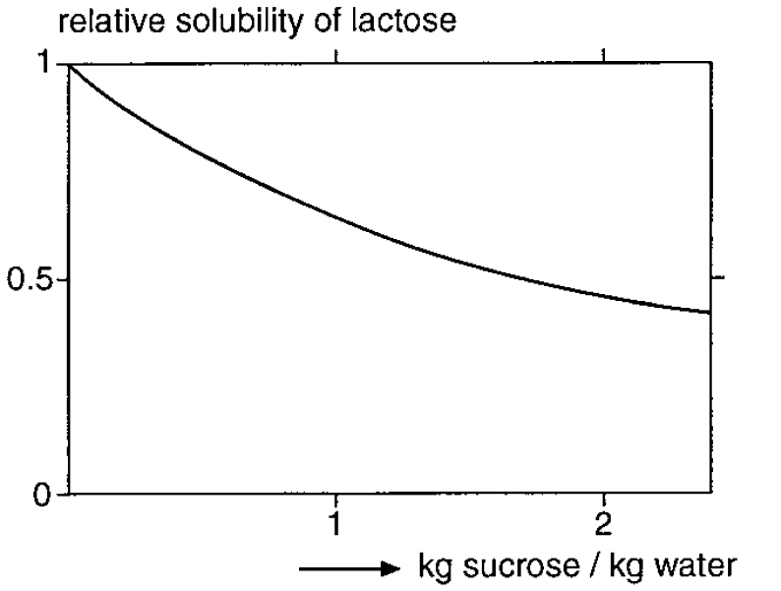
FIGURE 2.6 Effect of sucrose on the relative solubility of lactose in water at 50 ºC.
Slaid 50
Deviations from ideality
3. Adsorption. Several kinds of molecules can adsorb onto various surfaces or bind onto macromolecules, thereby lowering their activity coefficients. Binding should not be interpreted here as forming a covalent or an ionic bond, for in such a case the concentration of the substance is indeed decreased. It is well known that for many flavor components the threshold concentration for sensory perception is far higher in a particular food than in water. This means that the activity coefficient is smaller in the food than in water, and a decrease by a factor of 10³ is no exception. It may be recalled that many flavor components are fairly hydrophobic molecules, which readily adsorb onto proteins. Because of this, the so-called head space analysis for flavor components makes good sense, since the concentrations of the various components in the gas phase (which is, in principle, in equilibrium with the food) are indeed expected to be proportional to the activities in the food.
Slaid 51
Deviations from ideality
A surface active component naturally adsorbs onto many surfaces, say of oil droplets or solid particles or macromolecules, by which its activity is decreased. Another example is the binding of cations, especially of heavy metals, to proteins; when concentrating by ultrafiltration a protein solution that also contains some Cu, almost all of the Cu is concentrated with the protein, although Cu ions would be perfectly able to pass the ultrafiltration membrane.
Slaid 52
Deviations from ideality
In the simplest case, the amount adsorbed is proportional to the concentration (or rather activity) of the species in the solution, implying that the activity is a constant fraction of the concentration. If there is a limited number of binding or adsorption sites, as is often the case, we often have a Langmuir type adsorption isotherm, given as
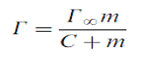$2\text{.}\text{23}$
where Г is the surface concentration of adsorbed material (in mol m⁻²), Г∞ its value if all adsorption sites are occupied, and the constant C denotes the concentration at which Г = 0.5 Г∞. Note that m (mol m⁻³) refers to the concentration in solution; the total concentration equals m + ГA, where A is the specific surface area. The activity coefficient then would be given by m/(m + ГA), which increases with total concentration, as illustrated in Figure 2.7b.

Slaid 53
Deviations from ideality
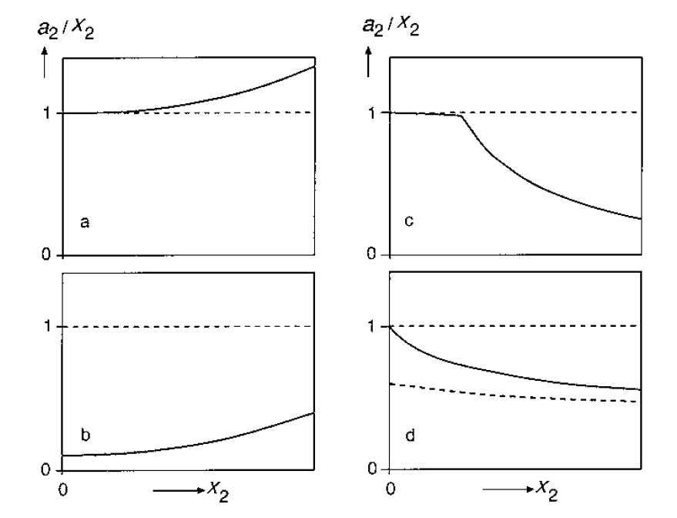
FIGURE 2.7 Hypothetical examples of nonideality of a solute (2) in aqueous solutions. The activity coefficient is given as a₂/x₂ versus the mole fraction x₂: (a) ‘‘High concentration.’’ (b) Adsorption or binding. (c) Self-association, especially micellization. (d) Electric shielding; the broken line is for a case where other salts are present at constant concentration.
Slaid 54
Deviations from ideality
4. Self association. Amphiphilic molecules, i.e., molecules that consist of a hydrophilic (or polar) and a hydrophobic (or apolar) part, often tend to associate in an aqueous environment. Good examples are soaps and other small-molecule surfactants, which form micelles, roughly spherical aggregates in which the hydrophobic tails are in the interior and the hydrophilic heads to the outside; see Figure 2.8a. Micelles are often formed at a well-defined critical micellization concentration (CMC), above which almost all additional molecules are incorporated into micelles. This implies that properties that depend on the activity of the solute, like osmotic pressure and surface tension, hardly alter above the CMC, since the activity hardly increases anymore; see Figure 2.8b. The way in which the activity coefficient alters is illustrated in Figure 2.7c.
Slaid 55
Deviations from ideality
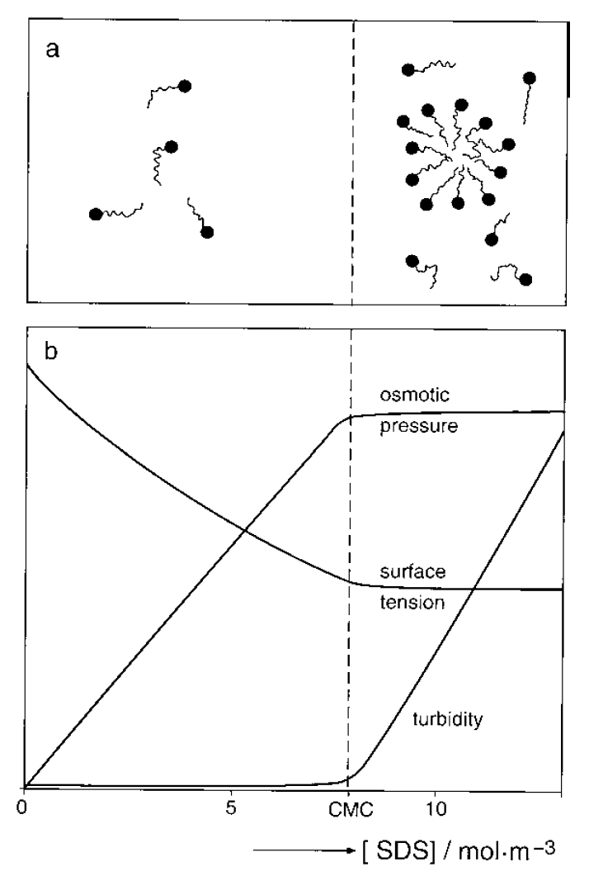
FIGURE 2.8 The effect of micelle formation on some solution properties. (a) Schematic picture of micelle formation. (b) Osmotic pressure, surface tension, and turbidity of solutions of sodium dodecyl sulfate (SDS) as a function of concentration (approximate). CMC = critical micellization concentration.

Slaid 56
Deviations from ideality
Incidentally, the presence of micelles may greatly enhance the apparent solubility of apolar components in an aqueous phase, since they tend to be incorporated into the interior of the micelles up to a certain level.
The activity of such an a polar component remains of course very low, but it may still be available as a reactant, although it will react only sluggishly. But if no micelles were present, a very apolar ‘‘solute’’ would not be there and thus would not react at all.
Other kinds of self-association occur. Several proteins associate to form fairly large aggregates, thereby markedly decreasing their activity.
Fatty acids present in an oil phase always dimerize through hydrogen bonds:
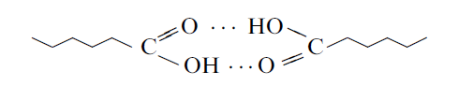
thereby greatly decreasing their activity and increasing their solubility.

Slaid 57
Deviations from ideality
5. Electric shielding. The activity of ions is diminished by electric shielding. The total ionic strength rather than the concentration of the ions studied determines the activity coefficient; see Figure 2.7.d.
Slaid 58
Deviations from ideality
Note We have tacitly assumed that all activity coefficients equal unity. This may be reasonable, except for Ac; taking its activity coefficient into account would cause the total concentration in the water phase to be somewhat higher. (We do not need an activity coefficient for H⁺, since pH is a measure of activity, not concentration.)
Note A certain amount of the fatty acid may adsorb on the oil–water interface. If the oil droplets are small, this may be an appreciable amount. If the adsorption isotherm is known, the effect can be calculated.
Note If the aqueous phase contains protein, it may well be that some fatty acid becomes associated with the protein, whereby the activity coefficient is lowered and the concentration in the water will be increased.
Slaid 59
Electrolyte solutions
Ionizable substances, like salts, acids, bases, and polyelectrolytes, partly dissociate into ions when dissolved in water. As a consequence, the osmolarity will be higher than the molarity. More important, ionic species generally are reactive because of their electric charge, and the charge generally is shielded to a certain extent by the presence of ions of opposite charge, called counterions. This implies that the activity coefficient may be greatly diminished if the concentration of counterions is high.
We will briefly recall some basic facts about dissociation and its consequences, before discussing the magnitude and the importance of ion activity coefficients.
Slaid 60
Dissociation
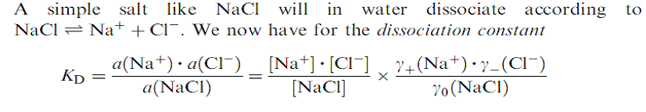$2\text{.}\text{24}$
The first right-hand expression is written in activities, and this quotient gives the intrinsic dissociation constant. The second right-hand expression is made up of two factors, a quotient of (molar or molal) concentrations that may be called the stoichiometric dissociation constant, and a quotient of activity coefficients. All dissociation constants, association constants (K_{A} = 1/K_{D}), and solubility products in reference books are intrinsic constants. They apply to concentrations only if the solution is extremely dilute for all ionic species. In other cases, one has to know the activity coefficients. γ₀, γ for a nonionic species, will mostly be close to unity, but γ⁺ and γ⁻ will generally be < 1, the more so for a higher ion concentration. One may define the freeion activity coefficient of NaCl as
$2\text{.}\text{25}$
Slaid 61
Dissociation
Note that the subscripts to the activity coefficient here have the following meanings:
± of the salt in its dissociated form
0 of the salt in its undissociated form
+ of the cation
- of the anion
The solubility of a salt is given as the solubility product Ks, which is to be compared with the activity product Ka. For NaCl this is given by
$2\text{.}\text{26}$
The activity product of the ions in solution thus cannot be higher than Ks. To be sure, for a very soluble salt like NaCl, it often would make little sense to use the solubility product, because of the large nonideality at the relevant concentration; but it is a very useful concept for salts of lower solubility, especially if the activities of the cations and anions are not equal, as will often be the case in foods.
Slaid 62
Dissociation
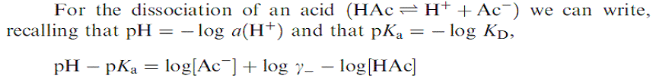$2\text{.}\text{27}$
The pKa (subscript a for acid) is the pH at which the dissociation is exactly 50% ([Ac⁻] = [HAc], provided that γ⁻ = 1; however, the latter mostly is < 1, implying that the stoichiometric pKa is smaller than the intrinsic one, say by 0.1 or 0.2 units. Strong acids have a low pKa (large K_{D}), often < 1; fatty acids, for instance, are weak acids and have a pKa ≈ 4.7. At a pH one unit higher, the acid will be dissociated for 91% according to (2.24), at a pH one unit lower for 9%, at 2 units lower for 1%, at 3 units lower for 0.1%, etc. This is illustrated in Figure 2.9a.
Slaid 63
Dissociation
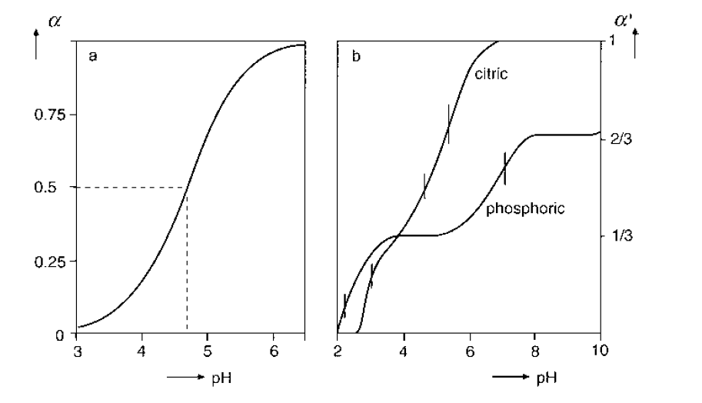
FIGURE 2.9 Dissociation of acids as function of pH. (a) Calculated degree of dissociation (α) of a fatty acid (intrinsic pKa = 4.7) at very small ionic strength. (b) Titration curves, experimentally determined degree of neutralization (α′) by KOH of citric acid and phosphoric acid; the intrinsic pKa values are indicated by vertical dashes.
Slaid 64
Dissociation
For instance, the intrinsic pKa values of citric acid, CH₂(COOH)-CH(COOH) - CH₂(COOH), are 3.1, 4.7, and 5.4. The three acid groups are almost identical, and the differences in pK are due to the increased charge if more than one group is dissociated. When increasing the pH, the second proton to be dissociated must be removed against the electric potential of two, rather than one negative charge. This needs additional free energy and will happen at a higher pH, where the driving force for dissociation is greater. Figure 2.9b gives a titration curve for citric acid; here the degree of neutralization rather than dissociation is given, and only when using a very strong base for the titration and after extrapolation to zero ionic strength would the two be identical. Figure 2.9b also gives a titration curve for phosphoric acid; this has intrinsic pKa values of 2.1, 7.2, and about 12.7. These differences are far larger than in the case of citric acid, because the three acid groups are essentially different; the neutralization of the various groups can now be distinguished on the titration curve.
Slaid 65
Dissociation
For bases comparable relations hold.
The relations involving activity coefficients are slightly more complicated for ions of a valence higher than 1. For instance, for CaCl₂ -> Ca²⁺+ 2Cl⁻ the dissociation constant is given by
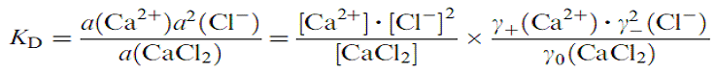$2\text{.}\text{28}$
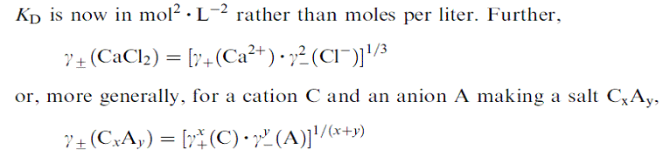$2\text{.}\text{29}$
Slaid 66
Dissociation
It should finally be remarked that dissociation constants generally depend, and often strongly depend, on temperature. The dissociation may either increase or decrease with temperature, and there are no general rules. The same holds for solubility products.
Note In principle, the ion activity coefficient of a salt (γ±) can be determined, but not those of individual ions (γ⁺ and γ⁻), because their concentrations cannot be varied independently. Nevertheless, the activity coefficients of individual ions are very useful, and as mentioned, one tries to calculate them from theory. Ion-selective electrodes measure chemical potentials (which depend on activities, not concentrations), but the standard potential is unknown. For the measurement of pH, which is the negative logarithm of the hydrogen ion activity, one has therefore arbitrarily chosen a reference potential for a certain buffer, which potential is of course as close to the real one as theory permits it to be calculated.
Slaid 67
Not very dilute solutions
The situation becomes far more complicated for higher concentrations, say I > 0.03 molar, which still is fairly dilute, a few times 0.1% for many salts. The most important aspect may be that the association of ions into ion pairs, undissociated salt molecules (or ions, CaCl⁺), becomes significant. It is often assumed that salts completely dissociate into ions, unless the concentration is very high. This assumption is generally not true, and it would lead to considerable error in many foods. To be sure, most ion pairs are very short lived, but at any time a certain proportion of the ions is in the associated form. We may write for the association constant
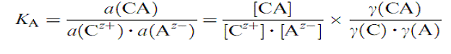$2\text{.}\text{31}$
where all γ denote free ion activity coefficients, except possibly (CA), which ≈ 1 if CA is neutral. Although K_{A} varies among ions, in first approximation it is governed by the valence of the ions
Slaid 68
Not very dilute solutions
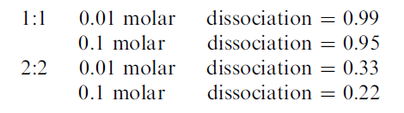
and it is seen that especially for valences higher than 1 the effect is great. In calculating the above figures, one has to know γ⁺, which means that one has to know the dissociation to obtain the ionic strength, which is needed to calculate the ion activity coefficients. This can be done by first taking an assumed activity coefficient and then reiterating the calculation until the coefficient is in agreement with the dissociation.
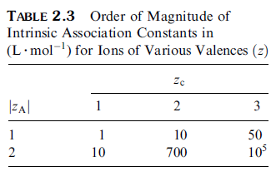
Slaid 69
Not very dilute solutions
This reveals an important problem. Most ion activity coefficients given in the literature, including those of Figure 2.10, are total ion activity coefficients, they relate to the total salt concentration; the ionic strength is calculated as if the dissociation of the salt were complete. This is a suitable method if there is only one salt in solution, or if there are only monovalent ions and the concentration is very small. But in all other cases, which implies in almost all foods, where we have several ions, some of which have valences larger than unity, the method does not work. One should rather take the ions only, taking the association into account, for calculating the ionic strength as well as the activity coefficients. The latter then are called free ion activity coefficients. Another complication is that for concentrated solutions, where this may also mean that there are other solutes than ionizable ones (say, sugars), the concentration unit of moles per liter is not suitable any longer. It is much better to use molality, moles per kg water.
Slaid 70
Not very dilute solutions
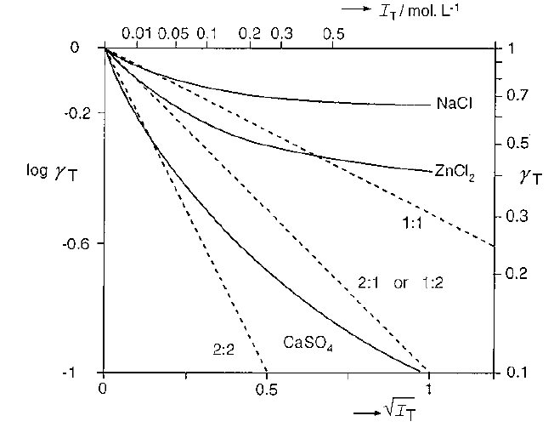
FIGURE 2.10 Total ion activity coefficients (T) as a function of total ionic strength
(IT) of NaCl, ZnCl2, and CuSO4. The broken lines presented ideal solution for salts with ions of various valences (indicated).

Slaid 71
Recapitulation
Thermodynamics describes the (changes in) energy (or enthalpy H) and in entropy (S) of a system; entropy is a measure of disorder. These parameters are combined in the free or Gibbs energy G = H - TS. Absolute values of these parameters cannot be given, but the magnitude of changes in them can often be established. Every system tends to change in the direction of the lowest free energy, for instance by evening out of concentration (increase in entropy) or by reaction between components (decrease in enthalpy). If it has attained such a state, it is stable; if not, it is unstable. However, thermodynamics tells us nothing about rates of change, and some systems can be metastable or change extremely slowly.
Slaid 72
Recapitulation
A substance in solution has a chemical potential, which is the partial molar free energy of the substance, which determines its reactivity. At constant pressure and temperature, reactivity is given by the thermodynamic activity of the substance; for a so-called ideal system, this equals the mole fraction. Most food systems are nonideal, and then activity equals mole fraction times an activity coefficient, which may markedly deviate from unity. In many dilute solutions, the solute behaves as if the system were ideal. For such ideally dilute systems, simple relations exist for the solubility of substances, partitioning over phases, and the so-called colligative properties (lowering of vapor pressure, boiling point elevation, freezing point depression, osmotic pressure).
At high concentrations of a (neutral) solute, the activity coefficient is generally greater than unity, often appreciably. The activity coefficient can be markedly below unity if the substance is subject to self-association or to association with (adsorption onto) other substances.
Slaid 73
Recapitulation
For ionizable substances, the activity coefficient is generally smaller than unity, the more so for a higher total ionic strength, due to screening of positive charges by negative ones and vice versa; the coefficient is also smaller for ions of higher valence. For fairly small ionic strength (up to about 0.1 molar), a simple theory predicts the value of the activity coefficients. The smaller the activity coefficient, the higher the solubility of the substance and the stronger its degree of dissociation. This means that addition of a different salt (NaCl) to a solution (of calcium phosphate) will increase the degree of dissociation and the solubility of the latter. It should be realized that salts of multivalent ions are not nearly completely dissociated unless the ionic strength is very small. The relations (especially the state of association) of multicomponent salt solutions are intricate.
3 Bonds and interaction forces
Slaid 74
Bonds and interaction forces
Atoms, groups of atoms, ions, molecules, macromolecules, and particles always are subject to forces between them. These interaction forces may cause chemical reactions to occur, cause the formation of other molecular species, but they are also responsible for the existence of condensed phases (solids and liquids), for adherence of a liquid to a solid surface, or for aggregation of particles in a liquid. In short, all structures form because of interaction forces. Generally, formation of a structure causes a decrease in entropy, and this may counteract the tendency of formation, depending on its magnitude compared to that of the energy involved.
Slaid 75
Bonds and interaction forces
There are several, rather different, types of interaction forces, although all of them are ultimately due to the electromagnetic force. This force can become manifest in various ways. The interactions greatly differ in specificity: what group or molecule will interact with what other group?
For instance, they all decrease in magnitude with interparticle distance, but the relation between energy and distance may vary widely. One generally considers the energy needed to bring two particles (or molecules) from infinite distance to close proximity. Since there is always more than one type of force acting, this energy (U) may be negative or positive, depending on the interparticle distance (h), for instance as depicted in Figure 3.1.
Slaid 76
Bonds and interaction forces
The force (F = - dU/dh) generally is the derivative of the energy (F = - dU/dh) and, as
illustrated in the figure, the net force is zero where the energy is at minimum;
here we have a stable configuration.
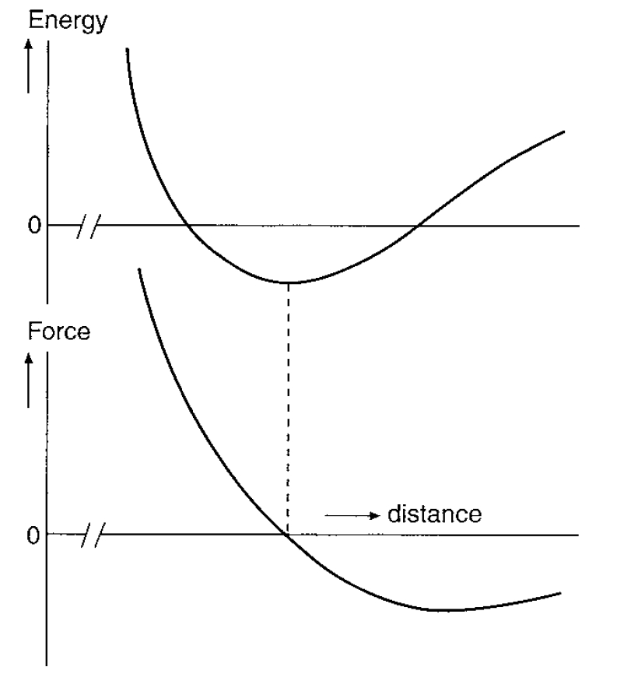
FIGURE 3.1 Hypothetical example of the net energy needed to bring two molecules or particles from infinite separation to a certain mutual distance, and of the corresponding interaction force.
Slaid 77
Bonds and interaction forces
Table 3.1 gives an overview of the various types of forces. The first one mentioned cannot lead to bond formation, since it is always repulsive. If two atoms approach closely, their electron clouds start to overlap, and this causes a repulsion that increases very steeply with decreasing distance; it is therefore called hard-core repulsion. If it is ions that approach each other, the interaction is often called Born repulsion.
Slaid 78
Bonds and interaction forces
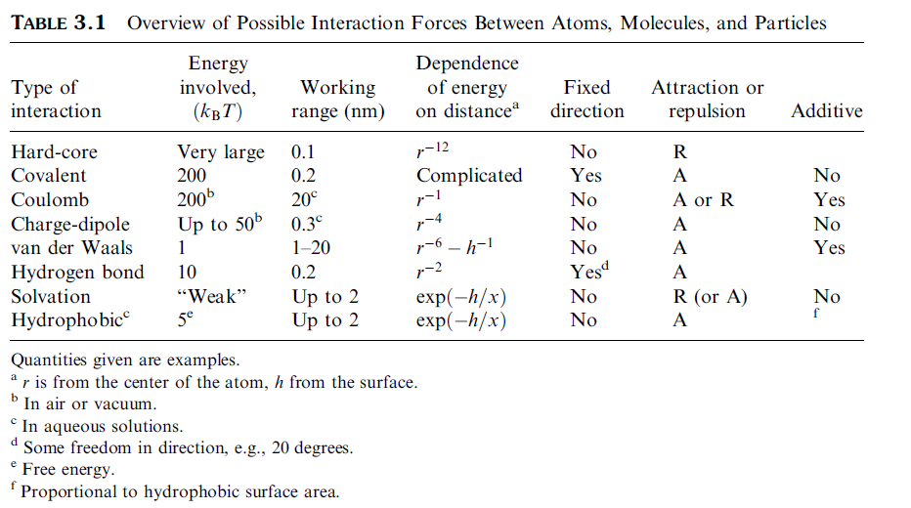
Slaid 79
Type of bonds
The next five rows in Table 3.1 relate to what may be properly called bonds.
They vary widely in strength, also within one type. The strength is commonly given in terms of energy, expressed in J per mole of bonds. (Note that the expression of a strength in units of energy is quite unlike that for macroscopic systems, where strength commonly refers to the force per unit cross-sectional area needed to cause breaking, in N m⁻².) In general, only covalent bonds and some ion–ion bonds may be strong enough to give ‘‘permanent’’ single bonds. Permanent here means that the atoms or groups bonded stay in this configuration for ordinary times (at least several seconds). If the bond energy is small, thermal motion of the atoms tends to break the bonds within a very short time. The average kinetic (thermal) energy of a molecule is of the order k_{B}T. Therefore it is often useful to give interaction energies relative to k_{B}T, as is done in Table 3.1; at room temperature 1 kJ mol⁻¹ ≈ 0.4k_{B}T. If bond energy << k_{B}T, bonds will not be formed; if it is >> k_{B}T, permanent bonds will be formed.
Slaid 80
Type of bonds
A great number of weak bonds acting on the same molecules or ensembles of molecules may also cause permanent bonding. Examples are van der Waals bonds holding molecules in crystals and various weak bond skeeping globular proteins in a compact conformation or keeping particles flocculated.
Slaid 81
Type of bonds
Covalent Bonds. Covalent bonds exist if some electrons participate in the orbitals of more than one atom. These bonds are highly specific and are extensively discussed in texts on organic chemistry. Here it may suffice to remark that covalent bonds may be very strong (mostly 150 – 900 kJ mol⁻¹) and act over a very short distance in a very restricted range of directions.
Slaid 82
Type of bonds
Charge-Dipole. Several uncharged molecules bear permanent dipoles, the geometric centers of the positive charge(s) and the negative charge(s) do not coincide. Such molecules therefore have a dipole moment and they are called polar. The dipole moment is the product of charge (expressed in coulombs) and distance between charges; it is mostly given in Debye units (D), where 1D = 3.34 10⁻³⁰ Cxm. Water is the prime example of a small polar molecule (dipole moment = 1.85 D); see Figure 3.2a. This polarity is the origin of the high dielectric constant of water and it also leads to fairly strong bonds between ions and water molecules. Chargedipole interactions are always attractive, since the dipole is free to orient in such a way that the positive ‘‘end’’ of the molecule is close to a cation. Ions in water, for instance, are accompanied by a few water molecules. Like ion–ion bonds, charge-dipole interactions are inversely proportional to the dielectric constant of the medium.
Slaid 83
Type of bonds
van der Waals Forces. They act between all molecules and are always attractive. They may be due to three somewhat different interactions:
1. Dipole–dipole: dipoles on average orient themselves so that the positive end of one molecule is close to the negative one of another.
2. Dipole–Induced Dipole: a dipole always induces a slight unevenness in the charge distribution— a dipole—in a nonpolar molecule, thereby causing attraction.
3. Induced Dipole–Induced Dipole: even an atom is at any moment a weak dipole, due to the oscillatory motion of its electrons, although on average its dipole moment is zero. Fluctuating dipoles arise and those of neighboring atoms or molecules affect each other so that always a net attraction results. The resulting forces are called London or dispersion forces, and they act always between all atoms. The other two types need polar groups to be present, which can only exist in molecules. In most pure compounds, the dispersion forces are predominant, but not, for instance, in water, with its strong dipole moment.
Slaid 84
Type of bonds
Hydrogen Bonds. These bonds form between a covalently bound hydrogen atom and an electronegative group like = O or N. In a water molecule, as shown in Figure 3.2a, the two H atoms each provide a local positive region (since its only electron is exclusively in the orbital with the oxygen) and the O atom provides two negative ones. Hence a net attraction between H and O of different molecules results, if their mutual orientation allows this. The so formed hydrogen bond is to some extent like a covalent one, especially in the sense that it is direction dependent: a small deviation from the optimum orientation results in appreciable weakening of the bond. An H bond is clearly weaker than a covalent one, and it will often be short-lived. On the other hand, H bonds are much stronger than van der Waals interactions.
Slaid 85
Type of bonds
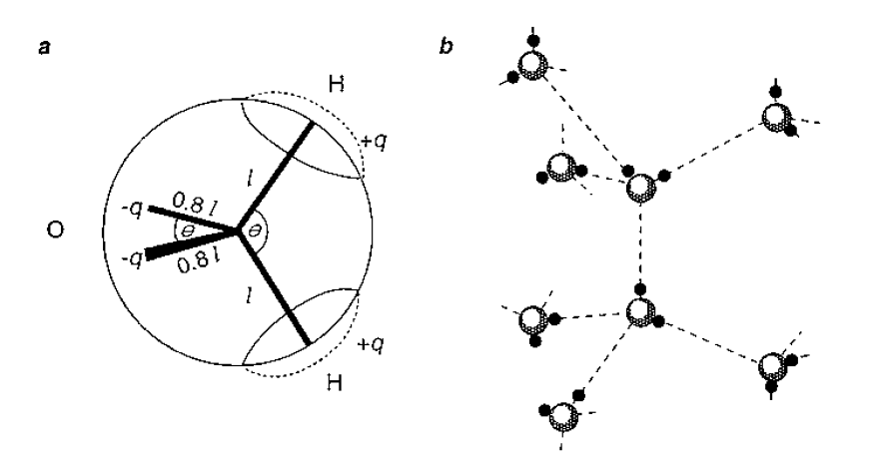
FIGURE 3.2 Structure of water. (a) Model of a water molecule. The distance between the nuclei of O and H is l ≈ 0.1 nm, the net charges q are 0.24 times the charge of an electron, and the bond angles θ are 109º. (b) Example of how water molecules form H-bonds with one another; schematic and not to scale.
Slaid 86
Type of bonds
Water. Extensive hydrogen bonding occurs in water, about as depicted in Figure 3.2b; the resulting configuration is somewhat comparable to that in ice. The molecules try to make as many H bonds as possible, without losing too much entropy. This results in a fluctuating network of bonded molecules: although there are many H bonds at any one time, the bonds continually break and form again, though often in a different configuration. This implies that water, though a liquid, has some ordering, a structure.
The extensive hydrogen bonding gives water some of its specific properties. Compared to other compounds consisting of small molecules, it has high melting and boiling temperatures; the enthalpies of fusion and of vaporization are high; also the surface tension is high. Moreover, the temperature dependence of several properties is exceptional, such as the well-known maximum in density at 4 ºC.
Slaid 87
Solvation
As mentioned above, net attractive interactions occur between all pairs of molecules (excluding ions for the moment), except at very small distances. In a pure liquid, all these interactions are on average the same, and it makes no difference whether the one or the other molecule is close to a third one. In a solvent (1) with a solute (2), however, some different interactions occur. In the simplest case, where we consider spherical molecules of the same size, the solvent–solute interaction is governed by
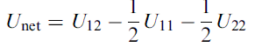$3\text{.}1$
where U₁₂ stands for the attractive energy between solvent and solute molecules; hence all U’s are negative. If U_{net} < 0, solvation occurs, the solute molecules are preferentially surrounded by solvent molecules rather than by other solute molecules, as illustrated in Figure 3.3a. In such a good solvent, two solute molecules are on average farther away from each other than they would be if there were no net attraction (U_{net} = 0). This results then in a repulsive force between the solute molecules, that may be felt over a range of at most a few solvent molecules. It generally implies that the activity coefficient of the solute is smaller than unity; hence the solute is well soluble.
Slaid 88
Solvation
If U_{net} > 0, we have negative solvation or, in other words, a poor solvent for the solute considered. Now the solute molecules are preferentially near to each other, rather than near to solvent molecules: Figure 3.3b. This generally implies that the solute has a high activity coefficient and poor solubility.
Solvation repulsion may also act between segments of one polymer molecule or between colloidal particles that have groups at their surface that become solvated. Negative solvation leads to attraction between polymer segments or between particles.
Slaid 89
Solvation
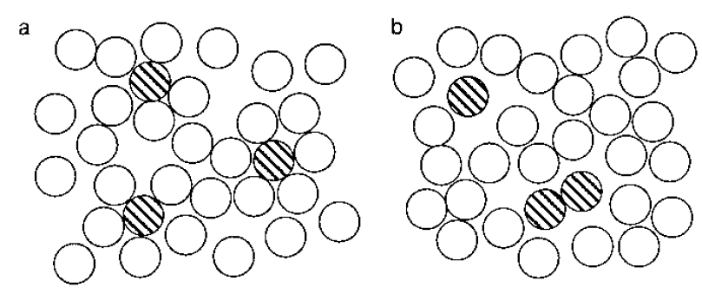
FIGURE 3.3 Solvation. (a) Solute molecules (hatched) are preferentially surrounded by solvent molecules. (b) Solvent molecules tend to stay away from solute molecules (negative solvation).
Slaid 90
Solvation
Hydration. If the solvent is water, solvation is called hydration. It is an intricate phenomenon, since water is such an intricate, not fully understood liquid. Hydration nearly always involves considerable change in entropy, since anything altering the fluctuating network of hydrogen bonds alters entropy. Four kinds of solute molecules or groups may be conveniently distinguished:
Slaid 91
Solvation
1. Ions or ionic groups. Due to the ion–dipole interactions mentioned, small ions tend to be strongly hydrated. Ions move, by diffusion or in an electric field, as if they were accompanied by a number of water molecules. Again, this does not imply that these water molecules are permanently bound: they interchange with other water molecules. Ion hydration is stronger for a smaller ion and a higher valence; cations tend to be more strongly solvated than anions of the same size and valence. The attraction between a proton and a water molecule is so strong that hydronium ions (H₃O⁺) occur in water, leaving very few free protons. The hydronium ion is, in turn, hydrated. It may further be noted that the formation of ion pairs (Na⁺ + Cl⁻ -> NaCl, or – COO⁻ + H⁺ -> COOH) requires desolvation (‘‘dehydration’’); especially if the ions or ionic groups involved are small, the increase in free energy involved can be appreciable. In other words, hydration then strongly promotes dissociation of ionizable species.
Slaid 92
Solvation
2. Groups with a strong dipole moment also become hydrated. A case in point is the peptide bonds in proteins.
3. Other somewhat polar groups, such as -OH groups, that can make H bonds with water. Substances with several -OH groups, like sugars, often are said to be hydrophilic. Hydration is mostly weak in this case. It appears that water molecules adjacent to an -OH group may have either a somewhat shorter or a somewhat longer residence time than water molecules in the bulk, according to the conformation of the OH group in relation to the rest of the solute molecule.
4. Nonpolar or hydrophobic groups. The water molecules cannot make H bonds with these groups. Bringing an apolar molecule or group in water then leads to some breaking of H bonds, which will cause an increase in enthalpy. The system tries to make as many H bonds as possible; this leads to a locally altered water structure and thereby to a decrease in entropy. Anyway, the free energy is increased, which implies negative solvation. Similar changes presumably occur at the surface of larger molecules and particles.
Slaid 93
Solvation
The Hydrophobic Effect. If two hydrophobic molecules or groups in water come close together, negative solvation is diminished, which implies a decrease in free energy. This works as if an attractive force is acting between these groups, and this is called hydrophobic bonding. Such bonds especially act between aliphatic chains or between aromatic groups. They are largely responsible for the micellization of amphiphilic molecules in water and for the formation of vesicles and membranes of lipid bilayers.
They are also important for the conformation of globular proteins. For a large hydrophobic group, the bond free energy is about proportional to the surface area involved, and equals about 4 k_{B}T (10 kJ mol⁻¹) per nm².
The explanation of the hydrophobic effect and the resulting hydrophobic bonding is still a matter of some dispute. For instance, attraction due to dispersion forces may provide a considerable part of the interaction free energy of a hydrophobic bond, varying with the chemical constitution of the groups involved.
Slaid 94
Solvation
The explanation of the temperature dependence of hydrophobic bonding is especially intricate and controversial. By and large, at low temperature (near 0 ºC), ΔH for bond formation is positive; ΔS is relatively large and positive. The result is a relatively small negative ΔG, bonds are formed. This would all be in agreement with an overriding effect of water entropy. Above a certain temperature, however, ΔS starts to decrease, but hydrophobic bonding nevertheless increases in strength, because - ΔH also increases. A hypothetical result is depicted in Figure 3.4, merely to illustrate trends. It may be concluded, that hydrophobic bonding strongly increases with temperature, especially in the range from 0 to about 60 ºC.
Slaid 95
Solvation
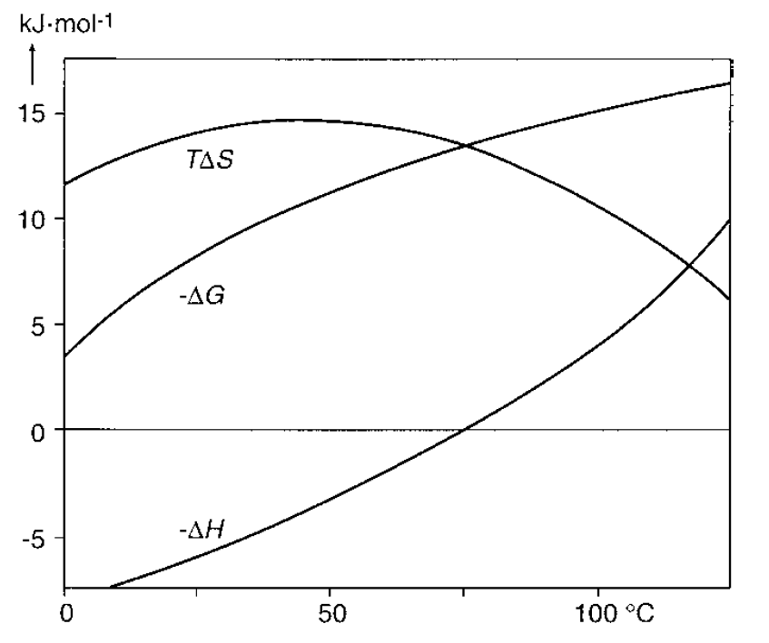
FIGURE 3.4 Assumed relation between the free energy of formation of hydrophobic bonds (- ΔG) and temperature. Also the entropic (TΔS) and enthalpic (ΔH) contributions to ΔG are given. The relations greatly depend on the chemical constitution of the apolar groups involved.
Slaid 96
Solvation
The Hofmeister Series. The specific effects of salts are often arranged in the lyotropic or Hofmeister series, or rather two series, one for anions and one for cations. For some ions of importance in food science these series are approximately as follows:
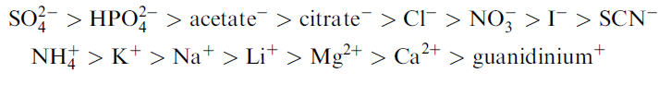
It should be noted that these are specific effects of ions that are independent of their valence. This is different from the general effects of ions as discussed in Section 2.3, which primarily depend on total ionic strength, on ion concentration and valence—and which become manifest at far smaller salt concentration.
Slaid 97
Recapitulation
Forces acting between molecules or groups not only determine chemical reactivity but also affect several other phenomena, such as formation of condensed phases and aggregation of colloidal particles. Several kinds of forces occur, greatly differing in strength, effective range, effective direction, and additivity. Strength of Coulombic type bonds is inversely proportional to dielectric constant. Bond strength is measured in terms of energy, but in some cases entropy is involved and free energy should be used.
Attractive interaction between solvent and solute molecules causes solvation, as a result of which solute molecules repel each other; thisdecreases the activity coefficient of the solute and increases its solubility. In other cases, negative solvation occurs, leading to net attraction between solute molecules. Hydration, solvation by water molecules, is an intricate phenomenon, due to liquid water being strongly hydrogen-bonded.
Negative hydration of apolar groups leads to the formation of hydrophobic bonds between these groups. Hydrophobic bonding strongly increases with temperature, being weak or absent below 0 ºC.
4 Reaction kinetics
Slaid 98
Reaction kinetics
Chemical kinetics is generally discussed with respect to reactions between molecules (or ions or radicals) in a gas phase or in a very dilute solution. In foods, its often have other situations. The system never is gaseous, it is rarely very dilute, and it may have more than one phase containing reactants. Changes may occur within molecules, especially macromolecules.
Reactions may be between particles, causing their aggregation. Numerous other changes may occur, such as phase transitions, leading to a change in rheological properties, color, or other perceptible property. In nearly all such cases there are greatly interested in the rate at which these processes occur. This cannot derive from the bond energies involved or from other thermodynamic considerations: these may tell us what the driving force is, but in general the rate results from a driving force divided by a resistance, and the resistance may be very large or highly variable.
Slaid 99
Reaction order
Before coming to factors determining reaction rates, it is useful to review the manner in which concentrations depend on time.
The reaction rate is usually given as the change in concentration c, as either + or - dc/dt.
For a zero-order reaction, the rate remains constant: see Table 4.1. Approximately zero-order reactions occur if small quantities of a substance, say one causing an off-flavor, are slowly formed from a very large reservoir of a parent component.
For a first-order reaction of the type A -> B or A -> B + C, we have
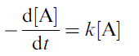$4\text{.}1$
where [A] stands for the molar concentration of A and k is the rate constant, which in this case is in s⁻¹. k varies with temperature and pressure, but it is generally assumed to be constant otherwise, independent of concentration; this is often (nearly) true, but not always
Slaid 100
Reaction order
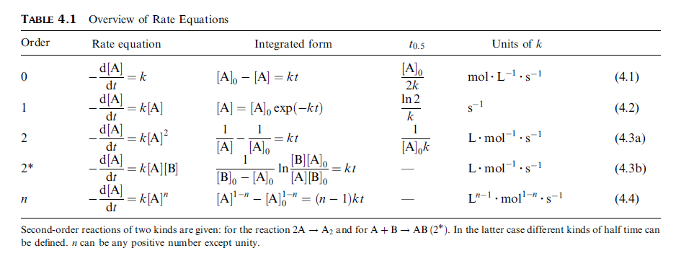
Slaid 101
Reaction order
Integrating the equation, and introducing the initial concentration of A, we obtain
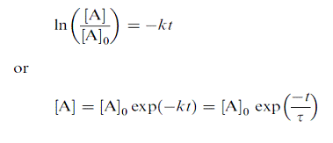$4\text{.}2$$4\text{.}3$
where τ is the relaxation time. If we plot the log of the concentration versus time, we obtain a straight line. The relations are illustrated in Figure 4.1. If, for example, 10% of A is left after D s, this means that 1% is left after 2D s, 0.1% after 3D s, and so on; D, which equals 2.3/k, is called the decimal reduction time and is mostly used by microbiologists. The killing of microorganisms and the inactivation of enzymes at high temperature often follow first-order kinetics, at least approximately. Also bacterial growth in the so-called exponential phase follows first order kinetics, but now the sign in Eq. (4.1) is positive.
Slaid 102
Reaction order
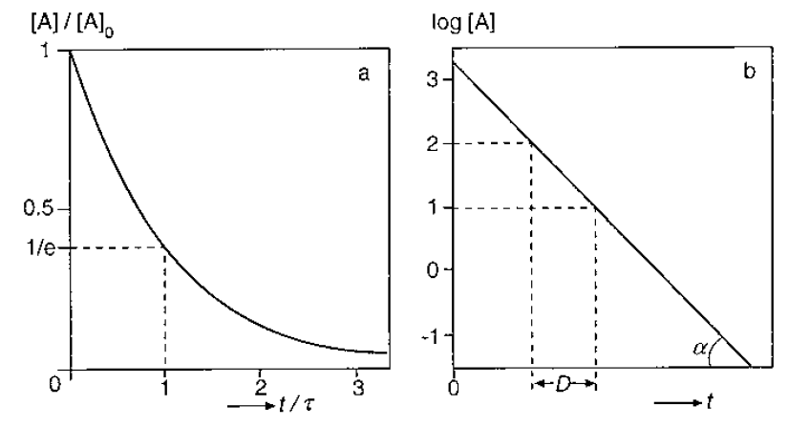
FIGURE 4.1 First-order reaction of the type A -> B. (a) Concentration relative to the original one as a function of time (t) over relaxation time (τ). (b) Example of log concentration versus time; tan α = k log e = 0.434k. D is the decimal reduction time.
Slaid 103
Reaction order
The relaxation time is mostly used by physical chemists and is the time needed for a certain change to occur over (1 – 1/e) ≈ 0.63 of its maximum value, after a specified change in conditions has been applied, say a change in temperature or in pH. It is said then that the system relaxes toward a new equilibrium situation. To be sure, the relaxation time has physical significance only for a first-order reaction, and many changes do not follow such a relation, for instance because more than one relaxation mechanism acts.
For a second-order reaction of the type A + B -> AB we have (4.4) (4.5)
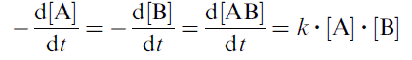$4\text{.}4$
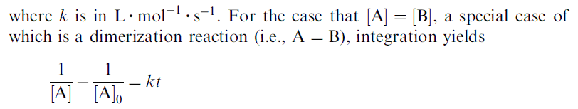$4\text{.}5$
Slaid 104
Reaction order
which implies that a plot of 1/[A] versus time yields a straight line. Notice that also the relative rate depends on concentration. A measure for the rate is the half time t0.5 = 1/k[A]0, the time needed for half of the reaction to become complete. Many reactions in foods approximately follow second-order kinetics. Further information is given in Table 4.1, also for the more complicated case of
A + B -> AB.
The reaction order is an empirical concept. Its value has to be determined, since it cannot readily be derived from the stoichiometry, often only apparent, of the reaction. Also the rate constant is an empirical quantity to be experimentally determined, and it depends on the reaction order. The combined knowledge of the order, the rate constant, and the initial concentration of the reactant(s) allows calculation of changes occurring. An example is prediction of the extent to which a certain component is formed or degraded during long storage of a food. As is illustrated in Figure 4.2, it may need very precise determination of the time dependent concentration of a reaction product to establish the order, as long as the reaction has not proceeded very far.
Slaid 105
Reaction order
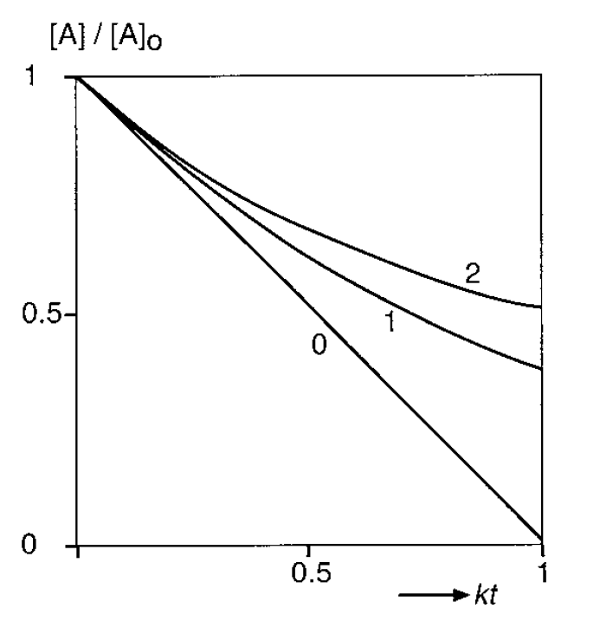
FIGURE 4.2 The change in concentration of reactant A with time for reactions of order 0, 1, and 2. k is the rate constant; t is time.
Slaid 106
Chemical equilibrium
In principle, any chemical reaction is reversible. If we have A -> B, we also have B -> A. The first reaction may have a rate constant k1, the reverse one k-1. We therefore have for the rate at which A is transformed
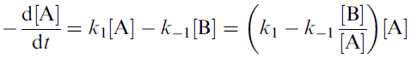$4\text{.}6$
If we start with A only, it will be changed into B, but the apparent rate constant (the factor between parentheses) will become ever smaller, since [B] increases. When the right hand side of [4.6] has become zero, at infinite time, equilibrium is obtained, and it follows that the equilibrium constant, K = [B]∞/[A]∞, equals k1 / k-1.
Slaid 107
Chemical equilibrium
Equation (4.6) yields upon integration and some rearrangement
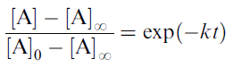$4\text{.}7$
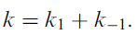
where the rate constant k = k1 + k-1. A good example of such a reaction is the ‘‘mutaroration’’ of reducing sugars like glucose and lactose, the transmutation of the a anomer into the b anomer and vice versa. Referring to Section 2.2, we observe that at equilibrium the chemical potentials of A and B must be equal. This leads to
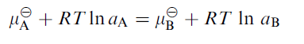
Slaid 108
Chemical equilibrium
Reaction Heat. A reaction can only proceed if ΔG < 0. In relation to Eq. (4.7), it was mentioned that for most reactions - ΔH is larger than TΔS. This implies that during the reaction heat is produced (the amount of reaction heat can be measured by calorimetry). The reaction then is said to be exothermic and enthalpy driven. There are also endothermic reactions, where heat is consumed; in other words, ΔH > 0. Because ΔG must be negative for the reaction to proceed, this implies that TΔS > ΔH, and the reaction is said to be entropy driven.
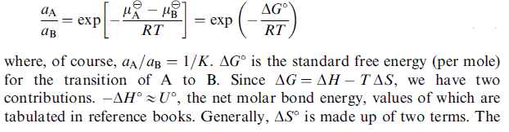
Slaid 109
Rate theories
Virtually no food is in thermodynamic equilibrium. We all know that food is a source of energy and that, for example, one gram of carbohydrate yields on oxidation in the body about 17 kJ (about 4 kcal). Assuming the elementary reaction to be
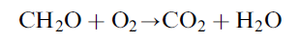
we calculate the molar bond energy difference at about 30 x 17 = 500 kJ mol⁻¹ ≈ 200 RT.
Now this calculation is not too precise, and several refinements must be made, but that does not materially alter the result. So the driving force for oxidation by the O2 in air of, say, plain sugar is very large; nevertheless plain sugar appears to be stable almost indefinitely.
Slaid 110
The Maxwell–Boltzmann distribution
All atoms, molecules, or particles constantly move (velocity v), except at absolute zero temperature. They have a translational kinetic energy, according to basic mechanics given by (1/2)mv², where m is mass. (In addition, they have rotational and vibrational kinetic energy, but these do not concern us at this moment.) It can be shown that for all particles, whether small or large, the average kinetic energy (U) depends on temperature only, according
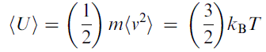$4\text{.}8$
where Boltzmann’s constant kB is a fundamental constant of nature, its magnitude being 1.38 10⁻²³ J K⁻¹. Incidentally, Eq. (4.8) also can be seen as the definition of temperature; notice that temperature thus can only refer to a fairly large ensemble of molecules or atoms, since it is defined in terms of an average.
Slaid 111
Activation Energy
The first useful theory of reaction rates was due to Arrhenius, and it is easiest to envisage for a bimolecular reaction. It is assumed that the molecules have to overcome an energy barrier before they can react. This is depicted in Figure 4.4. The energy barrier per mole is called the activation energy, symbol Ea. As mentioned, the average translational kinetic energy of a molecule is (3/2)kBT, and the average kinetic energy involved in a collision of two molecules is given by 2 times 1/3 of that value, i.e. kBT; the factor 1/3 arises because the molecules move in 3 dimensions and when they collide this happens in one dimension. The collision may now provide the activation energy needed for the molecules to react.
By changing from molecules to moles and by putting Ea, it follows that the rate constant would
Slaid 112
$4\text{.}9$Activation Energy
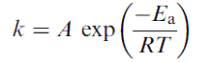
$k={\text{Ae}}^{−\frac{E_{A}}{\text{RT}}}$(4.9) where A often is called the frequency factor. It is also called the preexponential factor and denoted as k∞ or k0, the value that k would attain at infinite temperature T∞ or zero activation energy, respectively.

Slaid 113
Activation Energy
$\begin{aligned}k={\text{Ae}}^{−\frac{E_{A}}{\text{RT}}} \\ \text{ln}k=−\frac{E_{A}}{R}\text{.}\frac{1}{T}+\text{ln}A \\ \text{tg}β=\frac{E_{A}}{R}\end{aligned}$

Slaid 114
Activation Energy
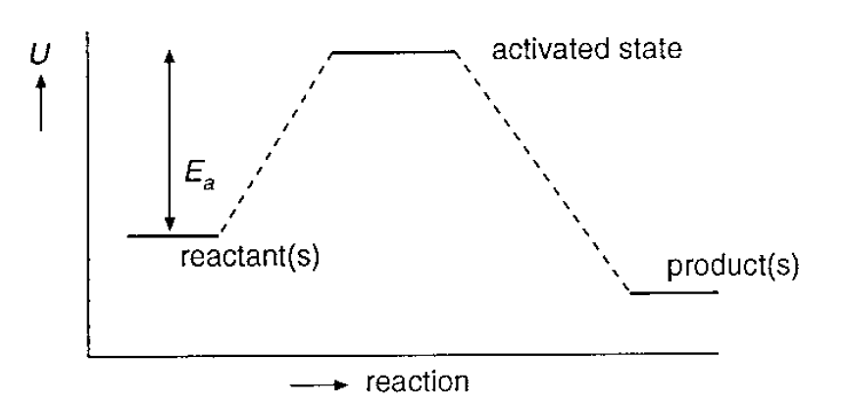
FIGURE 4.4 Arrhenius theory. Illustration of the energy state of the reactants, the reactants in the activated state, and the reaction product(s). Ea represents the activation energy.
Slaid 115
Activation Energy
Temperature Dependence. Eq. (4.10) predicts that log k is proportional to 1/T, and this is indeed very often observed, especially for reactions of small molecules, involving breaking and formation of covalent bonds. The Arrhenius theory can be said to be very successful, and as a semiempirical relation Eq. (4.10) is indeed useful in many cases.
Chemists generally express the temperature dependence of a reaction in Q10, the factor by which a reaction is faster if one increases the temperature by 10K. Bacteriologists use the Z value, the temperature increase (in K) needed to increase the reaction rate by a factor of 10. These parameters naturally depend on temperature, even if the activation energy is constant. We have
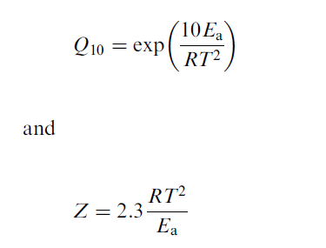
Slaid 116
Activation Energy
Note: The success of the Arrhenius theory has often induced workers to apply it to other phenomena. Several physical properties of a system tend to depend on temperature like an Arrhenius relation, but this does not necessarily mean that we can assign an activation energy to the phenomenon. A case in point is the fluidity, the reciprocal of the viscosity, since there is no such thing as an activation energy for fluid motion (a true fluid moves if only the slightest force is applied). In this case, the Arrhenius type relation directly derives from the Maxwell–Boltzmann distribution. The same holds true for diffusion.
Slaid 117
Further complications
In practice, numerous complications are encountered, concerning the order of reactions, their rate, and their temperature dependence. Some aspects important for the food scientist or technologist will be mentioned, if only to warn against pitfalls in handling or interpretation of kinetic results.
Order and Molecularity. If we have a very simple reaction, like H +H -> H2 in the gas phase, this is a true bimolecular reaction and also the order is two. Such a simple correspondence between molecularity and order is, however, the exception rather than the rule. For example, a reaction involving water as a reactant in a dilute aqueous solution, the hydrolysis of an ester,
Slaid 118
Further complications
may effectively be first order, although it is a bimolecular reaction. This is because the concentration of water (or the water activity, rather) does not significantly alter during the reaction. Another point is that even a fairly simple reaction may involve a number of elementary reactions or steps, and one of them may be effectively rate determining, thereby also determining the order. Consequently, the order has to be established from experimental results, and it may be very difficult to elucidate the elementary reactions involved. In many cases, it turns out that the order is not an integer number; or the order may change in the course of the reaction; or it may be different with respect to different reactants; or the order with respect to concentration may be different from that with respect to time.
Slaid 119
Further complications
Catalysis. Many reactions are catalyzed, increased in rate, by a compound in solution (homogeneous catalysis) or a group at the surface of a particle (heterogeneous catalysis), where the catalyst is not consumed itself. Examples are various hydrolyzing reactions, like the ester hydrolysis mentioned above, that are catalyzed by H⁺ as well as OH⁻ ions. In such a case the reaction rate greatly depends on pH, though the ions themselves do not appear as reactants in the overall reaction scheme. Ubiquitous in natural foods are enzyme-catalyzed reactions. The simplest case leads to Michaelis–Menten kinetics, but several complications may arise.
Negative catalysis may also occur, since several compounds are known that inhibit reactions. For example, some cations, notably Cu²⁺, catalyze the autoxidation of lipids; chelating agents like citrate may greatly lower the activity of divalent cations, thereby decreasing the oxidation rate. Inhibition of enzymes is frequently observed.
Slaid 120
Further complications
Compartmentalization. Be it of one or more reactants or of a catalyst, compartmentalization often occurs in foods. A simple case is oxidation, of unsaturated lipids in several foods, where the oxygen needed for the reaction is present in low concentration and has to diffuse from another compartment, the air above the food, to the oxidizable components. This will naturally slow down the reaction.
Monoglycerides dissolved in oil droplets can hardly react with water to be hydrolyzed into glycerol and fatty acids, and certainly not when the reaction has to be catalyzed by an enzyme (an esterase), which is in the water phase. Possibly, the reaction proceeds at the interface between oil and water, which usually means that it will be slow; but if a suitable enzyme adsorbs onto the said interface, the reaction may in fact be quite fast.
Slaid 121
Further complications
If one of the reactants is immobilized at a particle surface, this will in general slow down the rate, if only because the diffusion coefficient for that reactant is effectively zero.
In plant and animal cells, many enzymes are compartmentalized, and several are also immobilized, greatly slowing down reactions. After the cells have been mechanically damaged, some reactions may proceed fast. A wellknown example is the rapid enzymatic browning of apple tissue after the apple has been cut; here, the cutting allows an enzyme, polyphenoloxidase, to reach its substrate, mainly chlorogenic acid.
Slaid 122
Further complications
Slowness of Reactions. In foods, we are often concerned with reactions that are very much slower than the reactions studied in the chemical or biochemical laboratory. For instance, the maturation of products like hard cheese, wine, and chutney may take years, and the maturation is ultimately due to chemical reactions, often enzyme catalyzed.
Slow quality loss or deterioration of foods is ubiquitous. An example is loss of vitamins; when we accept a loss of 10% per year and assume it to be due to a first order reaction, this would imply that its rate constant would be given by
ln 0.9 = - k x 365 x 24 x 3600, or k ≈ 3.3 10⁻⁹ s⁻¹, a very small rate constant. We may also consider loss of available lysine due to Maillard reactions. Taking a very simplified view, this is ultimately due to a second order reaction between a reducing sugar and the exposed lysine residues of protein. Assume that we have 10% glucose (say in orange juice) and that 1% of it would be in the reducing, open-chain, form, this gives a molarity of about 0.005.
Slaid 123
Further complications
These examples may suffice to illustrate that we may have very slow reactions in foods. Here a brief summary is given of the possible causes for slow reactions.
1. The (effective) concentration of reactants is small, which is especially important in second-order reactions. It may be due to small total concentrations, to compartmentalization or immobilization, or to a complicated cascade of reactions with several ‘‘side-tracks’’ that consume reactants for other reactions.
2. The activity coefficient (s) may be small.
3. The activation free energy is large. If this means that also the activation enthalpy is large, as will often be the case, the reaction rate is strongly temperature dependent.
4. A suitable catalyst is missing or unavailable, or inhibiting substances are present.
5. Diffusion is very slow, because of a very high viscosity. This is often the case in low-moisture products.
Slaid 124
Recapitulation
Most foods are not in thermodynamic equilibrium. For several possible reactions, the reaction free energy is large and negative, suggesting that the reaction would be fully completed in a very short time, while nevertheless the reaction proceeds slowly. The composition of a reaction mixture then is not thermodynamically controlled but kinetically. In some cases, a steady state rather than an equilibrium state is attained, and it may be useful to distinguish these.
Reaction kinetics, or at least the mathematical formulas describing it, depend on the order of the reaction. Orders of 0, 1, and 2 are mostly considered. Reaction order, however, is an empirical number, mostly not equal to the molecularity of the reaction. It has to be determined experimentally, and noninteger values may be observed; moreover, order may change in the course of the reaction or may vary with conditions such as temperature.
Slaid 125
Recapitulation
The classical rate theory due to Arrhenius proceeds on the Maxwell–Boltzmann distribution of the velocity, and thereby the kinetic energy, of molecules or particles; their average kinetic energy equals (3/2)kBT. If two molecules collide with a kinetic energy larger than an activation energy Ea for a reaction between them to proceed, they are assumed to react. The proportion of collisions of sufficient energy increases with T, and the reaction rate would be proportional to exp (- Ea/RT). This is a useful relation to describe temperature dependence, but it is insufficient in other respects; for instance, it is difficult to fit into reactions of order (molecularity) unity. The theory of the activated complex proceeds on the basis of an activation free energy, including an entropy term. It often allows us to make quantitative predictions of the reaction rate.
5 Transport phenomena
Slaid 126
Transport phenomena
The transport of momentum, heat and mass, or in simpler terms the phenomena of flow, convection, heat conduction, and diffusion, are primarily studied by process engineers and in some aspects also by rheologists. Important though these topics are for the food technologist, they are not the subject of this book. Some basic concepts are needed in various chapters; this includes aspects of rheology and hydrodynamics. Furthermore, transport phenomena inside solidlike foods often are rather intricate, and this subject is also introduced in this chapter.
Slaid 127
Flow and viscosity
Rheologists study what happens with a system, be it an amount of fluid or a piece of solid material, when work (ј mechanical energy) is applied to it. Remembering that work equals force times distance, we come to the definition:
Rheology is the study of the relations between the force acting on a material, its concomitant deformation, and the time scale involved.
To keep the relations simple, rheologists tend to use stress rather than force; it is defined as the force divided by the area over which it is acting (S.I. unit N.m⁻² = Pa). The stress can be normal, in a direction perpendicular to the plane on which it acts, or tangential, acting in the direction of the plane. Of course, intermediate situations also occur.
Slaid 128
Flow and viscosity
Deformation implies change(s) in the distance between two points in the material. Strain – is used rather than deformation; it is defined as the relative deformation, the change in distance (length of a specimen) divided by the original distance; it is thus a dimensionless quantity. It may be noted in passing that the words stress and strain have almost identical meanings in everyday language, but that they apply to fundamentally different variables in rheology.
Slaid 129
Flow and viscosity
The notion of time scale needs some elaboration. It is generally defined as the characteristic time needed for an event to occur, a reaction between two colliding molecules, the rotation of a particle in a flow field, or the transformation of some dough into a loaf of bread. In rheology, the characteristic parameter is the strain rate, the time derivative of the strain. This will be further discussed below. The strain rate is expressed in reciprocal seconds, and the characteristic time scale during deformation is the reciprocal of the strain rate, rather than the duration of the experiment. In many systems, the relation between stress and strain is dependent on the strain rate.
Slaid 130
Flow
If a stress slight, is applied to a fluid, it will flow. A fluid may be a gas or a liquid, and we will primarily consider liquids. The flow may be laminar or turbulent. The latter is chaotic, implying that a volume element may at any moment move in any direction, though the average flow is in one direction. In laminar flow, the streamlines, the trajectories of small volume elements, exhibit a smooth and regular pattern.
Slaid 131
Flow
Laminar Flows. These exist in several types, depending on the geometrical constraints. Some examples are shown in Figure 5.1. An important characteristic of laminar flow is the velocity gradient C, defined in the figure. Figure 5.1a shows pure rotational flow (circular streamlines); here, a volume element in the center will only rotate and not be displaced (‘‘translated’’) nor deformed. The rotation rate equals the velocity gradient. Figure 5.1c shows hyperbolic streamlines, an example of elongational flow (also called extensional flow). A volume element in the center will be deformed by elongation, as depicted in Figure 5.2. The velocity gradient is in the direction of the flow. There is no rotation. Figure 5.1b depicts what is called simple shear flow (straight streamlines), although it is not such a simple flow type. Layers of liquid appear to slide over each other. A volume element is sheared, as depicted in Figure 5.2, but it is also rotated (its diagonal rotates). Simple shear is a rotating flow, and the rotation rate is half the velocity gradient. The gradient is in a direction perpendicular to the direction of flow.
Slaid 132
Flow
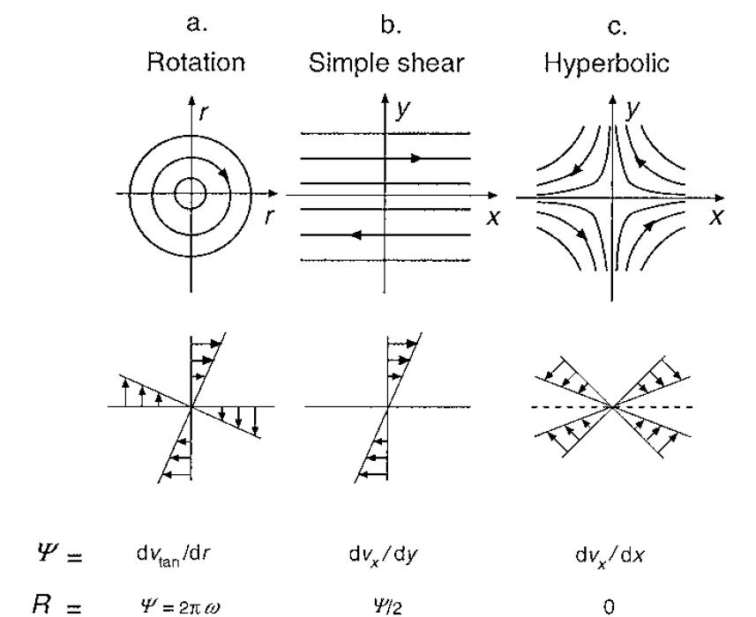
FIGURE 5.1 Cross sections through three types of laminar flow. The upper row gives the streamlines, the second row the velocity profiles. The flows are two dimensional, implying that the patterns do not change in the z-direction (perpendicular to the plane of the figure). Ψ = velocity gradient, v = linear flow velocity, R = rotation rate, ω = rotation frequency.
Slaid 133
Flow
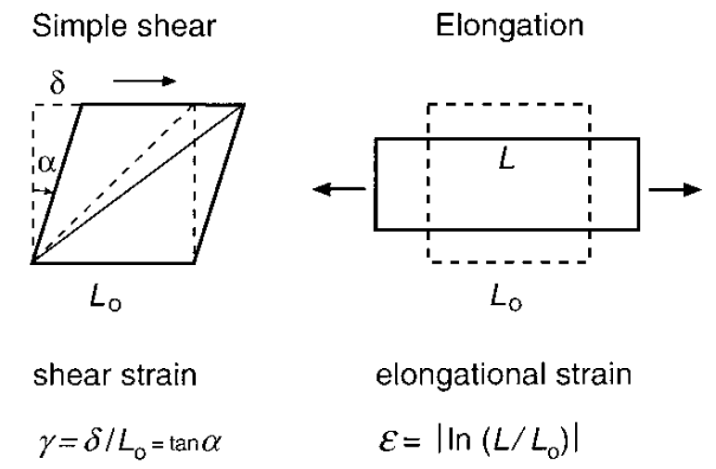
FIGURE 5.2 Explanation of the type of strain occurring in a volume element subjected to simple shear (shear strain) or to elongation (strain expressed as Hencky strain).
Slaid 134
Flow
Most flows are not two-dimensional as in Figure 5.1, where the flow pattern does not change in the z-direction. Consider Figure 5.1c and rotate it around one of the axes: it then represents axisymmetric flow. By rotation around the x-axis, uniaxial elongational flow in the x-direction results; a practical example is flow through a constriction in a tube. By rotation around the y-axis, biaxial elongational flow in the x,z-plane results; a practical example is squeezing flow between two closely approaching plates. Some kind of elongational flow is always involved when a liquid is accelerated or decelerated.
Slaid 135
Flow
Any flow exerts a frictional or viscous stress ηΨ onto the wall of the vessel in which the liquid is flowing or onto particles in the liquid. This has several consequences, the simplest one being that particles move with the liquid; some others are illustrated in Figure 5.3, which applies to simple shear flow. A solid sphere rotates, as mentioned. Solid anisometric particles also rotate, but not at a completely constant rate. An elongated particle will rotate slower when it is oriented in the direction of flow than when in a perpendicular direction. This means that such particles show on average a certain preference for orientation in the direction of flow, although they keep rotating.
Slaid 136
Flow
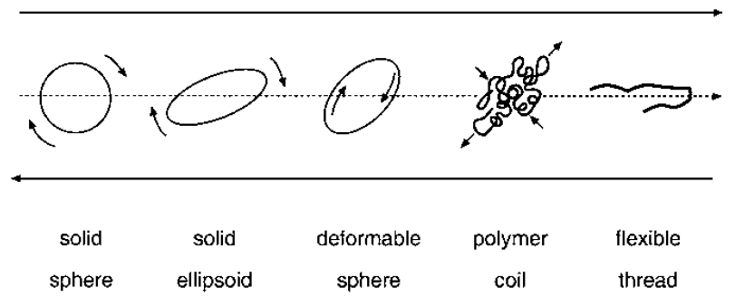
FIGURE 5.3 Motion of particles in simple shear flow. The arrows indicate the direction of flow relative to the particles. In the central plane the flow velocity is zero or, in other words, the coordinate system moves with the geometric center of the particle.
Slaid 137
Flow
Axisymmetric simple shear flow occurs in a straight cylindrical tube; this so-called Poiseuille flow is depicted in Figure 5.4a, further on. The figure also illustrates another point. The liquid velocity v equals zero at the wall of the tube and is at maximum in the center, whereas the velocity gradient ψ is zero in the center and is at maximum at the wall. This is more or less the case in many kinds of flow. The flow velocity at the wall of a vessel always equals zero, at least for a Newtonian liquid (explained below).
Slaid 138
Flow
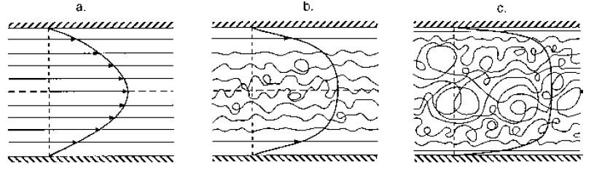
FIGURE 5.4 Streamlines of flow through a tube. In (a) the flow is laminar (Poiseuille flow), in (b) and (c) flow is turbulent. The average flow velocity increases from (a) to (c). In (a) a velocity profile is given, in (b) and (c), average velocity profiles.
Slaid 139
Flow
Turbulent Flow. In Figure 5.4, flow through a tube is depicted. In Figure 5.4a, the flow is laminar (simple shear, Poiseuille flow) and the velocity profile is parabolic. If the flow velocity is increased, a flow profile like that in 5.4b may develop. The streamlines become wavy and eddies develop. This implies that the flow becomes more chaotic and is called turbulent. Near the wall the flow is still laminar, at an increased velocity gradient as compared to the situation in 5.4a. For still higher velocity, the flow becomes increasingly chaotic, and the thickness of the laminar layer near the wall decreases, as depicted in 5.4c. The flow profile drawn now gives the time average of the flow velocity at various distances from the center. Any volume element is subject to rapid fluctuations both in velocity and in direction of flow. The average flow profile is almost block-shaped, except for a high velocity gradient near the wall.
Slaid 140
Flow
What are the conditions for flow to become turbulent? This depends on the preponderance of inertial stresses—proportional to ρv² — over frictional or viscous stresses. The latter are equal to ηΨ in laminar flow; Ψ is proportional to v/L, where L is a characteristic length perpendicular to the direction of flow. The ratio is proportional to the dimensionless Reynolds number, given by
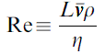$5\text{.}1$
Here v is the average flow velocity, the volume flow rate (flux) divided by the area of the cross section of the flow channel. The characteristic length is, for instance, a pipe diameter. If now Re is larger than a critical value Recr, turbulence will set in. Table 5.1 gives the Reynolds number equation for some flow geometries, as well as values for Recr. The flow around a sphere relates, for instance, to a sedimenting particle, where turbulence will develop in its wake for Re > 1.
It may finally be noted that a geometrical constraint that induces elongational flow if Re < Recr (a sudden constriction in a tube) tends locally to depress turbulence if Re > Recr. Turbulence is also depressed by the presence of large-molar mass polymers or by a high concentration of dispersed particles in the liquid.
Slaid 141
Flow
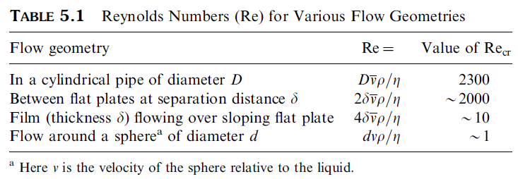
Slaid 142
Viscosity
Molecules in a fluid continuous Brownian or heat motion and have kinetic energy. When the fluid flows have some additional kinetic energy and—owing to the velocity gradient—this energy varies from place to place. Envisaging simple shear flow, adjacent layers have a different velocity. During such flow, some molecules will move by Brownian motion from one layer to another one, which means to one with another velocity; such a molecule is accelerated or decelerated. This implies that a (small) part of the kinetic energy related to the flow is lost and converted into heat. This is the classical explanation for the viscosity of gases. The theory predicts that the viscosity of a gas increases with temperature (see Table 5.2) and is virtually independent of pressure. Neither of these two predictions is true for liquids. The explanation of viscosity in a liquid involves other factors, and has much to do with the limited free volume between the molecules: it is difficult for them to move past the other ones and this difficulty is enhanced in the presence of a velocity gradient.
This then would mean that the viscosity is far greater in liquids than in gases and decreases with increasing temperature (higher T -> lower density -> more free space between molecules).
Slaid 143
Viscosity
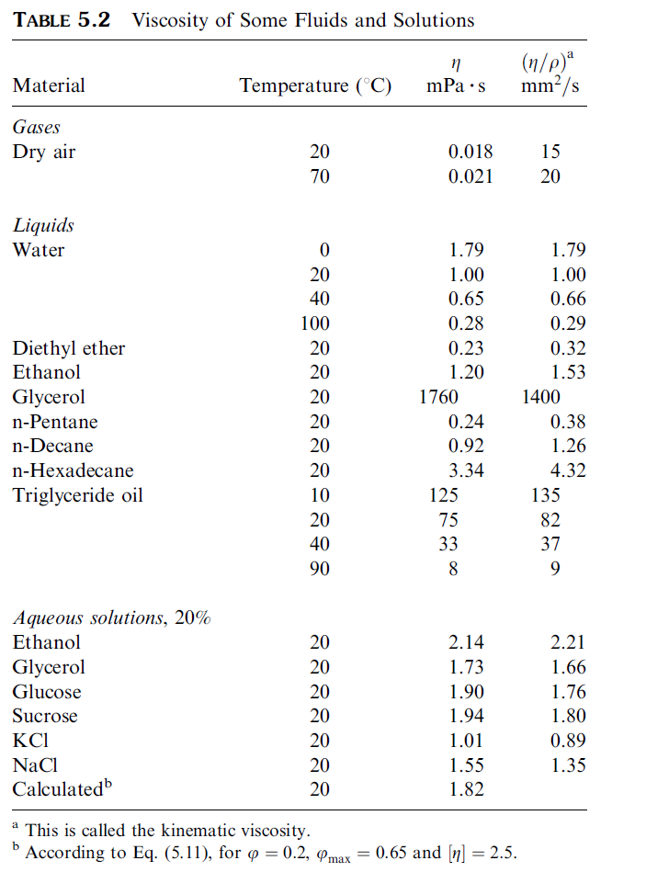
Slaid 144
Viscosity
Dispersions.* When particles are added to a liquid, the viscosity is increased. Near a particle the flow is disturbed, which causes the velocity gradient Ψ to be locally increased. Because the energy dissipation rate due to flow equals ηΨ², more energy is dissipated, which becomes manifest as an increased macroscopic viscosity. The ‘‘microscopic’’ viscosity, as sensed by the particles, remains that of the solvent (pure liquid) η_{s}. For very dilute dispersions of solid spherical particles, Einstein derived
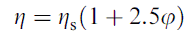$5\text{.}2$
a very simple relation. Note that only the volume fraction φ of the particles, not their size, affects viscosity (provided that the size is significantly larger than that of the solvent molecules). This is illustrated in Figure 5.5. The particles now also sense a greater stress, because the local velocity gradient is increased.
Slaid 145
Viscosity
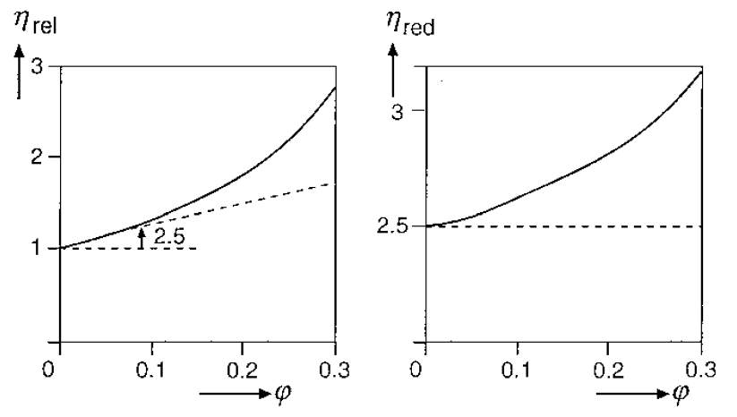
FIGURE 5.5 Example of the effect of concentration on viscosity. The relative (η_{rel}) and the reduced viscosity (η_{red}) of dispersions of spherical particles are given as a function of volume fraction (φ).
Slaid 146
Viscosity
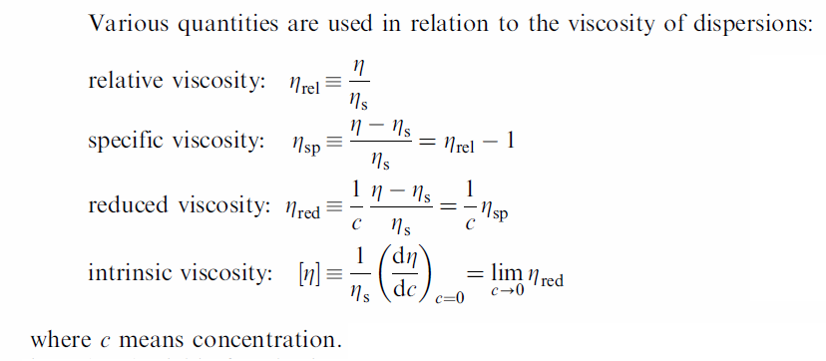
Slaid 147
Viscosity
Concentrated Dispersions. For the viscosity of not very dilute systems, the Krieger–Dougherty equation is often useful. It reads
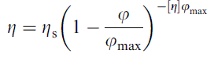$5\text{.}3$
Here φmax is the maximum volume fraction (packing density) that the dispersed particles can have. At that value the viscosity becomes infinite (no flow possible). For random packing of monodisperse spheres, (φmax) ≈ 0.65.
For polydisperse systems, its value can be appreciably higher. Note that now particle size becomes a variable, though its spread (relative standard deviation) rather than its average is determinant.
Slaid 148
Viscosity
Intrinsic Viscosity. Table 5.2 gives some values for the viscosity of 20% solutions; it is seen that for some neutral solutes the outcome does not greatly differ from what is calculated by Eq. (5.3) with [η] = 2.5. This suggests that the Einstein equation (5.2) can reasonably well apply to particles of molecular size. The agreement is far from perfect, and several factors may cause [η] to deviate markedly from the value 2.5, generally being larger.
Slaid 149
Viscosity
1. Particle shape. In emulsions the particles tend to be almost perfectly spherical, but in other food dispersions spherical particles are the exception rather than the rule. In shear flow particles rotate (Figure 5.3). This means that they sweep out a bigger volume during rotation than does a sphere of the same net volume. In other words, the effective volume fraction of particles is increased. This is more strongly so for prolate (cigar-shaped) ellipsoids or rods, than for oblate (disc-shaped) ellipsoids or platelets. The effect increases with increasing anisometry. Particles with an irregular or dented surface also exhibit a difference between effective and net volume.
2. Colloidal interaction forces between particles. If particles repel each other, the viscosity is always increased, except at very small φ; this means that η is generally affected but [η] is not. Weak mutual attraction also tends to enhance η somewhat, but if the attraction is strong enough to cause aggregation of particles, [η] can be greatly enhanced: the aggregates tend to enclose a lot of solvent, which means that effective φ is greatly increased.
Slaid 150
Viscosity
3. Swelling. Figure 5.3 schematically depicts a coiled polymer molecule and illustrates that such a ‘‘particle’’ encloses a lot of solvent (although the enclosed solvent is not completely immobilized). This is comparable to the entrapment of solvent in aggregates mentioned above. Protein molecules always contain some water, are ‘‘swollen.’’
Slaid 151
Viscosity
4. Particle size. For anisometric particles, their size has an effect.
Small particles show rotational diffusion, and this is more rapid for a smaller particle. This affects the average orientation of the particles, hence the increase in viscosity due to anisometry. Smaller particles would give a higher viscosity. Also Factor 2 can come into play: the smaller the particles at a given value of φ, the smaller the interparticle distance and the larger the effect of repulsive interaction can be. On the other hand, attractive forces tend to have a smaller effect on smaller particles.
Slaid 152
Viscosity
Strain Rate Thinning. For a Newtonian liquid, η is independent of the magnitude of the stress, or of the velocity gradient, applied. In many cases, this is not the case, and the viscosity depends on the velocity gradient (or strain rate) applied, or on the stress applied. The ratio of stress over strain rate then is called the apparent viscosity, symbol ηa.
Slaid 153
Viscosity
Thixotropy. In most systems the latter effect is not directly reversible: at constant strain rate ηa tends to decrease with time, and it gradually increases again when flow is stopped (aggregates then are formed again). Such behavior is called thixotropy. Many thick liquid foods are thixotropic; a good example is tomato ketchup. For such systems, the apparent viscosity observed will depend not only on the shear rate applied but also on the time during which it is sheared. Moreover, agitation applied to the sample before measurement may have markedly decreased the apparent viscosity, especially when measured at low strain rate.
Slaid 154
Viscosity
Slaid 155
Viscoelasticity
Figure 5.6 illustrates what can happen when an amount of material is put under a given stress for some time. Envisage, for instance, a cheese cube onto which a weight is placed and after some time removed. In (a) the stress–time relation applied is shown, and in (b) we see the response of a purely elastic material. The material is instantaneously deformed upon applying the stress and it instantaneously returns to its original shape.
In Figure 5.6c we see what happens with a purely viscous material, a Newtonian liquid. As soon as a stress is applied, it starts to flow, and after removal of the stress, flow stops, and the deformation attained remains. The liquid has no memory for its original shape, and the energy applied to cause flow is dissipated into heat.
Slaid 156
Viscoelasticity
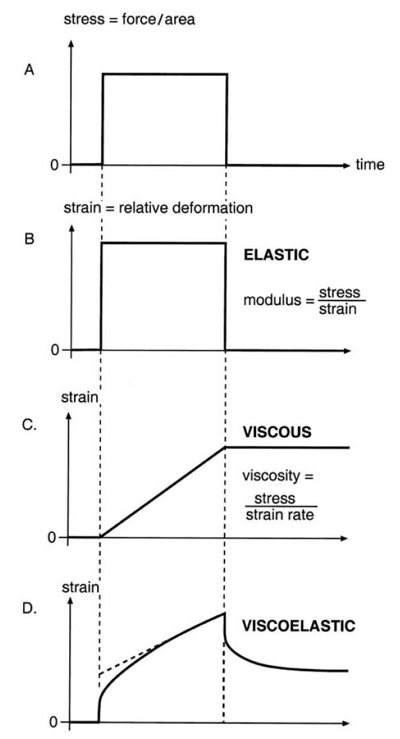
FIGURE 5.6 Various kinds of behavior of a material under stress. (a) Stress applied as a function of time. (b) Resulting strain as a function of time for a purely elastic material. (c) Same, for a Newtonian liquid. (d) Same, for a viscoelastic material.
Slaid 157
Viscoelasticity
In Figure 5.6d an intermediate behavior, called viscoelastic, is depicted; such a relation is often called a creep curve, and the timedependent value of the strain over the stress applied is called creep compliance. On application of the stress, the material at first deforms elastically, ‘‘instantaneously’’, but then it starts to deform with time. After some time the material exhibits flow; for some materials, the strain can even linearly increase with time. When the stress is released, the material instantaneously loses some of it deformation (which is called elastic recovery), and then the deformation decreases ever slower (delayed elasticity), until a constant value is obtained. Part of the deformation is permanent and viscous. The material has some memory of its original shape but tends to ‘‘forget’’ more of it as time passes.
Slaid 158
Viscoelasticity
Dynamic Measurements. Viscoelastic materials show an elastic and a viscous response upon application of a stress or a strain. To separate these effects, so-called dynamic measurements are often performed: the sample is put, for instance, between coaxial cylinders, and one of the cylinders is made to oscillate at a frequency ω. Stress and strain then also oscillate at the same frequency. In Figure 5.7, a shear strain (γ) is applied, and it is seen to vary in a sinusoidal manner. If the material is purely elastic, the resulting shear stress (σ) is always proportional to the strain, and the ratio σel/γ is called the elastic or storage shear modulus Gʹ (‘‘storage’’ because the mechanical energy applied is stored).
Slaid 159
Viscoelasticity
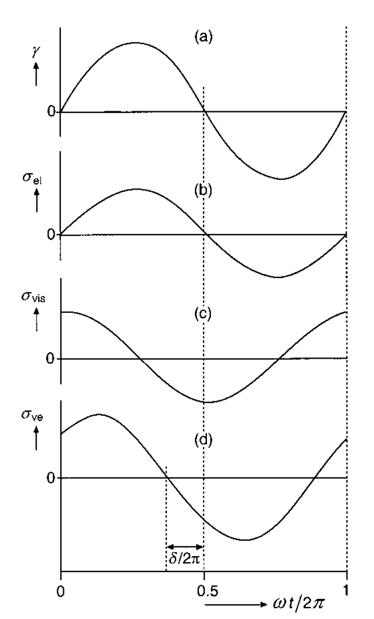
FIGURE 5.7 Illustration of dynamic (oscillatory) measurement of rheological properties. In (a) the applied shear strain (γ) is shown as a function of time t; ω is the oscillation frequency. In (b–d) the resulting shear stress σ is given for an elastic, a viscous, and a viscoelastic response. δ is the phase or loss angle.
Slaid 160
Viscoelasticity
Relaxation Time. Figure 5.8 illustrates what may happen in stress relaxation experiments. A material is somehow deformed until a given strain is obtained and then kept at that strain (a). In (b) the response of the stress is given. For a Newtonian liquid, the stress will instantaneously go to zero. For a purely elastic solid, the stress will remain constant. For a viscoelastic material, the stress will gradually relax. The figure illustrates the simplest case, where
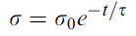$5\text{.}4$
Here τ is the relaxation time (defined as the time needed for the stress to relax to 1/e ≈ 0.37 of its initial value). In most materials the stress relaxation follows a different course, since there may be a number (a distribution) of relaxation times. Nevertheless, the relaxation time, even if it merely concerns an order of magnitude, is a useful parameter.
Slaid 161
Viscoelasticity
It depends on the time scale of observation what we observe or, more precisely, on the Deborah number:
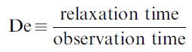$5\text{.}5$
If Dе << 1 we call the material a liquid; and at Dе >> 1 the material appears solid. It is only if De is of order unity that we observe viscoelastic behavior. Variation of the frequency (ω) in dynamic tests amounts to varying the Deborah number.
Slaid 162
Viscoelasticity
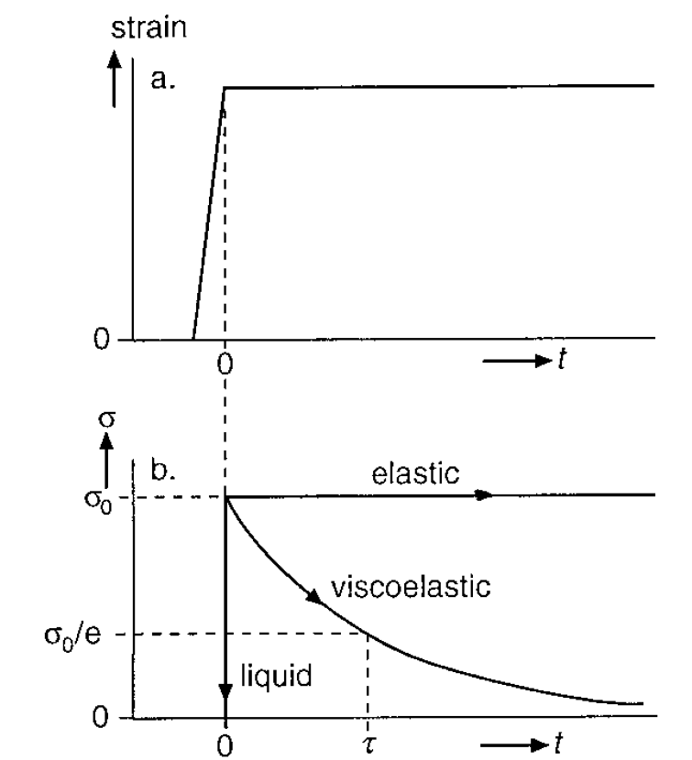
FIGURE 5.8 Stress relaxation. (a) Strain applied to a material as a function of time t. (b) Resulting stress σ for various materials; τ = relaxation time.
Slaid 163
Viscoelasticity
Nonlinearity. Many rheological measurements, virtually all dynamic measurements, are carried out in the so-called linear region. This means that the strain is proportional to the stress. In practice (during processing), large deformations are often applied, and in most viscoelastic materials the linear region is quite small, the proportionality of stress and strain is lost at a small value of the strain, say, between 10⁻⁴ and 0.02. Figure 5.9 gives some examples of the velocity gradient Ψ—be it due to shear or to elongation—resulting from applying increasing stresses (σ). Curve (a) relates to a Newtonian liquid and curve (b) to a strain rate thinning liquid.
Slaid 164
Viscoelasticity
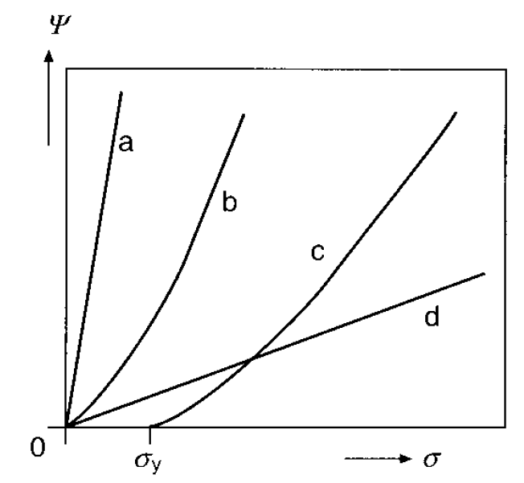
FIGURE 5.9 Examples of the relation between velocity gradient ψ and stress σ for Liquid like systems. σ_{y} is yield stress.
Slaid 165
Viscoelasticity
Yield Stress. Curve (c) is characteristic for many viscoelastic materials. At small stress, the material behaves elastically, as shown in Figure 5.6b. Above a given stress, however, it starts to flow, and its behavior is like that in Figure 5.6d. This critical stress is called the yield stress. Beyond τ_{y}, the liquid is strain rate thinning. The magnitude of the yield stress varies widely, and values from 10⁻⁵ Pa (some fruit juices) to over 10⁵ Pa (some butters) have been observed. If τ_{y} < 10 Pa, the yielding behavior tends to go unnoticed at casual observation. Thus the existence of a yield stress does not mean that a high stress is needed to cause a certain flow rate. A high-viscosity Newtonian liquid, like curve (d), may have a much higher apparent viscosity, at least at high σ.
The yield stress is not a clear-cut material property, since its magnitude generally depends on time scale, often markedly so. If the applied stress lasts longer, a lower yield stress is commonly observed. In other words, the Deborah number determines whether or not yielding occurs at a given stress.
Slaid 166
Diffusion
Diffusion is caused by the thermal motion of molecules (and small particles), which is briefly discussed in Section 4.3.1. The molecules (or particles) can rotate and translate. This section will be restricted to translational diffusion in liquids.
Slaid 167
Brownian motion
When observing a dilute dispersion of small particles (order of 1 mm) under the microscope, one observes—as was originally described by Brown—that the particles display an erratic motion. If there is no convection, every particle makes a random walk, implying that it very frequently alters direction and speed of motion; the change in direction is completely random, that in speed within certain bounds. This Brownian motion is illustrated in Figure 5.10. The figure gives the projection on a plane of the positions of a particle at regular time intervals, connected by straight lines. The positions at 10 times shorter time intervals are also given, and it is seen that the straight lines on the left-hand figure turn into pathways that have an appearance like the total trajectory at left, though at a smaller scale. The average pattern of the Brownian motion is thus independent of the length of the time step considered, unless the latter is extremely short. Actually, the particles may change position, say, 10⁸ times per second.
Slaid 168
Brownian motion
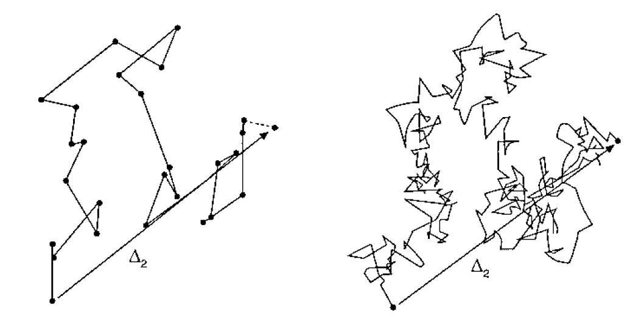
FIGURE 5.10 Brownian motion. Projection on a plane of the trajectory of a gamboge particle, taking observations at constant time intervals. The right-hand side shows the same trajectory, but the time interval is 10 times shorter than at the left hand side.
Slaid 168
Mass diffusion
So far, we have tentatively assumed that all molecules and particles are randomly distributed throughout the volume available. If there are two (or more) substances present, say solute and solvent, concentration differences can occur for a number of reasons. If so, the heat motion causes the molecules to attain a (more) random distribution, the concentration differences will eventually disappear, except over very small distances. The process is entropy driven. The rate at which it occurs is generally described by Fick’s laws. Fick postulated in his first law that the diffusional
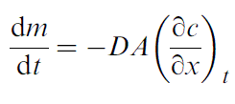$5\text{.}6$
where dm is the amount of solute transported in the direction of x through the area A of a cross section perpendicular to x. The amount m can be given in any unit of substance, and the concentration c must be taken in the same units per unit volume.
Slaid 170
Mass diffusion
From Eq. (5.6) Fick’s second law can be derived, which gives the change in c with time at any place as a function of the local concentration gradient
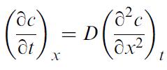$5\text{.}7$
Total mass transport and concentration profiles as a function of time can be obtained from these differential equations. The solution greatly depends on the boundary conditions, the geometrical constraints.
Slaid 171
Heat transfer
If a temperature gradient exists in a liquid—and this is also valid for a solid—heat motion of the molecules will cause the temperature to become equal throughout; after all, temperature is proportional to the average kinetic energy of the molecules, and the molecules collide with each other, thereby transferring momentum and smoothing out temperature differences. This diffusion of heat (or conduction) proceeds in the same way as diffusion of mass. The diffusion coefficient for heat ΔH is generally called the thermal diffusivity.
Slaid 172
Transport in composite materials
A liquid food of not very high viscosity can be stirred to speed up transport of heat or mass. Even if it contains dispersed particles, these mostly are small enough to allow rapid diffusion in or out of them. Many foods, are solidlike, and there are even some that contain a lot of water (cucumbers, for example, contain about 97% water); transport generally is by diffusion and in some cases by—greatly hindered—flow. Some examples are during several processing operations, like drying, extraction, and soaking, diffusion is the rate determining step. When a food is kept, it may lose substances by diffusion or leaking, such as water or flavor components, or it may take up substances from the environment, from packaging material.
Slaid 173
Flow rates
Through a porous material, liquid may flow, albeit often sluggishly. It is useful to consider the material as a solid matrix, containing several capillary channels or pores. In practice, the pores are always narrow enough and liquid velocity is slow enough to ensure that flow is laminar. The permeability may be considered as a material constant, provided that the Reynolds number Re << 1.
Moreover, the pores tend to be irregular in shape and cross section, they are tortuous and bifurcate, and some may have a dead end.
The permeability may even be anisotropic, be different in different directions.
Slaid 174
Effective diffusion coefficients
Even for such a simple case as the diffusion of a small-molecule solute, say sugar, in a gel made of a dilute polymer solution, say gelatin or pectin, the macroscopic viscosity of the system greatly differs from the microscopic viscosity as ‘‘sensed’’ by the diffusing molecules: they just diffuse around the strands of the gel. The effect is illustrated in Figure 5.11, and it is seen that the discrepancy may be by several orders of magnitude, even for quite low concentrations of matrix material. To be sure, the viscosity of a gel is an ambiguous property; it concerns in fact an apparent viscosity determined at a stress larger than the yield stress of the gel. But the example serves to illustrate the point: the effective viscosity cannot be obtained from macroscopic measurements. Nevertheless, diffusion in a gel is slower than in pure solvent, the more so for a higher concentration of matrix material.
Slaid 175
Effective diffusion coefficients
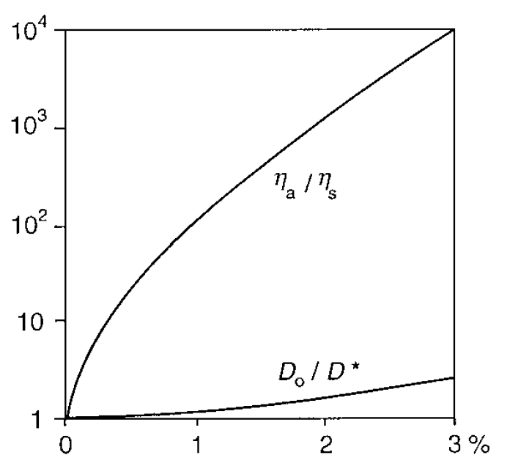
FIGURE 5.11 Example of the effect of polysaccharide concentration (%) on the apparent viscosity of the polysaccharide–water mixture (ηa) and of the effective diffusion coefficient (D*) of a solute in the mixture. D0 is the diffusion coefficient in the absence of polymer, ηs the viscosity of the solvent.
Slaid 176
Effective diffusion coefficients
Numerous theories have been developed for diffusion in compound systems, and they all depend, of course, on the structure of the matrix; in other words, they are model dependent. Here, a microscopic approach is taken, where part of the material, the matrix, is inaccessible to the diffusing species; the matrix has pores filled with solvent or solution, through which diffusion can occur. Quite generally, the following factors affecting the effective diffusion coefficient D* can be distinguished.
The result is given in Figure 5.12, and it is seen that the effect is very strong. Also more sophisticated theories, in which the pores considered are more realistic, show that the ratio l often is the most important factor limiting diffusion rate in porous materials.
Slaid 177
Effective diffusion coefficients
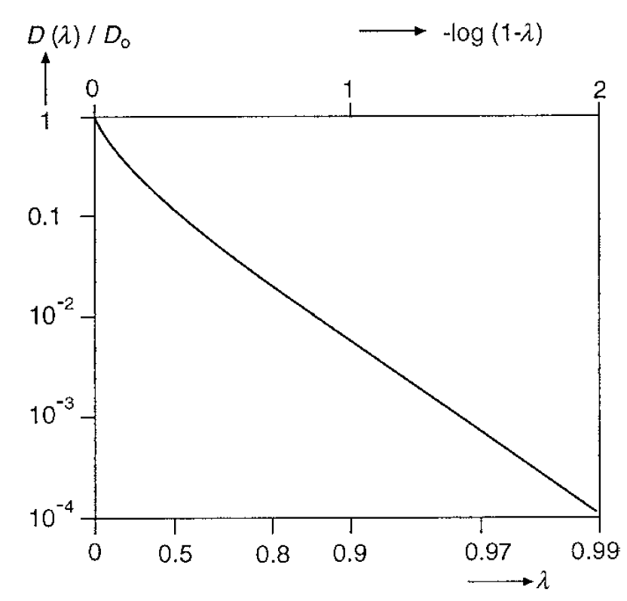
FIGURE 5.12 Relative diffusion coefficient D(λ)/D0 as a function of λ = r_{m}/r_{p} for diffusion of spherical molecules of radius r_{m} through a cylindrical capillary of radius r_{p}.
Slaid 178
Effective diffusion coefficients
Partial Osmosis. If constriction is significantly stronger for larger molecules, of a solute—than for small ones, of the solvent—the diffusional fluxes are not anymore equal and opposite, as is the case in unhindered diffusion (barring volume change upon mixing). This results in partial osmosis. For example, if a piece of fruit is put in a concentrated sugar solution, water diffuses faster out than sugar diffuses in, leading to a decrease in volume. A prerequisite then is that the piece of fruit can shrink, which means a compression of the cellular structure. This is a way of ‘‘drying’’ the fruit, called osmotic dehydration. It is, not pure osmosis, since the fruit is not impervious to sugar: it only diffuses slower, say by a factor of five, than water. If the fruit is left in the sugar solution, it will eventually obtain the same sugar content, relative to water, as in the said solution. The fruit then becomes candied besides dried, which is commonly applied to dates. Several other examples could be given; for instance, when salting cheese by immersing it in brine, the loss of water from the cheese is generally more than twice the uptake of salt.
Slaid 179
Diffusion through a thin layer
Different regions in a food may have different effective diffusion coefficients for a solute. Moreover, the solubility of the solute may differ. Figure 5.13 depicts a situation in which a solute diffuses from left to right because of a difference in concentration in two compartments of phase α, which are separated by a (thin) layer of a phase β. For sake of simplicity, it is assumed that within each entire compartment the concentration is everywhere the same. The solubility is not the same in a and b, and the distribution coefficient or partition ratio K_{D} = cβ/cα.
Slaid 180
Diffusion through a thin layer
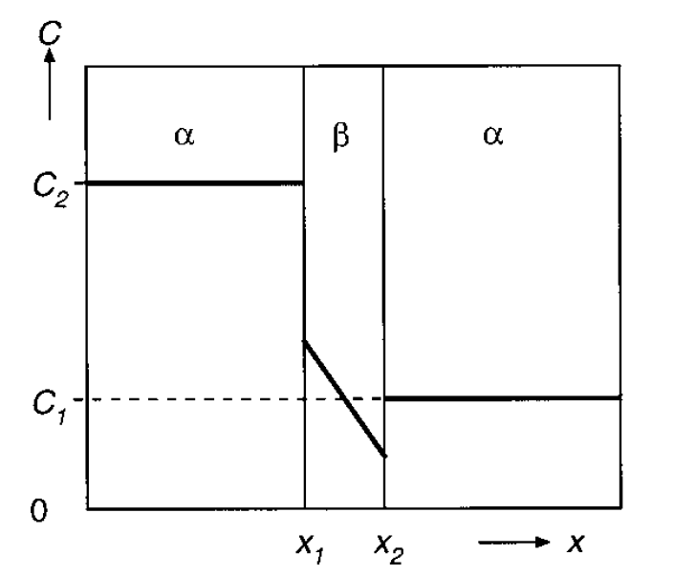
FIGURE 5.13 Example of the concentration C of a component as a function of distance (x) as it diffuses through a layer of another phase (β).
Slaid 181
Recapitulation
Flow. Liquids thus flow when a stress is applied. The flow is laminar if the streamlines are straight lines or smooth curves. The flow is characterized by its velocity gradient (which equals the strain rate) and the type of flow. Flow type can be rotational or elongational. Best known is simple shear flow (parallel streamlines), which has an elongational and a rotational component. In elongational flow, the velocity gradient is in the direction of flow, in simple shear, normal to the direction of flow. The elongational viscosity is larger than the common or shear viscosity. The flow exerts a frictional stress on particles or other objects; this stress equals viscosity times velocity gradient. The stress can cause particles to rotate and to become deformed.
Slaid 182
Recapitulation
Viscosity. The viscosity of liquids varies among molecular configurations and generally increases with molar mass; it decreases with increasing temperature. The addition of particles or of a solute leads to an increased viscosity, the more so for a higher volume fraction. The increase is generally (almost) independent of particle size, but it does depend on particle shape and on the inclusion of solvent by the particles, particle aggregates, or polymer molecules, since these variables affect the effective volume fraction. The extent to which a substance can increase viscosity is expressed in the intrinsic viscosity (relative increase of viscosity per unit solute, extrapolated to zero concentration). The maximum volume fraction possible for the particles present also affects viscosity, as the latter becomes infinite at the said maximum.
Slaid 183
Recapitulation
Viscoelasticity. Some strain rate thinning liquids, especially polymer solutions, are also viscoelastic. This means that after exerting a stress on the liquid, it deforms at first elastically and then starts to flow; upon release of the stress it regains part of the original shape. If a given deformation is applied to a viscoelastic material, the stress slowly relaxes; the characteristic time for this is called the relaxation time.
The Deborah number (De) is defined as the ratio of this relaxation time over the observation time. For a solid De is very large, for a liquid very small, and for a viscoelastic material of order unity. It thus depends on the time scale of observation whether we call a material solid or liquid. Several foods appear to be solid at casual observation, but show flow during longer observation.
Slaid 184
Recapitulation
Diffusion. Molecules show heat motion, and this has some consequences: (a) particles in a liquid undergo Brownian motion, in fact the equivalent of molecular motion at a slower rate; (b) if concentration gradients exist, these are evened out by diffusion, and (c) the same applies to temperature gradients. The rate of these processes depends on the diffusion coefficient, which is inversely proportional to viscosity and to molecule or particle radius. Heat motion is a random process, governed by statistical laws. This causes (the root-mean-square value of) the transport distance to be proportional to the square root of time. Consequently, diffusion is a rapid process at very small distances and very slow at large distances. In practice, the rate of mass transport is commonly enhanced by mixing. Diffusional transport can generally be calculated by integration of Fick’s laws. Also the amount of mass transported by diffusion into a lump of material is in first approximation proportional to the square root of time.
Slaid 185
Recapitulation
Heat. Heat can also be transported by diffusion, also in solids. The diffusion coefficient then is called thermal diffusivity; it has a fairly constant value that is much larger than that of mass diffusion coefficients. This means that temperature evens out much faster than concentration. To calculate the transport of the amount of heat, the diffusion coefficient in Fick’s laws must be replaced by the thermal conductivity. Under various conditions, heat can also be transported by mixing, by radiation, and by distillation.
Slaid 186
Recapitulation
Composite Materials. Many solid foods can be considered as solid matrixes, interspersed with a continuous liquid phase. Transport through such a material may be greatly hindered. Flow of the liquid through the matrix under the influence of a pressure gradient is proportional to a material constant called permeability, which is about proportional to pore diameter squared and pore volume fraction.
6 Polymers
Slaid 187
Polymers
Almost all foods contain macromolecules and almost all of these macromolecules are polymers. Polymers have specific properties, warranting a separate treatment; some aspects of them are discussed in this chapter.
Slaid 188
Introduction
A polymer molecule in its simplest form is a linear chain of covalently bonded identical monomers. A very simple synthetic polymer is polyethylene, which is obtained by linear polymerization of ethylene, CH2CH2, yielding [– СH2 – СH2 –]n ; i.e., a very long paraffin chain. Another simple example is poly (oxyethylene), [– O – СH2 – СH2 –]n. n is the degree of polymerization, and it can be very high, up to about a million. The monomers may have one or more reactive side groups. Such molecules have very specific properties, due to their size and flexibility. A linear molecule with n = 10⁴, built of monomers with a molar mass of 30 Da, will be taken as an example. The molecule is thus very large, molar mass 300 kDa. Its length-to-diameter ratio is like that of a 10m string of about 1mm thickness. If it were tightly coiled up in a sphere, it would assume a diameter of about 10 nm. In other words, it would be of colloidal rather than molecular size, and many polymer molecules are even far larger.
Slaid 189
Introduction
Altogether, polymer solutions show essential differences with normal solutions as well as with colloidal dispersions and need a special treatment. Highly concentrated polymer systems behave differently, again, and tend to form amorphous solids. Typical concentrated synthetic polymers are plastics and rubbers.
Until now, identical linear homopolymers were considered, but such molecules are rather exceptional. Polymers can be heterogeneous or more complicated in various ways: most polymers, especially synthetic ones, vary in degree of polymerization and in molar mass. Moreover, long polymer molecules will generally contain a few irregularities, since polymerization without error is almost impossible.
Slaid 190
Introduction
Heteropolymers are (purposely) built of more than one type of monomer. Some are copolymers, constituted of two different monomers (A and B). The latter can be arranged in various ways: evenly (e.g., alternating),
– A – B – A – B – A – B – A – B – A – B – A – B – A – B – A – B – A –
at random,
– B – A – A – A – B – A – B – B – A – B – B – B – A – A – A – A – B –
or in fairly long blocks built of one monomer.
– A – A – A – A – A – A – A – A – A – A – B – B – B – B – B – B – B –
If several different monomers are involved, the molecules can be far more complicated.
Branched polymers occur, and various modes of branching and subbranching have been observed. Polyelectrolytes contain monomers that are charged. They are virtually always heteropolymers as well, since only part of the monomers will have a charge. A polyelectrolyte may be a polyacid, a polybase, or a polyampholyte (acid and basic groups).
Slaid 191
Introduction
Natural polymers come in a far wider range of composition and properties than synthetic ones. Natural polymers are for the most part of three main types, all of which occur in foods.
Nucleic acids, DNA and RNA. These are linear heteropolyelectrolytes (four types of monomers) of very large degree of polymerization (especially DNA). Their biological function is the transfer of information. In foods, their concentrations mostly are too small to affect physicochemical properties, and they will not be further discussed.
Proteins, linear heteropolyelectrolytes, built of amino acids, 20 different monomers of highly different configuration and reactivity. The degree of polymerization typically is about 10³. They may have any of several biological functions.
Polysaccharides, linear or branched heteropolymers of sugars and derived components; several are polyelectrolytes. The degree of polymerization is mostly 10³ to 10⁴. The main biological functions are ‘‘nutritional’’ (primarily starch in plants, glycogen in animals) and ‘‘building material’’ (in plants). The latter are called structural polysaccharides, which occur in a great variety of types and mostly form mixed and highly complex structures, especially in cell walls.
Slaid 192
Introduction
Several polysaccharides and proteins can be isolated to be applied in manufactured foods; examples are given in Table 6.1. It should be realized that such preparations may significantly vary in properties and also in purity. Moreover, several natural polymers are chemically modified to obtain altered (‘‘improved’’) properties. For instance, cellulose is insoluble in water, but by carboxymethylation of part of the – CH2OH groups, the material becomes well soluble (and charged, since free carboxyl groups are formed). Cellulose can also be methylated, whereby it becomes soluble, despite the presence of hydrophobic groups. Starch is modified in various ways, by cross-linking.
Slaid 193
Introduction
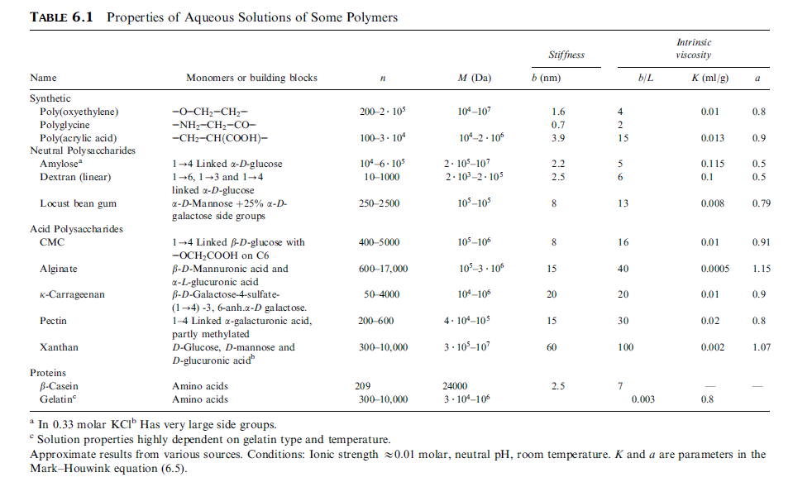
Slaid 194
Introduction
Natural or modified polymers are often used as thickening or gelling agents, especially polysaccharides. Figure 6.1 gives examples of the effect of polymer concentration on apparent viscosity. Clearly, polysaccharides can be very effective thickeners. Polymers may be used to obtain a certain consistency or to provide stability by arresting or slowing down the diffusion of molecules or the leaking out of liquid. Another important function of polymers is to stabilize dispersions. Polymers in solution can slow down sedimentation and aggregation of particles, or even prevent these phenomena if they form a gel. Many polymers, especially proteins, adsorb onto fluid or solid particles, thereby greatly affecting colloidal interactions between the particles, hence their stability.
Slaid 195
Introduction
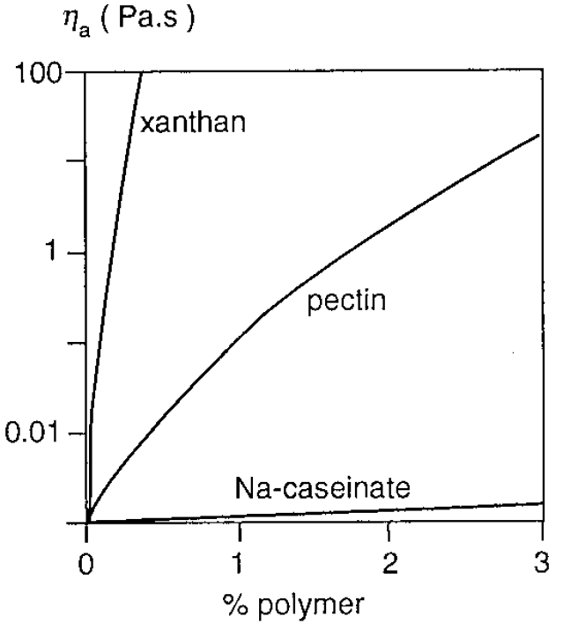
FIGURE 6.1 Apparent viscosity (ηa) of polymer solutions of various concentration (% w/w). Shear rate zero (extrapolated) for xanthan, about 100 s⁻¹ for the other solutions.
Slaid 196
Very dilute solutions
In this section, uncharged polymers in very small concentrations will be considered. This means that the behavior of a polymer molecule will not be affected by the presence of other polymer molecules, but only by the solvent.
Slaid 197
Conformation
Ideal Polymer Chain. The simplest model of a polymer molecule is a linear chain of n segments, each of a length L, where each segment is free to assume any orientation with respect to its neighbors, and where all orientations have equal probability. The molecule as a whole then has a conformation that can be described by a random walk through space: all steps have the same length L but can be in any direction. This is very much like the path that a diffusing molecule or particle follows in time, and it can be described by the same statistics. An example of such a statistical or random chain is depicted in Figure 6.2.
This is an important conclusion. It implies that the volume occupied by a certain mass quantity of polymer increases with increasing molar mass or molecular length, other things being equal; in other words, the coils are more tenuous (rarefied, expanded) for a larger M or n. It also implies that the viscosity of a polymer solution of a given concentration increases with increasing M.
Slaid 198
Conformation
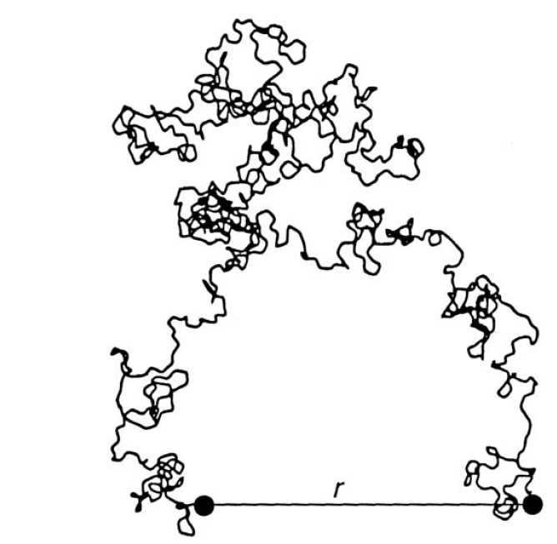
FIGURE 6.2 Example of a projection of a calculated random coil of 250 segments. r is the end-to-end distance.
Slaid 199
Conformation
Complications. The above qualitative statements are generally true, but is mostly not obeyed precisely, because the theory is an oversimplification. The main complications are
1. Stiffness of chain. An actual polymer chain will always be less flexible than the statistical chain considered above, because the bond angle between monomers is fixed. Figure 6.3 demonstrates that the position of a monomer–monomer bond with respect to the next one can only be at any point of a circle, rather than at any point of a sphere of radius L. Bulky side groups of the monomer may further restrict the freedom of orientation. Moreover, in the case of polyelectrolytes, electrical repulsion between chain segments may limit flexibility. Nevertheless, the same laws may hold for the polymer conformation, by taking into account that the position of a bond with respect to another that is several monomers away can still be random. This is illustrated in Figure 6.4.
Slaid 200
Conformation
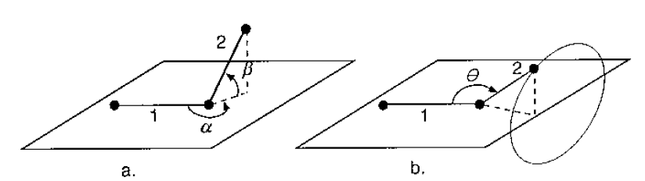
FIGURE 6.3 Orientational possibilities of two segments of a polymer, where a segment is depicted by its axis. Segment 1 is fixed in the horizontal plane. (a) Ideal chain; the angles α and β can assume any value. (b) More realistic chain; the bond angle θ is fixed (about 109 degrees for a C – C – C bond) and the end of segment 2 must be on the circle depicted.

Slaid 201
Conformation
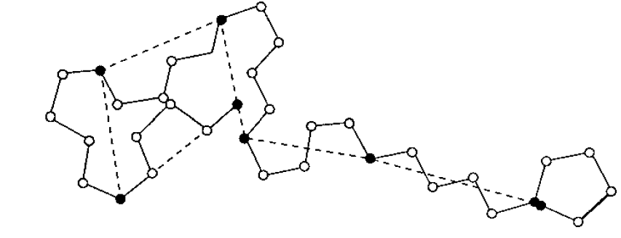
FIGURE 6.4 The effect of the stiffness of a polymer chain on its conformational freedom. This is illustrated for a two-dimensional case, with a fixed, obtuse bond angle, implying two possible conformations at each bond. Although over a distance of two or three segments, the position cannot vary at random, this is possible over a distance of, say, 5 segments, as illustrated. The broken lines would then indicate the statistical chain elements.

Slaid 202
Conformation
2. Excluded volume and solvent quality. Up till here, the volume taken up by the polymer itself, n times the volume of a monomer, has been neglected. In other words, such an ideal random chain has no volume, which would imply that two different segments can occupy the same place in the solvent at the same time. This is, of course, physically impossible, which is why the statistics of a real chain are different from those of a random walk (diffusion). Instead of this, a self-avoiding random walk should be considered, and the average conformation then is different, rm being proportional to nʹ to the power 0.6, rather than 0.5. This means that the molecule is more expanded than an ideal chain.
Slaid 203
Conformation
3. Polydispersity. As mentioned, most polymers show a range in degree of polymerization or molar mass. This means that suitable averages should be taken. The theory is fairly involved and will not be discussed here.
4. Branched polymers. Some polymers are highly branched, and amylopectin is a prime example. In such a case, the volume taken up by a polymer molecule will be much smaller than that of a linear molecule of the same number of the same segments. The exponent in the relation between rm or rg and nʹ will generally be smaller than 0.5. For amylopectin, exponents of 0.41 to 0.43 have been observed. Calculation of the conformation of branched polymer molecules is generally not possible.
Slaid 204
Conformation
5. Heteropolymers. Several complications may arise. The stiffness and the bulkiness of the chain may be different in different stretches. The same may be true for the quality of the solvent, which implies that the excluded volume parameter of the polymer is a kind of average value. Specific interactions may occur between different side groups. Simple theory is not available.
Slaid 205
Conformation
Polysaccharides. Many natural or modified natural polymers exhibit most or all of the complications mentioned. This is especially true for many polysaccharides, which tend to be fairly stiff molecules, Table 6.1. The b values are generally small, often < 0.1. The chemical constitution varies considerably, some polysaccharides (xanthan) having very large side groups on the primary chain. Besides causing steric hindrance, which also makes the chain stiffer, side groups may exhibit (weak) mutual attraction. Some of these polymers tend to form helices in solution. Altogether, polysaccharides vary widely in such properties as solubility, tendency to form a gel, and extent of expansion. When characterizing the latter by the hydrodynamic voluminosity, the hydrodynamic volume of a polymer molecule per unit dry mass of polymer, values ranging from 10 to more than 10³ ml/g have been observed for polysaccharides of M = 10⁶ Da.
Slaid 206
Viscosity
In Section 5.1.2 the effect of solute molecules and particles on viscosity is briefly discussed. It follows that the intrinsic viscosity [η] is a measure of the extent to which a certain solute can increase viscosity. (Remember that [η] equals specific viscosity (η/ηs - 1) divided by concentration for infinitesimally small concentration.)
Slaid 207
Viscosity
Strain Rate Dependence. The outline given above is, it has been implicitly assumed that the flow would not affect orientation or conformation of the polymer coil. This is not true. It is always observed that η, and thus [η], is affected by the shear rate applied. Various types of flow can occur and, more generally, we should say strain rate or velocity gradient, rather than shear rate. We will restrict the discussion here to simple shear flow. An example is shown in Figure 6.5, lower curve. At very low shear rate, the solution shows Newtonian behavior (no dependence of η on shear rate), and this is also the case at very high shear rate, but in the intermediate range a marked strain rate thinning is observed.
Slaid 208
Viscosity
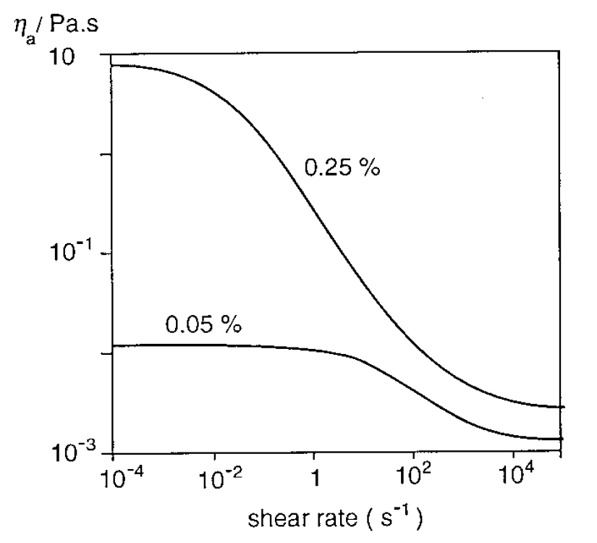
FIGURE 6.5 Dependence of the apparent viscosity ηa of xanthan solutions (concentration indicated) on shear rate; low ionic strength.
Slaid 209
Viscosity
Second, deformation of a particle like a random coil polymer molecule may occur in a shear field. As illustrated in Figure 5.3, the particle becomes elongated in one direction and compressed in another one. Since the particle also rotates, this effectively means that the particle is repeatedly compressed and elongated, which goes along with solvent locally being expelled from it and locally being taken up. This causes additional energy dissipation and an increased viscosity. The polymer molecule has a natural relaxation time for deformation: if it is deformed by an external stress and then the stress is released, it takes a time t_{def} for the deformation to be diminished to 1/e of its original value.
Slaid 210
Polyelectrolytes
In this section some specific aspects of polymers bearing electric charge will be discussed. The reader is referred to Section 2.3, Electrolyte Solutions, for basic aspects.
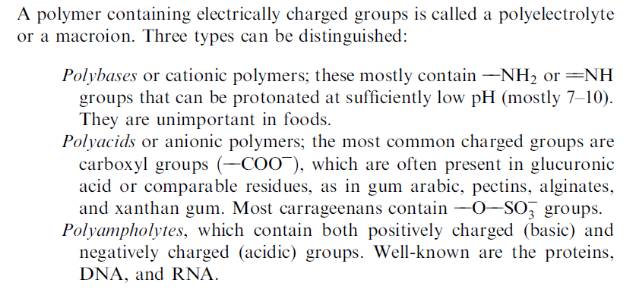
Slaid 211
Description
Ionization. The number of charges depends on the degree of ionization, hence on pH. The sulfate groups mentioned are virtually always ionized. Carboxyl groups, have a pKa value of about 4.7, or about 3.4 for uronic acid groups (primary carboxyl group on a sugar ring), implying that their ionization can vary greatly over the pH range occurring in foods. At low pH, where the hydrogen ion activity is high, they are fully protonated, having no charge; at high pH they are ionized, having negative charge. The situation is more complicated than for a simple monovalent acid. It is useful given in dissociation of an acid HAc:
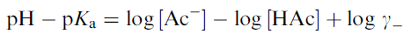
where γ is the ion activity coefficient of Ac. Calling the fraction of the molecules that is dissociated α, the equation can be rewritten as
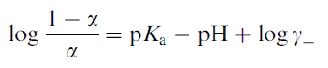
Slaid 212
Description
Figure 6.6a gives titration curves of a sample of poly (methacrylic acid). We will first consider the curve for low ionic strength, where γ⁻ is not much smaller than unity. With pKa = 4.7 is not nearly obeyed: the curve is shifted to higher pH (by almost 2 units), and the slope is far too small (spanning nearly four pH units rather than two).
Slaid 213
Description
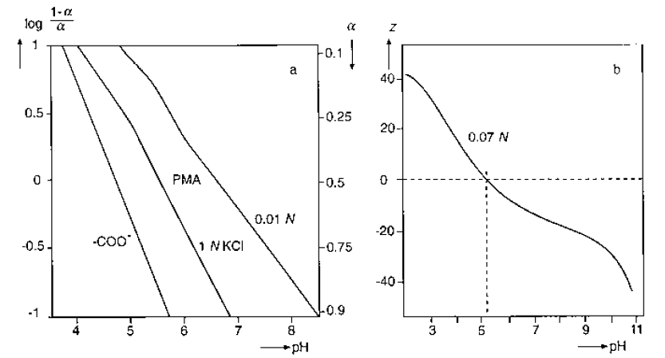
FIGURE 6.6 Titration curves. (a) The degree of ionization a) as a function of pH for a single carboxyl group (calculated) and for solutions of poly(methacrylic acid) in 0.01 and 1 normal KCl. (b) The (average) valence z of β-lactoglobulin as a function of pH.

Slaid 214
Conformation and viscosity
Figure 6.7 schematically depicts the conformation of a polyelectrolyte (a polyacid) at various ionic strength. At high I (small 1 = k) the negative charges can only sense each other if they are very close. This implies that the conformation is not greatly different from that of a similar but uncharged polymer. As the ionic strength decreases, the molecule becomes more expanded, because the charges sense each other over a longer distance. The radius of gyration is relatively large. If the molecule is not very long, it will attain an almost rodlike conformation at very low ionic strength. The conformation will also depend on the linear charge density.
Slaid 215
Conformation and viscosity
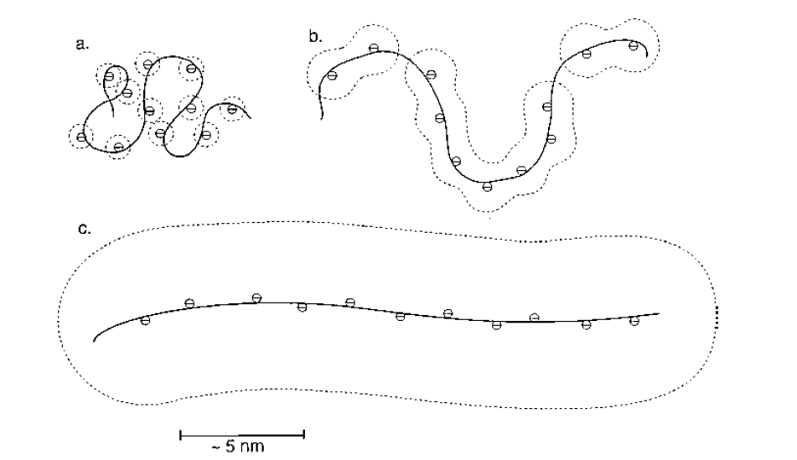
FIGURE 6.7 Examples of the conformation of a polyacid molecule at various ionic strengths, which would roughly be 400, 80, and 7 mmolar for (a), (b), and (c). The dotted lines are at a distance of about 1=k of the charges. Only ions that are part of the polymer are indicated. Highly schematic.

Slaid 216
Conformation and viscosity
Viscosity. The effects of charge (degree of dissociation) and ionic strength on expansion (radius of gyration) of polyelectrolytes are, of course, reflected in the extent by which they increase viscosity. Figure 6.8 gives an example. It is seen that a higher degree of dissociation and a lower salt concentration both yield a higher intrinsic viscosity, as expected. It is also seen that at large α; [η] decreases again, at least at low salt concentration. This may be explained partly by the contribution of the polyelectrolyte to the ionic strength. At high z, high α, this means that an increase in a leads to an appreciable increase in ionic strength, and at low salt concentration this is sufficient to decrease the radius of gyration of the molecule and thereby [η]. If the ionic strength is kept constant at high z, the anomaly is much smaller. Figure 6.11 further illustrates the effect of ionic strength on intrinsic viscosity of a polyacid.
Notice: that the exponent a markedly increases with decreasing ionic strength, leading to very high intrinsic viscosities.
Slaid 217
Conformation and viscosity
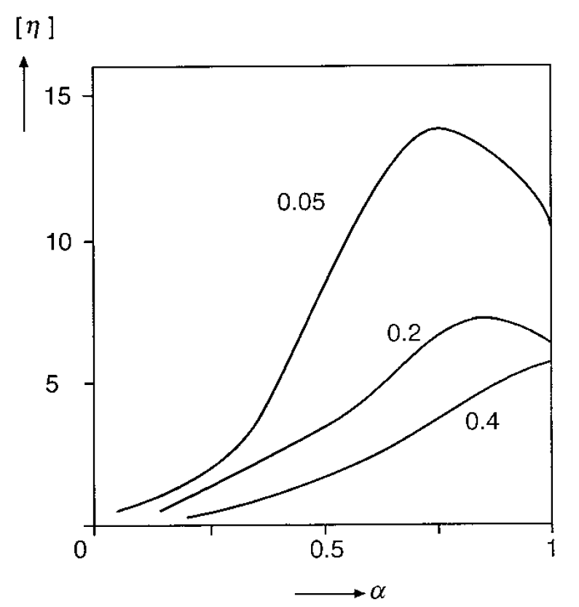
FIGURE 6.8. Intrinsic viscosity [η] (in dL/g) of aqueous solutions of partially esterified poly(methacrylic acid) as a function of degree of ionization α, at various concentrations of NaCl (mmolar, indicated).

Slaid 218
Conformation and viscosity
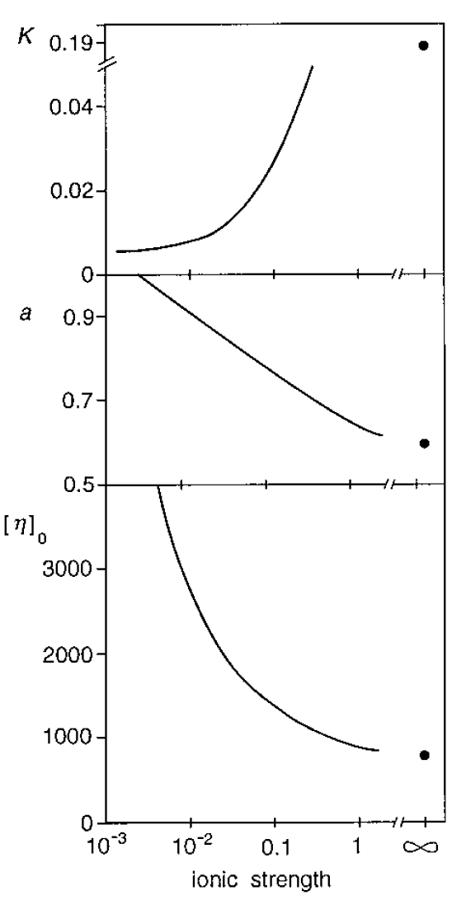
FIGURE 6.10 Viscosity parameters of solutions of carboxymethyl cellulose (Na salt) at various ionic strengths (molar). Mark–Houwink parameters K (ml/g) and a, and intrinsic viscosity [η]₀ for a molar mass of 10⁶ Da.

Slaid 219
The Donnan effect
The behavior of polyampholytes is in some respects different. At a pH far from its isoelectric point, a polyampholyte behaves roughly like a polyacid (high pH) or a polybase (low pH), but near the isoelectric pH the molecule has about equal numbers of positive and negative charges, and these attract each other, thereby causing a less expanded conformation. The effect of ionic strength on conformation will then be opposite to that of a simple polyelectrolyte: at lower ionic strength, the oppositely charged groups attract each other over a greater distance, leading to a more compact conformation. In other words, near the isoelectric pH, salt screens (diminishes) attraction, far away from this pH, it screens repulsion.
Slaid 220
The Donnan effect
Principles. The condition of electroneutrality implies that a polyelectrolyte molecule in solution is accompanied by counterions (small ions of opposite charge). Unless a strong external electrical potential is applied, the polyelectrolyte cannot be separated from its counterions. To be sure, the counterions freely diffuse toward and away from the polyelectrolyte molecule, but this only applies to individual ions. Each polyelectrolyte molecule is always accompanied by the same number of counterions, apart from statistical fluctuations around the average.
Slaid 221
The Donnan effect
The polyelectrolyte also affects the distribution of coions (small ions having a charge of the same sign). This is known as the Donnan effect, which may be illustrated by envisaging a system with two compartments that are separated by a semipermeable membrane. This membrane does not allow passage of polymers but is permeable for small ions.
Slaid 222
The Donnan effect
Polyelectrolyte Conformation. Up till here, we have considered two compartments separated by a semipermeable membrane. However, this is not essential to the existence of the Donnan effect. In Figure 6.7 (especially 6.7c) a polyelectrolyte molecule is depicted with a volume around it that contains an excess of counterions and that is depleted of coions. Actually, there is no sharp boundary surface involved, since the difference in concentration between counterions and coions gradually decreases with distance from the polyelectrolyte molecule. This is reflected in the gradual decrease in electric potential.
Slaid 223
The Donnan effect
Consequences. Due to the effect discussed in the previous paragraph, it is difficult to remove specific ions from a polyelectrolyte. Of course, the condition of electroneutrality implies that counterions must always be present, in proportion to the valence of the polymer. They can be exchanged by other ions, say Ca²⁺ by K⁺. Several ‘‘washings’’ are needed: at high ionic strength because the ion concentration is high, at low ionic strength because the volume containing counterions is large. This means that usually several washings of the polyelectrolyte with a salt solution of other composition would be needed. Another consequence of the Donnan effect is that it is difficult, if not impossible, to calculate ionic strength and composition of a solution of polyelectrolytes and salts, especially if the polyelectrolyte concentration is high. One should try to separate a portion of the salt solution from the mixture, without applying a substantial chemical potential difference. This can be done by ultrafiltration. The ultrafiltrate then contains, ideally, no polyelectrolyte, but all the salts. It can be chemically analyzed, and from the result the ionic composition can be calculated.
Slaid 224
More concentrated solutions
So far, we essentially considered interactions between one polymer molecule and the solvent. In this section, mutual interactions between polymer molecules come into play. The solutions remain fairly dilute, at most a small percentage of polymer.
Slaid 225
Gelation
In a polymer solution above the chain overlap concentration, entanglements occur (Fig. 6.11). If such a solution is deformed, part of the polymer chain sections between entanglements will become stretched, by which their conformational entropy decreases. Each chain section tends to regain its original conformation, which implies that the material behaves in an elastic manner. If the deformation is very slow, the entangled chains can slide along each other while continuously seeking a conformation of largest entropy, and the main result of the entanglements is an increase in viscosity. If the deformation is fast, considerable stretching of chain sections will occur, and the elastic effect will be strong. We now have a viscoelastic or memory fluid. If permanent cross-links are formed between entangled chains, a gel is obtained.
Slaid 226
Gelation
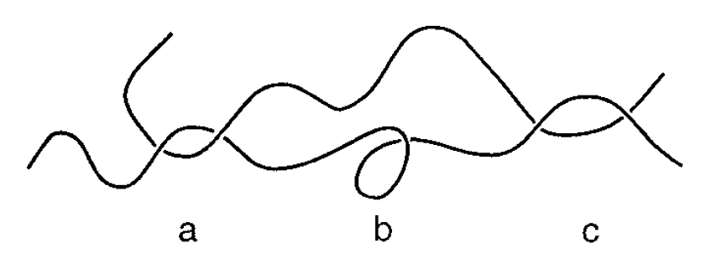
FIGURE 6.11 Entanglements. Depicted are two polymer chains. At (a) they form an entanglement, but not at (b) or (c).

Slaid 227
Phase separation
Polymers have, like all solid materials, a limited solubility, but if the concentration becomes greater than the solubility, separation into liquid phases occurs, not precipitation. The factors governing this are briefly discussed below.
Slaid 228
One solute
In Figure 6.12 shows a (hypothetical) result for the solubility of a homopolymer. It follows that the important variables are the excluded volume parameter β and the polymer–solvent molecular volume ratio q (proportional to the degree of polymerization n). It is also seen that the critical value of β for solubility is close to zero for high molar mass polymers.
Slaid 229
One solute
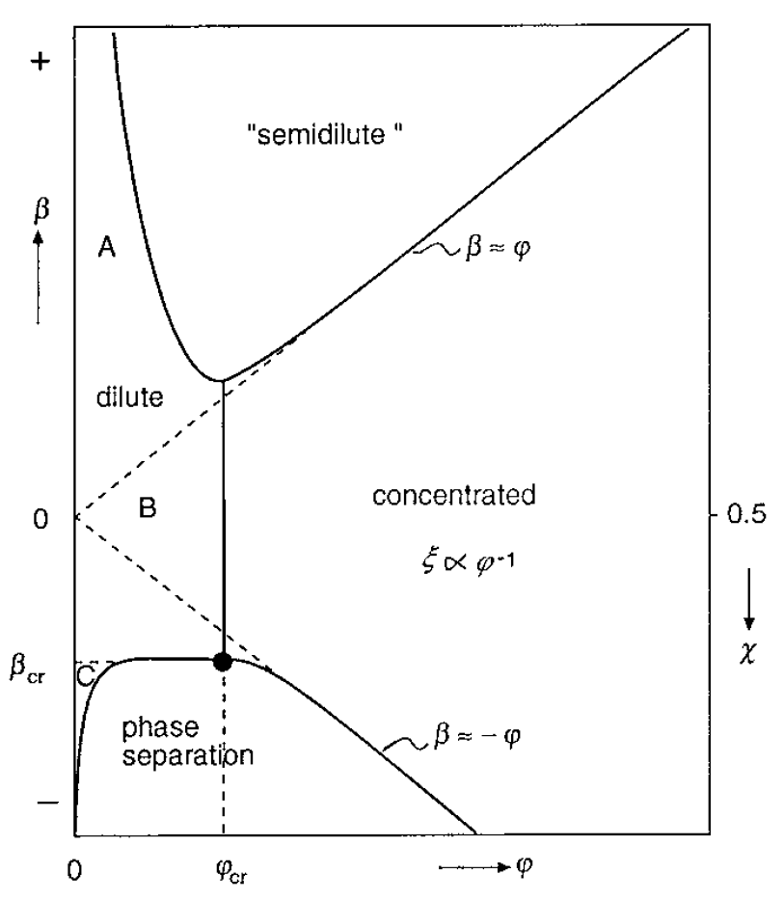
FIGURE 6.13 Idealized example of a part of a state diagram of polymer solutions. φ = net polymer volume fraction, β = excluded volume parameter, and ξ = correlation length. The critical point for phase separation is denoted by •

Slaid 230
One solute
To explain these observations, it may be remembered that the solubility of a substance is reached if its molar free energy is equal in the undissolved and the dissolved states. This can be expressed as - ΔG_{mix} = ΔH - TΔS = 0, and since entropy generally decreases when a solute goes from the dissolved to the undissolved state (ΔS < 0), ΔH must be negative (net attraction between solute molecules). For small spherical molecules, the enthalpy change precisely equals T times the mixing entropy at the solubility limit. For a polymer the situation is more complicated. The enthalpy term is directly related to β, and for β < 0, there is net attraction between polymer segments. The translational mixing entropy is very small; it goes to zero when q becomes very large, since the molar concentration then is negligible.
Slaid 231
One solute
Figure 6.13 shows two kinds of curves, ‘‘binodals’’ and one example of a ‘‘spinodal.’’ The binodal is the curve for ΔG_{mix} = 0, and below that curve the solution is supersaturated. This does not necessarily mean that phase separation occurs. Any thermal fluctuation in the system will lead to the formation of regions of different composition, which means phase separation. In the regime between the binodal and the spinodal curves, phase separation depends on a mechanism of nucleation and growth of a phase. The system is metastable, and it may take a long time before phase separation occurs, especially if the initial φ is high (very high viscosity).
Slaid 232
One solute
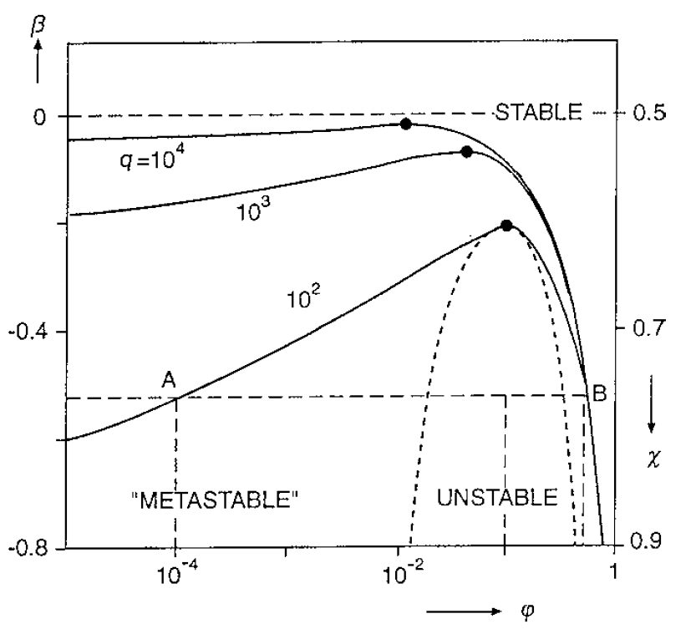
FIGURE 6.13 Solubility of a homopolymer according to the Flory–Huggins theory. Variables are the excluded volume parameter β (or the polymer–solvent interaction parameter χ), the net volume fraction of polymer φ, and the polymer-to-solvent molecular volume ratio q. Solid lines denote binodal, the broken line spinodal decomposition. Critical points for decomposition (phase separation) are denoted by •

Slaid 233
One solute
That even small changes in chemical structure can have an enormous effect on solubility is illustrated by the difference between amylose and cellulose. Both are 1 -> 4 linked linear chains of glucose, but as shown in Figure 6.14, amylose is a polymer of α-glucose and cellulose of β-glucose. This implies that amylose cannot form a straight chain, but that cellulose can. The latter molecules can become perfectly aligned, forming stacks that are almost true crystals, held together by Van der Waals attraction and hydrogen bonds. Accordingly, cellulose is completely insoluble in water. A similar structure cannot occur for amylose, which is to some extent soluble in water. Actually, even amylose can form a kind of microcrystalline regions, since the linear molecules can readily form regular helices, which then can become stacked. Dextrans are chemically almost identical to amylose, but have some branching of the polymer chain, which prevents this kind of stacking. Consequently, most dextrans are well soluble in water.
Slaid 234
One solute
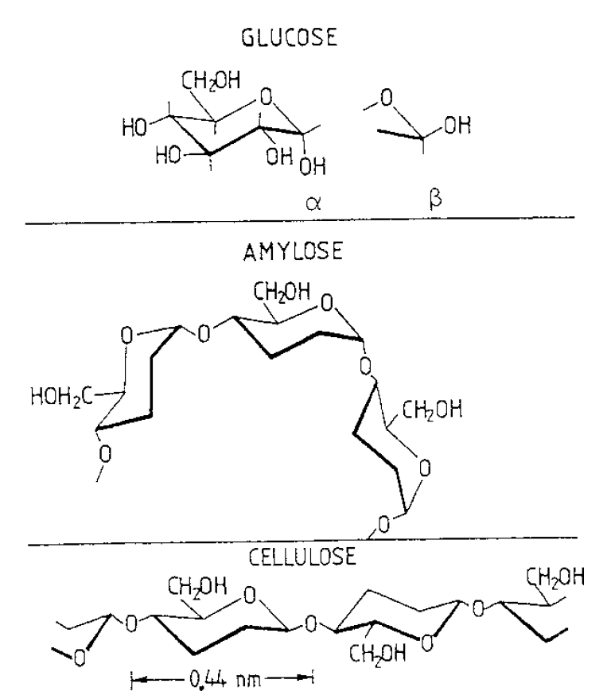
FIGURE 6.14 A glucose molecule in α- and β-configuration, and formation of 1–4 glycosidic polymers. The α-form produces amylose, the β-form cellulose.

Slaid 235
Polymer mixtures
If a solution contains two polymers at high concentration, phase separation generally occurs, especially if the polymers have a high molar mass. Phase separation may be of two kinds. The so-called mutual second virial coefficient B₂₃ now determines what will happen. If B₂₃ > 0, the two polymers tend to stay away from each other; they are preferentially surrounded by identical molecules (or by solvent). This may lead to a separation in a phase rich in polymer 2 (and poor in 3) and one rich in 3 (and poor in 2). Figure 6.15a gives a hypothetical phase diagram. The polymers show segregative phase separation and are said to be incompatible. If, on the other hand B₂₃ > 0, the two polymers attract each other. This leads to associative phase separation in a phase rich in both polymers, called a complex coacervate, and a phase depleted of polymer. A hypothetical phase diagram is in Figure 6.15b. Also for B₂₃ ≈ 0, complex coacervation will generally occur at high polymer concentration.
Slaid 236
Polymer mixtures
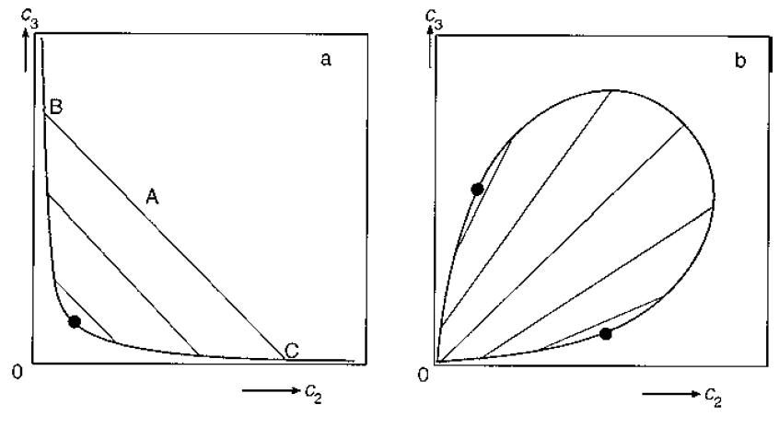
FIGURE 6.15 Idealized cases of phase separation in aqueous mixtures of two polymers, concentrations c₂ and c₃. (a) Segregative phase separation or incompatibility. (b) Associative phase separation or complex coacervation. The heavy lines denote the binodal (solubility limit), the thin ones are tie lines. The dots indicate critical points.

Slaid 237
Polymer mixtures
Incompatibility. For two polymers that do not have side groups causing mutual attraction, incompatibility mostly occurs, and the concentration needed for phase separation is smaller as the molar mass of the polymers is higher. A good example is the phase separation occurring between amylose and amylopectine in fairly dilute (gelatinized) starch solutions. The solvent quality also affects phase separation; for instance, incompatibility is generally less at large sugar concentrations.
Figure 6.15a gives a hypothetical example. The tie lines indicate how the separation will be. A mixture of composition A will separate into phases of composition B and C; the ratio of the volumes of the solutions of composition A to B is as the ratio of the distances AC/AB. The longer the tie line, the stronger the incompatibility. The dot gives the critical point, the composition at which the tie line vanishes. The heavy line giving the solubility is a binodal. It is mostly not possible to calculate the phase diagram from the properties of the two polymers.
Slaid 238
Polymer mixtures
An important case of incompatibility is formed by mixtures of proteins and neutral polysaccharides. Examples are in Figure 6.16. It is seen that the phase diagrams may be very asymmetric, the protein concentrations needed for phase separation being much larger than the polysaccharide concentration. The asymmetry is stronger for globular proteins than for more or less unfolded molecules like gelatin or casein. Proteins are polyelectrolytes, and if the pH is not close to the isoelectric point and the ionic strength is low, phase separation does not occur. This is due to the Donnan effect.
Slaid 239
Polymer mixtures
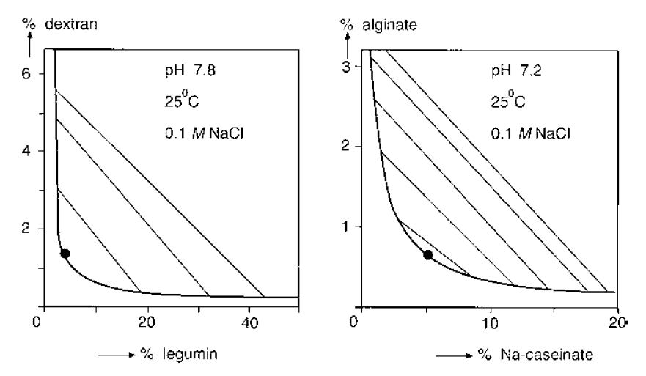
FIGURE 6.16 Examples of incompatibility of proteins and polysaccharides.

Slaid 240
Starch
In this section a particular food polymer will be discussed in some detail. Starch is a very important nutrient, providing roughly half of the edible energy used by mankind. Moreover, large quantities are isolated and used as functional ingredients, starch being the most important thickening agent applied in manufacture and preparation of food.
In its native form, starch occurs as a very concentrated polymer mass, and discussion of its properties may provide some understanding of such systems in general. On the other hand, native starch granules provide an example of a highly specific structure. Another example of a concentrated system of polymers is the cell wall of plants. A cell wall contains several different polysaccharides, and its structure is even far more intricate and specific than that of starch. It will not be discussed here.
Slaid 241
Description
Starch is a polymer of α-D-glucose. It occurs in most higher plants species, in the form of roughly spherical granules, ranging from 2 to 100 μm in diameter. Starch granules often are surrounded by large quantities of water, but they do not dissolve, in accordance with their physiological function. Starch consists of two components. The one is amylose, a linear polymer of 1 -> 4 linked anhydroglucose monomers. Amylose in solution readily forms helices of a pitch of about 6 monomers and a diameter of about 1 nm.
Slaid 242
Description
Amylopectin, the main component, has n = 10⁵–10⁸, but it should be realized that the size of very large polymer molecules (n > 10⁶) is always uncertain, since the solubilization procedure needed for determination readily causes breaking of very long molecular chains. Amylopectin is highly branched, 4–5% of the monomers also having a 1 - 6 linkage. Its structure is still a matter of some debate; a fairly well-established model is in Figure 6.17.
Slaid 243
Description
FIGURE 6.17 Schematic illustration of the structure of a small part of an amylopectin molecule. The lines denote stretches of linear 1 -> 4 linked anhydroglucose units, the branching points are 1 -> 6 linkages. The molecule grows from left to right.

Slaid 244
Description
Whether a material is crystalline or not can be established by x-ray diffraction. X-rays have a very small wavelength, of the order of 0.1 nm, which implies that individual atoms may cause scattering. If the atoms (or small molecules) occur at regular distances, sharp diffraction maxima occur, and the crystal structure can be derived from the diffraction pattern. Native starch indeed shows a distinct diffraction pattern. It can be concluded from these and other data that 20 to 45% of the starch is in a crystalline form. Since this concerns almost exclusively amylopectin, this material would be crystalline for 30 to 50%. A starch granule has crystalline regions, the remainder being amorphous. The crystalline regions are small (order of 10 nm) and are called (micro) crystallites. The starch structure is similar to that of concentrated synthetic polymers below a given temperature. Above this temperature we have a polymer melt, and upon cooling, microcrystallites are formed, in which parts of the long molecules have a parallel orientation, as illustrated in Figure 6.18.
Slaid 245
Description
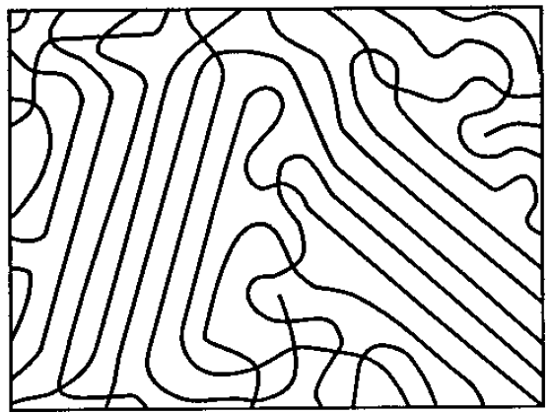
FIGURE 6.18 Highly schematic picture of microcrystalline regions in a mass of a linear polymer at very high concentration (little or no solvent). The reader should remember that a two-dimensional picture cannot give a fully realistic representation of a three-dimensional structure in a case like this.

Slaid 246
Description
The crystalline material is in highly curved strips that form large helices: see Figure 6.18. In potato starch such a helix has an outer diameter of 18 nm and an inner diameter of 8 nm; the strips are 5 nm wide and have a thickness a ≈ 4 nm. The pitch of the helices, which equals b, is about 10 nm. In the cavity of each helix and in the space between the strips, amylose and noncrystalline amylopectin is found; presumably, the amylose is predominantly in the cavity. Native starch granules are very stiff or rigid particles. They have crystalline regions, which will contain about half of the water present, and the remainder of the starch and water forms a glass.
Slaid 247
Description
FIGURE 6.18 Schematic model of the crystal morphology in potato starch. At left, the building blocks of double molecular helices are shown. At right, shape and stacking of the large helices is depicted. The large helices are packed in a tetragonal array, and neighboring helices partly interlock as they are shifted by half the pitch with respect to each other.
Slaid 248
Gelatinization
Starch granules can be isolated from various plant materials, washed and air-dried to obtain a powder. When the powder is put in cold water, the granules take up a little water, but that is about all that happens. Native starch is physically and chemically inert. To change it into a functional product, it is generally heated in an excess of water. This causes what is called gelatinization, which involves a number of changes, including water uptake.
The most conspicuous change may be melting of the crystallites. When a suspension of starch granules in water is heated, their birefringence disappears. Examples are in Figure 6.19a; in each separate granule, the temperature range over which birefringence disappears is significantly more narrow. The melting is also observed with x-ray diffraction and calorimetry. The melting enthalpy ranges from 12 to 22 J g⁻¹ dry starch, 40–50 J g⁻¹ crystalline material. This is much less than the melting enthalpy of crystalline sugars, which is generally of the order of 400 J g⁻¹. This indicates, again, that the degree of ordering in starch crystallites is far less perfect than in a sugar crystal.
Slaid 249
Gelatinization
FIGURE 6.19 Gelatinization of starch from wheat (- - -), potato (——), and maize (corn) (……). (a) Percentage of starch granules showing birefringence as a function of temperature T during heating up. (b) Melting temperature Tm as a function of water content (% w/w). (c) Water uptake in g per g dry starch during heating in an excess of water as a function of temperature.

Slaid 250
Gelatinization
There is an important complication. Data as presented in Figure 6.19a have been obtained by slow heating of starch granules in an excess of water. During this process, the granules can take up water, which they tend to do with increasing temperature. During melting, the water content will be close to the equilibrium content at that temperature, which is the plateau value obtained at water contents above 50 or 60% (Figure 6.19b). If starch–water mixtures of lower water content (about 35–60%) are heated, two melting temperatures may be observed, the plateau value and a higher one. Some results obtained by differential scanning calorimetry are shown in Figure 6.20. The explanation is presumably that part of the crystallites have been in a position to take up sufficient water to melt at a low temperature, whereby little water is left to be taken up by the remaining crystallites. It is also seen in Figure 6.20 that the melting occurs over a wider temperature range at low water content, indicating that the crystallites are less perfect.
Slaid 251
Gelatinization
FIGURE 6.20 Differential scanning calorimetry (DSC) as applied to potato starch – water mixtures; % water (w/w) indicated near the curves. In DSC, the differential amount of heat (or more precisely, enthalpy, H) needed to increase the temperature (dH/dT) is registered as a function of temperature (T), and any melting (or similar transition) causes a peak in the heat uptake. The peak area is proportional to the melting enthalpy. In the figure, the specific heat capacity of the material has been subtracted, providing horizontal base lines.
Slaid 252
Retrogradation
When keeping a gelatinized starch solution or paste at ambient temperature, physical changes are observed, which are generally lumped under the name retrogradation. These changes can be of various types: a solution becoming turbid, precipitation of part of the starch, gel formation, or a once formed gel becoming stiffer and more brittle. It greatly depends on conditions, especially starch/water ratio and temperature, what change will occur. These changes have the same origin: ordering of molecules or parts of molecules occurs, and such a change can be quantified by calorimetry. Upon heating, energy is consumed in disordering the structure over a certain fairly narrow temperature range, and this ΔH may be considered as a melting enthalpy. ΔH increases with time, Figure 6.21.
Slaid 253
Retrogradation
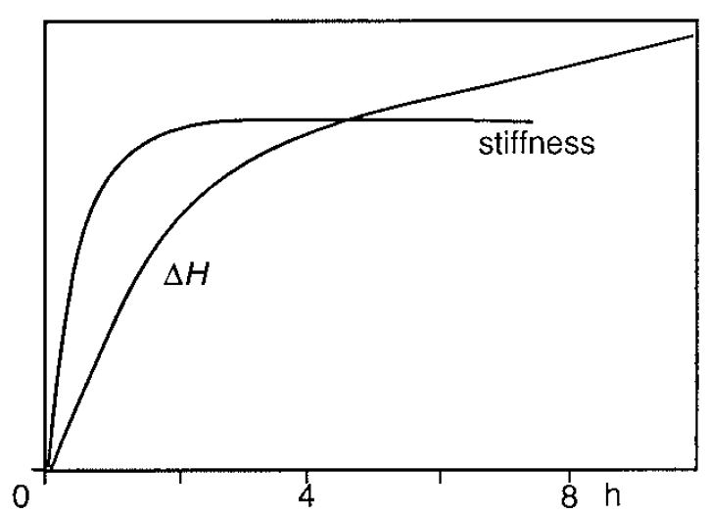
FIGURE 6.21 Retrogradation of a 7% amylose solution. The solution was cooled from 90 to 26 ºC and then kept for the time indicated. Stiffness (as shear modulus) and melting enthalpy (ΔH) were monitored; arbitrary scales.

Slaid 254
Retrogradation
Dilute Systems. We will first consider what will happen in an amylose solution. Actually, amylose is very poorly soluble in water at room temperature. It readily forms helices in water, of which at least part are double helices. These helices tend to align, forming parallel stacks that may be considered microcrystallites. X-ray diffraction shows the chain packing to be similar to that of B type crystallites in native starch. As much as 70% of the amylose may become crystalline. It depends on amylose concentration what the consequences will be. An amylose solution at 65 ºC has a chain overlap concentration c* of about 1.5%. If a more dilute solution is cooled, precipitation of amylose will occur.
Slaid 255
Retrogradation
In more concentrated amylose solutions, a gel will be formed. The gel stiffens during keeping, although the correlation between the increase in ΔH and the increase in stiffness is far from perfect: Figure 6.21. Much the same happens in a gelatinized starch solution. This implies that the amount of water available for amylose is reduced, and at starch concentrations of 2–4% (depending on starch type), the chain overlap concentration for amylose will be reached. Above this concentration, cooling will lead to the formation of an amylose gel, enclosing swollen granules. Gelatinized starch systems show retrogradation, as can be measured by calorimetry. The change in ΔH proceeds for a far longer time than in an amylose gel—compare Figures 6.21 and 6.22 — suggesting that also amylopectine exhibits retrogradation. Starch crystallites are observed. The crystallites are about 10 nm in size, and their structure is to some extent comparable to the B type crystallites in native starch.
Slaid 256
Retrogradation
Reversibility. The supermolecular structure present in native starch granules, like the one depicted in Figure 6.18, does not reappear upon cooling after the starch has been gelatinized. This is borne out by the observation that the melting enthalpies involved, about 2 to 10 J per g of starch, are much smaller than those for native starch (12–22 J g⁻¹). The crystallinity obtained after gelatinization and cooling is, reversible: it disappears at high temperature—which is applied to alleviate the staling of bread—and reforms, albeit slowly, after cooling.
Slaid 257
Retrogradation
The rate of retrogradation strongly depends on temperature: see Figure 6.22a. At a temperature that is further below the melting point, the ‘‘supersaturation’’ is greater. Although supersaturation is not a well-defined concept in polymer systems, it is clear that the driving force for crystallization is greater. For a starch/water ratio of unity, the melting temperature is about 75 ºC. The staling of bread, which is primarily due to retrogradation, will thus proceed faster at 5 ºC (refrigerator) than at 25 ºC (ambient). In a freezer staling rate is very much slower.
Quite in general, great care should be taken in directly relating retrogradation, for instance as measured by an increase of melting enthalpy, to physical changes occurring. Mechanical properties, whether evaluated sensorily or by rheological measurement, mostly depend, in a very involved manner.
Slaid 258
Retrogradation
FIGURE 6.22 Retrogradation of gelatinized starch. Effects of temperature (a), starch concentration (b), and starch type (c) on melting enthalpy (ΔH). Starch type and concentration, and storage temperature and time indicated.

Slaid 259
Recapitulation
Polymers are macromolecules that consist of long chains, for the most part linear, of identical or similar units called monomers. They derive special properties from their molecular structure, of which the possibility of assuming very many conformations is the most striking one.
Conformation. In solution, the average conformation tends to be much expanded, causing the molecules to occupy relatively large volumes. For simple polymers, theory is available to predict properties. The most important variables are molecular mass or size, the stiffness of the chain, and the solvent quality, for instance as expressed in the solvent exclusion parameter b. The greater these parameters, the more expanded is the polymer chain in solution. This implies that the relative viscosity of a polymer solution (relative to that of the solvent) can be very high and increases with increasing molar mass, for the same mass concentration. The viscosity is an apparent one, since it strongly decreases with increasing strain rate.
Slaid 260
Recapitulation
Most natural polymers are greatly heterogeneous, having specific structures, and polymer theory can only be used in a broad, semiquantitative sense. For most polysaccharides and for some proteins (gelatin, casein) the theory nevertheless is useful. For most polysaccharides, the solvent quality of water is rather poor, but many of them nevertheless have a quite expanded conformation, because they are relatively stiff molecules (starch being an exception). For globular proteins other theory is needed. Proteins and several of the polysaccharides are polyelectrolytes.
Polyelectrolytes, polymers containing charged groups (negative or positive or both), show some specific relations. Due to the repulsive effect of the charges if of the same sign, the polymer chain is relatively stiff. This implies a very expanded conformation, whereby polyelectrolytes produce very high viscosities. This greatly depends on the charge density, which in turn may depend on pH, and on ionic strength. At a high ionic strength, shielding by counterions causes the distance over which the repulsive effect is sensed to be far smaller, leading to a less expanded conformation.
Slaid 261
Recapitulation
Polyelectrolytes also show the Donnan effect. Charged macromolecules always are accompanied by counterions, small ions of opposite charge, in order to make the solution electroneutral. In the presence of salt, also the distribution of coions (small ions of the same charge) is affected, and relatively more so for a lower salt concentration. These phenomena are most readily observed when the polymer solution is contained within a semipermeable membrane, where the osmotic pressure is greatly affected by the Donnan effect.
Slaid 262
Recapitulation
Concentrated polymer solutions show strong nonideality. This is, for instance, observed in the osmotic pressure being very much higher than would follow from the molar concentration. The main variables are the b value and the volume fraction of polymer, and for polyelectrolytes also charge and ionic strength.
The solubility of neutral polymers depends primarily on molecular size and b. For long polymers, a b value just below zero leads already to very poor solubility. Generally, the polymer does not precipitate, but phase separation occurs into a highly concentrated solution (a coacervate) and a very dilute one. Quite in general, a number of ‘‘regimes’’ can be distinguished for polymer–solvent mixtures, depending on b value and concentration. Besides the dilute, there are semidilute and concentrated regimes.
Slaid 263
Recapitulation
Phase separation in mixtures of polymers especially occurs at high concentrations and for large molar mass. The separation can be of two kinds. If the two polymers show mutual affinity, associative phase separation or complex coacervation occurs, a separation into a solution high in both polymers (a complex coacervate) and a very dilute solution.
Slaid 264
Recapitulation
Starch. Starch is a polyglucan mixture, containing the linear amylose (about 25%) and the very large, heavily branched amylopectin. Native starch granules are virtually insoluble in water. Starch can be gelatinized by heating in excess water, which implies melting of the crystallites and extensive swelling; amylose and amylopectin become phase separated.
On cooling and keeping such systems, retrogradation occurs, which originates from partial crystallization of the starch and can cause physical changes like precipitation, gel formation, or gel stiffening (staling of bread). Amylose shows much more and quicker crystallization than does amylopectin. The original supermolecular structure is not regained. Retrogradation itself is reversible: it can be undone by heating and starts again upon recooling.
7 Proteins
Slaid 265
Proteins are polymers, more specifically polyelectrolytes. Chemical reactivity is at least as important as physical chemistry for protein properties in general and for many problems related to proteins in foods. Despite these qualifications, some important physicochemical rules can be derived, and this is the subject of this chapter. Proteins play many roles in foods, the most important one being nutritional. Another one is flavor binding, and so is flavor formation during processing and storage.
Two main groups of physicochemical functional properties can be distinguished:
Their role in formation and stabilizing of emulsions and foams, and in stabilizing suspensions. These functions depend on the propensity of proteins to adsorb at most interfaces. The formation of more or less ordered macroscopic structures, especially gels.
Slaid 266
Description
The chemistry of proteins is covered in most texts on food chemistry and, of course, on biochemistry. For the convenience of the reader, a brief review is given in this section.
Slaid 267
Amino Acids
Proteins are linear polymers of α-L amino acids linked by the formation of peptide bonds:
The degree of polymerization n ranges from 50 to several 100. R denotes a side group; basically 20 different ones exist in nature and are given in Table 7.1, together with some properties. According to the side group, they can be categorized as
This leaves Gly, which has a mere = H as a side group, and proline, which is not a primary amino acid.
Slaid 268
Primary Structure
The composition of proteins is variable. The percentage of a certain amino acid may readily vary by a factor of 10 among a number of proteins. Some amino acids do not occur in some proteins, notably Cys. The composition largely determines the nutritional quality and to a considerable extent the chemical reactivity of a protein. Most other properties depend on the primary structure, the sequence of amino acid residues, because the primary structure determines the higher structures, which in turn determine properties like conformational stability and solubility.
Slaid 269
Primary Structure
Figure 7.1 shows the configuration and dimensions of a peptide unit. The peptide bond has some special features, since the electron distribution over the O, C, and N of the bond is intermediate between that of the two structures.
This causes the peptide bond to be flat: rotation about the CO = NH axis is not possible. The bond is in the trans configuration, which is far more stable than the cis one. The peptide bond also has a significant dipole moment of 3.5 Debye units; this implies that it tends to be hydrated. The H of the = NH group can act as a donor, the - O as a hydrogen acceptor in forming hydrogen bonds.
Despite the flexibility of the peptide chain, most proteins do not assume random conformations in solution. Contrariwise, the conformation mostly is highly ordered, and some higher levels of structural organization are distinguished, secondary, tertiary, and quaternary structures.
Slaid 270
Secondary Structure
This concerns fairly regular arrangements of adjacent amino acid residues. Several types exist, but the most common ones are α-helices and β-strands. In the right-handed α-helix, the peptide chain forms a helix (like a cork screw) with the side groups on the outside, where each turn takes 3.6 residues (18 residues making 5 turns); the translation of the helix is 0.15 nm per residues. The helical conformation is stabilized by H-bonds, between the O of peptide bond i and the NH of peptide bond i + 4.
Slaid 271
Secondary Structure
The formation of an α-helix is a clear example of a cooperative transition. Although each of the bonds involved is weak, at most a few times k_{B}T, the collective bond energy of the whole structure may be sufficient to stabilize it. This is comparable to the formation of a molecular crystal from a solution, where bond energies often are 1 or 2 k_{B}T per molecule. Doublets of these molecules would be very short-lived, but a crystal of sufficient size is stable, mainly because each molecule now is involved in a number of bonds, six.
Slaid 272
Secondary Structure
In the β-strand the peptide chain is almost fully extended, although slightly twisted (the translation equals about 0.34nm per residue rather than 0.36nm when stretched). A single β-strand is unstable, but several of them can be aligned to form β-sheets, which can either be parallel or, more commonly, antiparallel. Note that the strands in one sheet need not be from nearby regions in the primary structure. In the sheets, several H-bonds are formed, again stabilizing the conformation by the cooperativity principle. The antiparallel β-sheet seems to be somewhat more stable than the parallel one. A single β-strand can also be stabilized by other structures, by alignment with an α-helix. The presence and abundance of the various secondary structure elements in a protein in solution can in principle be determined by spectroscopic techniques.
Slaid 273
Tertiary Structure
By means of x-ray diffraction of crystalline protein and of NMR spectroscopy of the molecules in solution, the complete three-dimensional structure of a protein can be established. Many proteins show an intricate, tightly folded structure, which includes secondary structure elements. Generally, hydrophilic amino acid side groups are predominantly at the surface, and hydrophobic ones in the core of the structure. The role of water is essential and it may be stated that polypeptide chain + water = protein.
Slaid 274
Tertiary Structure
It depends on the proportions of hydrophobic and hydrophilic residues, as well as on the length of the peptide chain, what the overall structure can be. This is illustrated in Figure 7.2. Assuming a hydrophilic outer layer of one peptide chain, about 0.5 nm in thickness, a larger protein molecule can accommodate a greater proportion of hydrophobic residues in its core. A method of excluding hydrophilic residues from the core, if they make up a high proportion of the residues, is the formation of an elongated shape (Figure 7.2c). On the basis of the outer shape, proteins can be classified into three groups: globular, fibrous, and disordered. In a globular protein the peptide chain is tightly folded into a roughly spherical shape. The secondary structures (α-helices and β-sheets) roughly span the diameter, and they are often linked by reverse turns.
Slaid 275
Tertiary Structure
FIGURE 7.2 Illustration of the effect of size and shape on the proportion taken up by the hydrophobic core (hatched) of a protein, taking the hydrophilic outer layer to be of constant thickness (0.5 nm). In (a) the proportion is 0.20, in (b) 0.50, and in (c) 0.12. In (d) molecules with a hydrophobic patch on the surface are illustrated, which tend to associate into a quaternary structure.
Slaid 276
Conformational stability and denaturation
In this section only globular proteins will be considered. Their tightly folded native conformation (designated N) may change into a more or less unfolded conformation (U). This change may be called denaturation, but the conformation change may be reversible, and several authors reserve the word denaturation for irreversible unfolding, or for the loss of a specific activity.
The loss of the native conformation generally has several important consequences:
1. Loss of biological activity, notably enzyme activity, because binding of molecules or groups is always involved, which depends in a precise manner on the conformation of at least part of the protein molecule.
2. Decreased solubility, because more hydrophobic groups become exposed to water. Also the surface activity may be altered.
Slaid 277
Conformational stability and denaturation
3. Increased reactivity with other compounds or among groups on the protein, because reactive side groups become exposed. In general, most of the charged side groups are already exposed in the native state, such as the e-amino groups of lysine, which are involved in the Maillard reaction.
4. Increased susceptibility to attack by proteolytic enzymes, because peptide bonds inside a tightly-coiled protein molecule are not accessible to these enzymes.
5. Increased hydrodynamic size and its consequences.
Slaid 278
Thermodynamic considerations
We will first consider fairly ideal cases, implying globular protein molecules containing one domain, and conditions that do not cause appreciable changes other than unfolding. Figure 7.3 gives examples of the change from the native to the unfolded conformation, induced in various ways. The change can be monitored from the change in hydrodynamic properties (viscosity) or in spectroscopic properties (optical rotation) and expressed as the fraction changed; it is generally observed that various methods give identical results. It is also observed that the changes are reversible and occur quickly. This all means a dynamic equilibrium of two reactions: unfolding, N->U, reaction constant k_{U}; and (re)folding, N->D, reaction constant k_{F}.
Eq. (7.1)
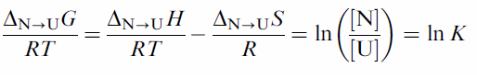
Slaid 279
Thermodynamic considerations
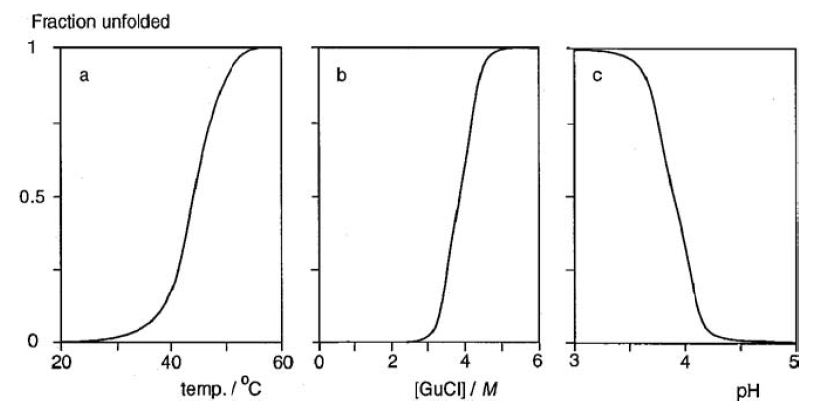
FIGURE 7.3 Transition of proteins from the native to the unfolded state. (a) Ribonuclease at pH 3.15, as a function of temperature. (b) Lysozyme as a function of guanidinium chloride concentration. (c) Nuclease A as a function of pH.

Slaid 280
Thermodynamic considerations
where K = k_{F}/k_{U} is the equilibrium constant. An example of ΔG as a function of temperature is shown in Figure 7.4. It is seen that there are two temperatures at which ΔG = 0, implying [N] = [U]; these are called the denaturation temperatures. ΔG may be considered a measure of the conformational stability, and it is seen to be fairly small, in this case about 25 kJ mol⁻¹ at its maximum. Equation (7.1) then yields lnK ≈ 10. For ΔG = 10 kJ mol⁻¹, it would amount to about 2%.
Slaid 281
Thermodynamic considerations
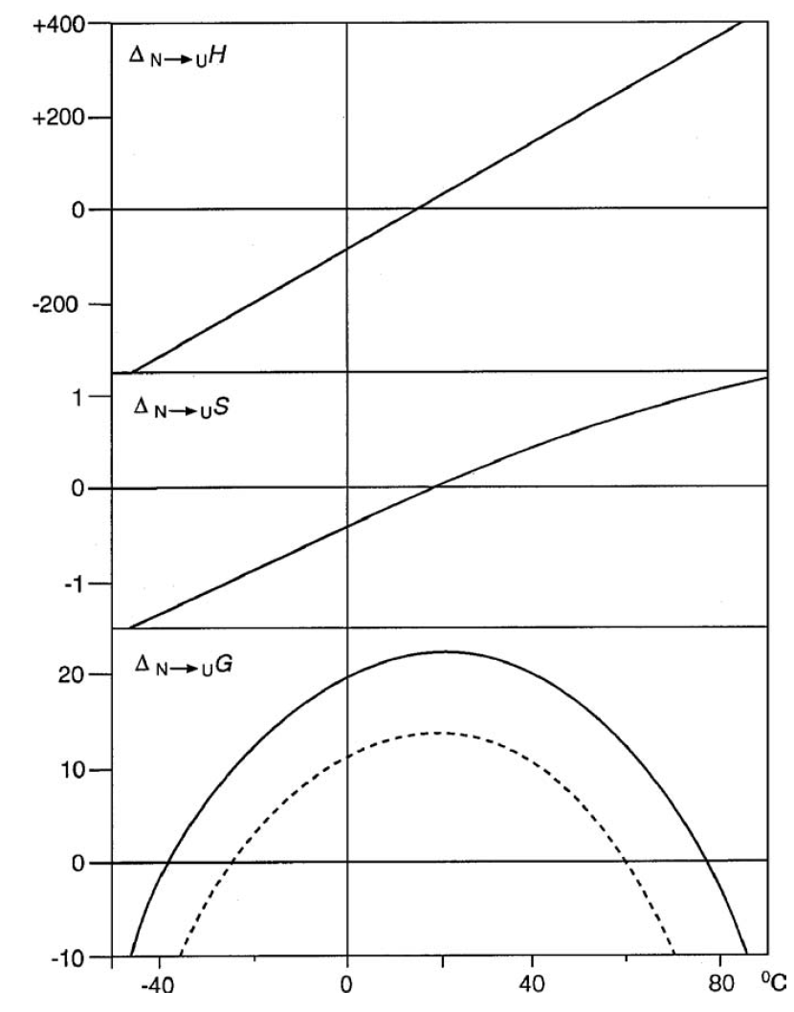
FIGURE 7.4 Approximate example of the stability of a fairly small globular protein as a function of temperature. Change from the native to the unfolded state in enthalpy (ΔH in kJ mol⁻¹), entropy (ΔS in kJ mol⁻¹K⁻¹) and in Gibbs energy (ΔG in kJ mol⁻¹). The broken line (only for ΔG) applies to a pH farther away from the isoelectric point. The temperatures at which ΔG = 0 are called denaturation temperatures.
Slaid 282
Thermodynamic considerations
According to Eq. (7.1), a van’t Hoff plot, of R ln K versus 1/T, would yield from its slope ΔH, and from its intercept ΔS. There is a difficulty, since ΔH and ΔS generally depend on temperature in the case of protein unfolding, as illustrated in Figure 7.4. ΔH can also be determined by DSC (differential scanning calorimetry). The example given in Figure 7.5a shows a sharp peak in heat uptake, almost like a melting transition. When results from a van’t Hoff plot and DSC can be compared, good agreement is mostly observed for singledomain proteins (within 5% or so). From such results and the observed denaturation temperatures, and with some interpolation, values for ΔH and ΔS can be derived as a function of temperature, to obtain curves like those in Figure 7.4.
Slaid 283
Thermodynamic considerations
Figure 7.3 shows that the transition N -> U occurs over a very small range of the variable applied. This is typical for a cooperative transition, where several bonds are broken (or formed) simultaneously. In other words, the molecule would either be in the native or in a (nearly) fully unfolded state. Also the narrowness of the peaks on DSC plots (Figure 7.5) points to a cooperative transition. For the unfolding at high temperature, the abruptness directly follows from the strong temperature dependence of ΔG, which is largely due to ΔH being very large.
Slaid 284
Thermodynamic considerations
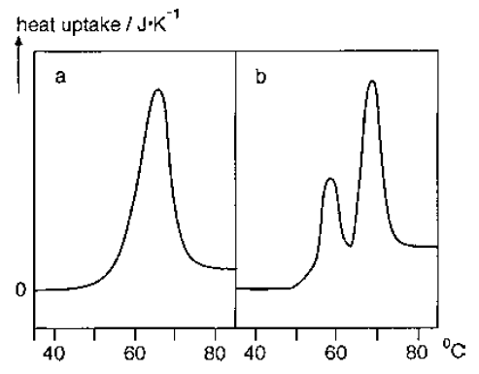
FIGURE 7.5 DSC diagrams (increasing temperature) showing denaturation of proteins; initial heat uptake (‘‘base line’’) has been shifted to zero. (a) Lysozyme (pH 2.5). (b) Transferrin.

Slaid 285
Thermodynamic considerations
Several workers have tried to calculate the various contributions to the free energy involved in stabilizing the native conformation. We will now consider what terms are involved in the hypothetical stability equation and how large they may be for a small molecule or domain of about 100 residues. The first four terms are negative, hence promote the native conformation:
- Hydrogen bonds.
It should be realized that all of the groups potentially involved can also make H-bonds with water, and the latter mostly are stronger. This would mean that no internal H-bonds are formed. The predominantly apolar interior of a globular protein molecule may have a dielectric constant as low as 5, as compared to 80 in water.
Slaid 286
Thermodynamic considerations
2. Hydrophobic interactions. It has long been accepted that these provide a major stabilizing force, but at present many workers assume them to play a fairly small, although not a negligible, part. Since changes in enthalpy as well as entropy are involved, and since it is difficult to separate hydrophobic interaction from other forces, the author feels that a definite answer has not yet been given.
Slaid 287
Thermodynamic considerations
3. Van der Waals attraction. Of course, this also occurs between groups and water molecules, but the net effect is likely to be stabilizing. Van der Waals attraction cannot be fully separated from hydrophobic interaction. Moreover, some dipole–dipole interaction may be involved. It concerns an enthalpic contribution.
4. Salt bridges. This concerns only a few bonds; they may on average contribute by an amount of about - 20 kJ mol⁻¹ to ΔH.
Slaid 288
Thermodynamic considerations
5.Conformational entropy. In the unfolded state each peptide unit would contribute about 4 degrees of freedom (O), but many side groups would also have more conformational freedom. Assuming the increase in O to be 6 to 8 per residue, this would lead to a ΔS = RlnΩ¹⁰⁰ between 1500 and 1700 J mol⁻¹K⁻¹.
6. Hydration of polar side groups and peptide bonds. This must provide a large term in ΔG, including enthalpic and entropic contributions. It cannot be separated from the interactions mentioned in items 1 and 2.
Slaid 289
Thermodynamic considerations
7. Bending and stretching of covalent bonds. Although such deviations from the state of lowest energy may be minor, it is inconceivable that all the bonds in a tightly folded protein molecule would remain completely undistorted. Since about a thousand bonds are present, the contribution to ΔH may be significant.
8. Mutual repulsion of charged groups on the surface. This is an enthalpic term, that may be appreciable if the pH is far away from the isoelectric point.
Slaid 290
Thermodynamic considerations
The stability is due to a very subtle balance. Small changes in the primary structure may leave the conformation virtually the same, but it is also possible that replacement of only one residue by another one leads to an unstable molecule. Globular proteins evolved to be stable under physiological conditions, and stability under other conditions may not be needed. Although more stable conformations would in principle be possible, it may be that such conformations cannot be reached because of the intricacies of the folding process. It is by no means certain that the native conformation of a protein is the one of lowest free energy possible; the conformation may just represent a local minimum.
Slaid 291
Thermodynamic considerations
There are some mechanisms that enhance conformational stability: formation of – S – S – bridges between Cys residues adjacent in the folded state; these would anyway prevent complete unfolding. Other posttranslational modifications, notably glycosylation of specific residues, presumably after folding of the peptide chain. Formation of structures on a larger scale than that of a domain. Binding of ligands mostly alters the conformation somewhat, but then generally stabilizes it.
Slaid 292
Thermodynamic considerations
Complications. The discussion given above is to some extent an oversimplification. The following complications may arise.
1. The protein consists of more than one domain and these can unfold independently of each other. A fairly simple example is in Figure 7.5b. In other cases, deconvolution of the DSC diagram may be less straightforward. In some proteins, two (or three) domains are so closely similar that they unfold (almost) simultaneously. In such a case, ΔH obtained from a DSC diagram would be about twice (or three times) the value derived from a van’t Hoff plot.
2. There may be intermediate stages between the native and the unfolded state. In some cases a transient and not very stable ‘‘prefolded state’’ is observed, which appears to be similar to that mentioned next.
3. Some proteins exhibit at some pH values, for instance, about three units below the isoelectric pH, an intermediate conformation designated ‘‘molten globule state’’.
Slaid 293
Thermodynamic considerations
Such a state appears to be characterized by being not fixed, the molecules showing a population of states;
A hydrodynamic size somewhat larger than in the native state, but far smaller than in the unfolded conformation;
A large amount of secondary structure, but any ternary structure appears to be fluctuating and many residues are in contact with water;
A conformational entropy that is almost the same as that in the unfolded state, which seems difficult to reconcile with the abundance of secondary structure;
Transitions with the native state are slow and cooperative, with the unfolded state fast and noncooperative. Characteristics and significance of the molten globule state are still a matter of debate.
Slaid 294
Thermodynamic considerations
4. In many cases, refolding to the native state is incomplete or not precise. For many proteins, the peptide chain produced in the cell assumes its native folded state with the aid of specific helper proteins, called chaperonins. These are missing when a protein has been denatured and is allowed to refold in practice. Several proteins refold into a near-to-native state, which then may or may not slowly change into the native conformation. In conclusion, proteins are individuals. Although the same factors determine the conformation and the conformational stability, the net result is highly variable. Moreover, they react in a different way on differences in environmental conditions, which is further illustrated below.
Slaid 295
Recapitulation
Description. Proteins are polyelectrolytes, but they occur in such a bewildering variety of composition, structure, and properties that physicochemical polymer theory is of limited use for understanding them. The properties ultimately depend on the primary structure of a protein, what amino acid residues occur and in what sequence. The 20 amino acid building blocks differ in several respects. The most important general properties may be their charge, which determines the charge of the protein as a function of pH; and the hydrophobicity, which is of prime importance for conformation and solubility.
Slaid 296
Recapitulation
Description. The conformation is the total three-dimensional folding of the peptide chain. Some levels of structure can be distinguished. The secondary structure involves fairly regular orderings of amino acid residues, especially the α-helix and the β-sheet. These are strongly hydrogen bonded, primarily via = O and NH of the peptide bonds. The tertiary structure involves the further folding of the peptide chain, including the secondary structure elements. Three types of tertiary structure can be distinguished, viz., (a) globular, which implies a tightly compacted chain forming a roughly spherical mass, with most of the very hydrophobic residues at the inside and nearly all charged residues at the outside; (b) fibrous, which implies elongated structures of mostly not very hydrophobic peptide chains; and (c) disordered, which structure somewhat resembles a random coil. The structures are often stabilized by posttranslational modifications, which may include glycosylation of some residues, and formation of intramolecular cross-links in the form of – S – S – bridges between Cys residues. Many large protein molecules form separate globular domains of 100–200 residues. Quaternary structure involves association of protein molecules into larger entities of specific order.
Slaid 297
Recapitulation
Conformational Stability. The compact conformation of globular proteins is due to a great number of weak intramolecular bonds. If the molecule unfolds, which leads to a greatly increased conformational entropy, this is generally via a cooperative transition, which implies that intermediate conformational states do not or hardly occur. The stability, defined as the free energy difference between the folded and unfolded states, is fairly small. It is, however, the sum of two very large terms, one promoting and the other opposing unfolding. This means that small changes in conditions can already lead to unfolding. The bonds involved are for the greater part H-bonds, but these can only be strong in an apolar environment, implying that the presence of hydrophobic residues is essential in obtaining a folded, i.e., globular, conformation. Unfolding generally occurs at high or very low temperature, at extreme pH, at very high pressure, and upon adsorption onto hydrophobic surfaces (solid, oil, or air). Several solutes may cause unfolding due to altering the solvent quality, such as salts that are ‘‘high’’ in the Hofmeister series. Other solutes have specific effects, such as the breakage of – S – S – bridges.
Slaid 298
Recapitulation
Denaturation of a globular protein may be equated to the unfolding of its peptide chain; it can also be related to the effects it has, such as loss of biological (e.g., enzyme) activity, or aggregation. If these changes are to be permanent, refolding of the peptide chain into its native conformation should be prevented. Several reactions, which especially occur at high temperature or high pH, can cause changes in configuration that do prevent refolding. The kinetics of denaturation, particularly of heat denaturation, is of great practical importance. In general, the kinetics is intricate, though in many cases the denaturation rate is controlled by the unfolding reaction.
Then, the reaction is first-order and has a very steep temperature dependence. The latter is due to the very large activation enthalpy (numerous bonds have to be broken simultaneously). The very large entropy change (e.g., the increase in conformational entropy) causes the reaction nevertheless to proceed at a reasonable rate at moderate temperatures (mostly 50–80 ºC). Several complications can cause more complicated denaturation kinetics.
Slaid 299
Recapitulation
Solubility. The solubility of a protein is primarily determined by the preponderance of charged groups and of hydrophobic groups that are exposed to the solvent. Considering a protein as a macroion, the Debye– Hu¨ ckel theory on the ion activity coefficient can be applied. It predicts that a smaller net charge and a lower ionic strength in the solvent lead to a smaller solubility. This is indeed observed, and most proteins are virtually insoluble at their isoelectric pH in the absence of salt. Adding some salt then may cause dissolution: i.e., ‘‘salting in.’’ High concentrations of salt may lead to ‘‘salting out,’’ but this is very salt specific. The salts, like many other solutes, affect solvent quality. The greater the number of hydrophobic groups that are in contact with the solvent, the smaller the solubility, and this effect is enhanced by lowering solvent quality. Unfolding of a globular protein thus greatly lowers its solubility, as more hydrophobic groups become exposed. It often leads to aggregation and possibly gel formation.
8 Water relations
Slaid 300
Water relations
The water content of foods varies widely, and several properties of foods greatly depend on water content. This concerns, among other things, rates of changes notably various kinds of deterioration—rheological properties, and hygroscopicity. The relations are far from simple, partly because water is not a simple liquid. Most of the intricacy relates to the many constituents in food, each of which may interact with water in a different way.
Slaid 301
Water activity
Many of the relations mentioned become simpler if water activity (a_{w}) rather than water content is considered. The chemical potential μ_{w} of water in a solution is given by
where μ_{w} is the chemical potential of pure water. a_{w} is expressed as mole fraction and varies between 0 and 1. The chemical reactivity of the water, as in a reaction formula, is exactly proportional to a_{w}, rather than to water concentration. Water activity is often a much better indicator for water dependent food properties (such as its stability) than gravimetric water content, in the first place because several constituents may be inert with respect to water.
Slaid 302
Water activity
Figure 8.1 gives some examples of the water activity versus mole fraction of water for some simple solutions. It is seen that Eq. (8.1) is poorly obeyed, except for sucrose at very small x_{s}.
Slaid 303
Water activity
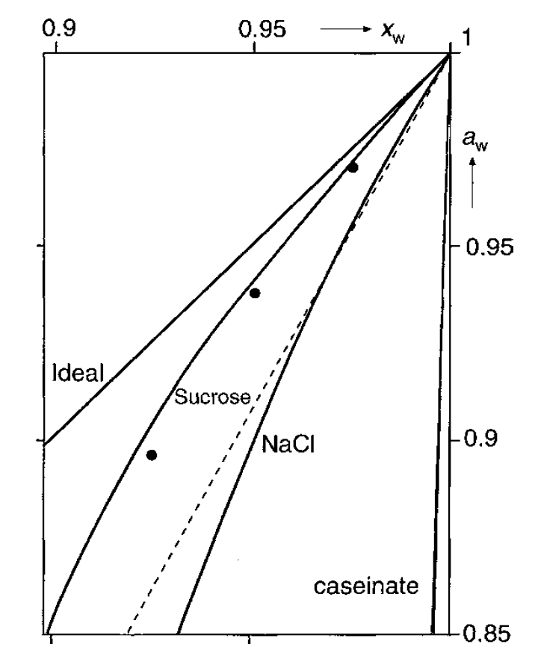
FIGURE 8.1 Water activity (a_{w}) versus mole fraction of water (x_{w}) for aqueous solutions of sucrose, NaCl, and Na-caseinate. Also given are the ideal relation (a_{w} = x_{w}), the relation for NaCl assuming complete dissociation (broken line), and some points (.)
Slaid 304
Water activity
Important causes of nonideality are
1. Dissociation of the solute. For NaCl, ms should be replaced by mNa + mCl, assuming complete dissociation. The broken line in Figure 8.1 has been drawn on this assumption. It is seen that dissociation explains by far the greater part of the nonideality for NaCl, but not all of it.
2. Solute molecule size or, more precisely. Figure 8.1 shows a few points calculated for β = 1, which implies nonet solvent–solute interaction, and q = 12, the approximate value for sucrose in water. It is seen that the correction is somewhat overestimated in this case.
3. Solvent–solute interaction. If there is net attraction or association between solute molecules and water molecules (‘‘hydration’’), β > 1. If the association is strong, the solvent quality is very good, it is as if some water molecules were removed. This then is as if the mole fraction of water were decreased. The resulting decrease of aw is only appreciable if x_{s} is fairly large.
Slaid 305
Water activity
Examples of the water activity of several foods, in relation to water content, are shown in Figure 8.2. For some foods a range is given, in other cases just one example. It is seen that most points fall within a band having a width corresponding to a variation in (1 – a_{w}) by a factor of about three. Two kinds of exceptions are observed. The one is exemplified by the point labeled ‘‘brine.’’ This represents a type of seasoning that is almost saturated with NaCl. Because of the small molar mass of the molecules and ions dissolved, the effective x_{w} is relatively small. Foods of a high fat content form the other exception. Skim milk and cream have exactly the same aqueous phase, and thereby the same a_{w}, despite the large differences in water content. Margarine has an even lower content of aqueous phase, and an extreme is cooking oil, which may have a water content of about 0.15% at room temperature, but virtually no substances that can dissolve in water; hence, aw will approach unity.
Slaid 306
Water activity
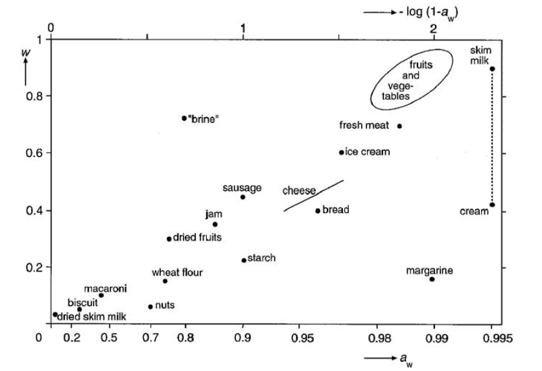
FIGURE 8.2 Approximate water activity (a_{w}) of some foods versus mass fraction of water (w).
Slaid 307
Sorption isotherms
It is customary to construct sorption isotherms or vapor pressure isotherms of foods, where water content (either as mass fraction or as mass of water per unit mass of solids) is plotted against a_{w}. Figure 8.3a gives an example of such an isotherm; here, the material is a powder below 10 and a liquid above 30% water.
Figure 8.3a gives the whole range of water contents, but if the water content is plotted on a linear scale, any differences, which are of greatest importance for low water contents, are not shown in sufficient detail. Consequently, one mostly plots only the part below a_{w} ≈ 0.9. Examples are given in Figure 8.3b, and considerable variation among foods is seen.
Slaid 307
Sorption isotherms
FIGURE 8.3 Water vapor pressure or water sorption isotherms of foods. Given are water content versus water activity (aw). (a) skim milk (powder). (b) Various foods: meat (1), apple (2), boiled sweet (3), skim milk (4), and peanuts (5). (c) Caseinate systems (water content expressed as g per g dry protein); pure caseinate (1), curd or renneted milk (2), and cheese (3).

Slaid 308
Sorption isotherms
Sorption Enthalpy. When removing water from a product, heat is consumed. This is because a lower water content goes along with a lower water activity, and the water has to be removed against a water activity gradient or, in other words, against an increasing osmotic pressure. The sorption heat or enthalpy ΔHs generally increases as a_{w} decreases (see Figure 8.4a), which would imply that removal of water becomes ever more difficult in the course of drying. ΔHs mostly is small: it is rarely over 20 kJ mol⁻¹ of water, and its average (integrated) value over the whole drying range is 0.2 2 kJ mol⁻¹. This is far smaller than the enthalpy of evaporation of water, which is 43 kJ mol⁻¹ at 40 ºC. Difficulty of removal of the last bit of water is not due to strong ‘‘binding’’ but to very slow diffusion, as discussed above. Note that the sorption enthalpy has always to be supplied, whether water is removed while remaining liquid (as in reversed osmosis), or by evaporation. In the latter case, also the enthalpy of evaporation has to be supplied.
Slaid 309
Sorption isotherms
FIGURE 8.4 (a) Sorption enthalpy ΔHs (kJ mol⁻¹) as a function of water activity a_{w}, for potato starch. Also the range obtained at a_{w} = 0.5 for various materials is given. (b) Desorption isotherms — wʹ in g water per g dry matter versus water activity—of (dried) potato at three temperatures (indicated).

Slaid 310
Sorption isotherms
Because of the finite ΔHs, the water activity of a product increases with increasing temperature (at a given water content), relatively more so for a higher ΔHs, which implies a lower aw. This is expressed in the relation of Clausius–Clapeyron: (2)
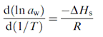$8\text{.}1$
Figure 8.4b gives an example of the temperature dependence of a_{w}. It is seen that a given water content is reached at a higher water activity for a higher temperature. This is an additional reason why drying is easier at a high temperature.
Slaid 311
Sorption isotherms
In many foods, the situation is more complicated. Often, the material, or an important component, may occur either in crystalline or in amorphous form. Figure 8.5a gives examples for sucrose: crystalline, amorphous, and in solution. Crystalline sucrose, if pure, cannot contain water and any water present is adsorbed on the crystal faces, and this is a very small amount. Amorphous sucrose can take up water, because this means in fact dilution of an extremely concentrated solution. If sufficient water has been taken up, the diffusion coefficient of sucrose has become large enough for it to crystallize. This then leads to the release of water. The a_{w} and the rate at which these changes occur greatly depend on temperature. Figure 8.5b shows sorption isotherms for dried skim milk, of which about 50% is lactose. The lactose can remain amorphous when the milk is spray-dried. It can also be made with crystalline lactose, and the normal crystalline form is a monohydrate. The water of crystallization is not available as a solvent, which means that a_{w} is smaller than for amorphous sugar at the same water content, provided the latter is fairly small.
Slaid 312
Sorption isotherms
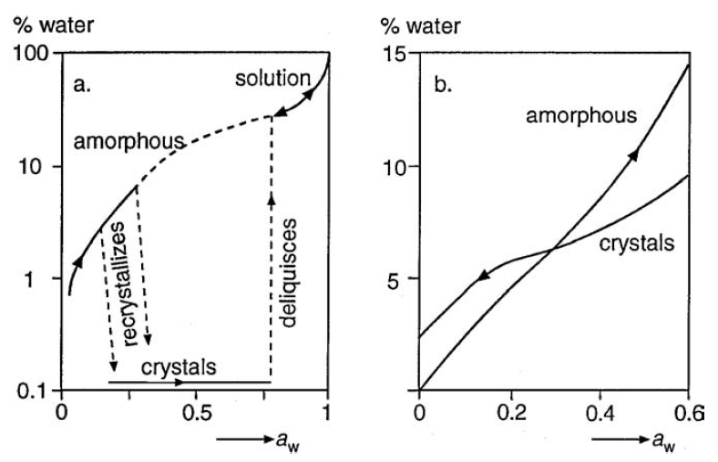
FIGURE 8.5 Relation between water content (weight %) and water activity for various situations. (a) Sucrose: in solution, amorphous and crystalline; recrystallization takes a very long time (years) at low water content (say 3%) and is quite fast at values over 6%). (b) Dried skim milk, with amorphous or crystalline lactose.

Slaid 313
Reaction rates and water content
Most, though not all, changes or reactions occurring in foods proceed slower at a smaller water content. Often, water activity is considered to be the key variable, but the situation may be far more complicated. Unfortunately, reliable quantitative theory is not available. We therefore can only give some general considerations and examples on physical changes, chemical reactions, and microbial growth.
Slaid 314
Physical changes
1. Composition of the dry matter. Figure 5.16a suggests that for several materials roughly one curve is found, but closer inspection shows differences by about an order of magnitude in D_{eff} for the same w. If the dry matter contains a water soluble substance of fairly small molar mass, diffusivity can be markedly greater than in its absence, at least at small w. If glycerol is added to an aqueous system of not too low water content, say w > 0.5, it will cause the diffusion coefficient to decrease, since glycerol has a higher viscosity than water. In a very dry food, say for w < 0.1, the presence of glycerol will generally increase the diffusion coefficient, since its presence means a greater proportion of liquid. The presence of sugars, like glucose or sucrose, may also enhance diffusivity of water at very small w.
Slaid 315
Physical changes
2. Molecular size. Point 1 concerns the properties, including molecular size, of the materials that form most of the mass of the system, for convenience called the matrix. Here we consider the size of diffusing molecules, which may be present in small quantities only. According to the Stokes–Einstein relation, the diffusion coefficient of a molecule is inversely proportional to its radius. At small w this dependence is much stronger, since it now concerns diffusion through narrow pores in the matrix. Semiquantitative examples are given in Figure 8.6a, where the upper curve relates to water. It is seen that at small w the differences become very large. This phenomenon explains retention of volatiles during drying of foods (coffee essence): most volatiles concerned have a distinctly larger molar mass than water. Most gases, on the other hand, will diffuse relatively fast.
Slaid 316
Physical changes
FIGURE 8.6 Effective diffusion coefficient (D_{eff}) of molecules in systems of various water contents. (a) Diffusivity of solutes of various molar mass as a function of mass fraction water (w). (b) Diffusivity of water at some temperatures as a function of w. (c) Diffusivity of water in two systems as a function of water activity. Very approximate, only to illustrate trends.

Slaid 317
Physical changes
3. Temperature. Figure 8.6b gives some examples, and it seen that the effect again is very strong at small w, involving several orders of magnitude.
This temperature effect is all that allows reasonably fast drying of several materials, or determination of dry matter content of most foods by oven drying.
4. Physical inhomogeneity of the system. Some authors have reported that diffusivities in systems of small w were markedly greater than expected on the basis of some theory, or when extrapolating from higher w values. Such a discrepancy may well be due to physical inhomogeneity of the matrix. Especially at very small w, tiny cracks may develop in the matrix, allowing much faster transport of small molecules. This phenomenon greatly upsets the interpretation of results on diffusivity, since it is not well known what factors cause crack formation; it greatly depends on the composition of the matrix.
Slaid 318
Recapitulation
Water Activity. The reactivity of water in a food is precisely given by its water activity, which is mostly expressed as a fraction, thus ranging from 0 to 1. In a dilute and ideal solution, aw equals the mole fraction of water, but in most foods there are several nonidealities, and it may be very difficult to predict aw from composition. This means that it has to be determined, which can be done by measuring the relative vapor pressure of air in equilibrium with the food.
Many food properties correlate better with water activity then with water content, especially if the food contains substances that are more or less indifferent to water, like crystals or oil droplets. This does not mean that relations between a property and aw are the same for all foods, not even in a relative sense. Some properties, notably rheological ones, generally correlate better with water content than with aw.
Slaid 319
Recapitulation
Sorption. The relation between aw and mass fraction of water w, at constant temperature, is called a sorption isotherm. It is a useful relation, giving information about hygroscopicity and about drying conditions to be applied. For almost all foods, it does not reflect true water adsorption, since much water is in a (concentrated) solution rather than adsorbed onto a welldefined surface. It mostly takes a very long time to determine a sorption isotherm, especially at the low aw end, presumably because the diffusivity of water then becomes very small. The only way to obtain (near) zero water content generally is drying at high temperature, where diffusivity is much greater. Moreover, it is commonly observed that going to progressively lower aw values (‘‘desorption’’) gives a sorption curve that differs significantly from one obtained by progressively increasing aw (‘‘adsorption’’). This hysteresis indicates that no true equilibrium is reached, implying that water activity is actually undefined. Nevertheless, sorption isotherms can be of great practical use.
Slaid 320
Recapitulation
Hydration. Hydration or true binding of water to food components generally involves only small quantities of water. Only polar groups, and to a lesser extent dipoles, can ‘‘bind’’ water molecules, immobilize them for a short time. It is often stated that bound water does not react, but water reactivity is just proportional to aw. Bound water would not be available as a solvent, but nonsolvent water is primarily due to negative adsorption of a solute onto particles or macromolecules and greatly depends on the nature, especially on its molecular size, of the solute. Bound water would not freeze, but some water remains unfrozen when its diffusivity has become virtually zero, so that its crystallization would take infinite time. And held or imbibed water is certainly not bound, but just mechanically entrapped. In other words, water fills space. Water binding as a general term therefore is confusing.
Slaid 321
Recapitulation
Reaction Rates. Dry foods are generally more stable than those with a higher w. This can be due to various mechanisms, and the relations are generally not well understood. Most physical changes depend on diffusivity, which becomes progressively smaller with smaller w. Most chemical reactions proceed slower for a smaller w. If water is a reactant, a lower aw means a slower reaction. At fairly low w, reactions may become diffusion–limited, which generally is the ultimate cause of stability in very dry foods. Activity coefficients may be greater at lower w, and removal of water may increase the concentration of reaction inhibitors or catalysts. It is possible that a reaction proceeds faster at a smaller w, at least over a certain range. For a bimolecular reaction this may be due to a higher concentration of reactants; moreover, water itself may be an inhibitor.

