5. Formation of Emulsions and Foams. Colloidal interactions.

Slide 2
Emulsions and foams are dispersions of two fluids which implies that the interface between the phases is deformable. This makes the breakup of one of the materials into small particles.
Many aerated foods are dispersions of air (whipped egg) or carbon dioxide (a head on beer) in water.
Emulsions come in two types: oil-in-water (O–W) and water-in-oil (W–O); in foods the oil is nearly always a triglyceride oil. O–W emulsions include milk and several milk products, creams, mayonnaise, dressings and some soups. Very few foods are true W–O emulsions - butter, margarine and most other spreads contain aqueous droplets in a mass of oil and crystals. In the making of foams and emulsions hydrodynamic and interfacial phenomena interact.

Slide 3
To make an emulsion (foam) one needs oil (a gas), water, energy and surfactant. The energy is needed because the interfacial area between the two phases is enlarged hence the interfacial free energy of the system increases. The surfactant provides mechanisms to prevent the coalescence of the newly formed drops or bubbles. Interfacial tension and Laplace pressure facilitating breakup of drops or bubbles into smaller ones.
Note: The word bubble is sometimes reserved for an air cell in air, a spherical cell surrounded by a thin film. A cell of air in a liquid call a bubble.

Slide 4
Several methods can be used to make emulsions or foams:
1. Supersaturation. This is not applied in food emulsion making but is fairly used in foams. A gas can be dissolved in a liquid under pressure and then the pressure is released and the gas bubbles are formed. The gas should be well soluble in water to obtain a substantial volume of bubbles and carbon dioxide. It is applied in most beverages. CO2 can also be formed by fermentation as in beer and in a dough.
2. Injection. Gas or liquid is injected through small openings in a porous sheet into the continuous phase. In this way bubbles or drops are directly formed. They are dislodged from the sheet (some foams) or by weak agitation (most emulsions). The method for making emulsions is often called membrane emulsification. The ‘‘membrane’’ generally consists of porous glass or ceramic material.

Slide 5
3. Agitation. In agitation (stirring, beating, homogenizing) mechanical energy is transferred from both phases to the interfacial region—which can lead to the formation of bubbles or drops—and from the continuous phase to these particles—whereby they can be appeared as a smaller. It is by far the most common method for making food emulsions and foams. Since all forces have to be transferred via the continuous phase.
4. Chemical energy. Some surfactant mixtures during gentle mixing of the emulsion ingredients can produce instability of an oil–water interface. Instability means that capillary waves form spontaneously which can lead to droplet formation by a kind of ‘‘budding.’’

Slide 6
Volume fraction of dispersed phase it determines some essential properties. For an emulsion the value desired can mostly be predetermined by the proportions of oil and water. This is often different for foams especially when made by beating: the value of φ obtained then depends on several conditions.
Particle size distribution, f(d). It is of considerable importance for the physical stability of the system. The smaller droplets or bubbles presented the more stable system, surface layer of the particles, thickness and composition. This greatly affects the stability.
Emulsion type, O–W or W–O.
Making an emulsion or a foam is a highly complex process involving several different phenomena connected with hydrodynamics and dynamic surface properties.

Slide 7
What is an emulsion?
A dispersion of one or more immiscible liquid phases in another, the distribution being in the form of tiny droplets.
Emulsions are metastable –from a thermodynamic standpoint they can exist in a form that is not the state of lowest energy.

Slide 8
emulsion types

Slide 9
The phase that is added tends to become the internal phase;
The predominant solubility of the emulsifier tends to determine the external phase (Bancroft’s rule);
Generally, the phase of the greatest volume tends to become the external phase;
The phase in which the stirrer is placed tends to become the external phase.

Slide 10
- Test
  - O/W emulsions tend to have a lighter test than W/O
- Dispersibility
  - Tested by dropping a small amount of emulsion in water – O/W disperses easily while W/O remains whole
  - Conductivity
  - O/W emulsions conduct electricity well showing high levels of conductance
- Color penetration
  - Water soluble color is easily taken up in O/W system but not in W/O

Slide 11
Microscopy
Uses
  - Droplet size and size distribution
  - Quality of manufacturing process e.g. undispersed thickener
  - Detecting unwanted crystallisation
  - Early indications of instability e.g. flocculation, coalescence
  - Comparison of different emulsions
  - Liquid crystals

Slide 12
What does an emulsion look like?
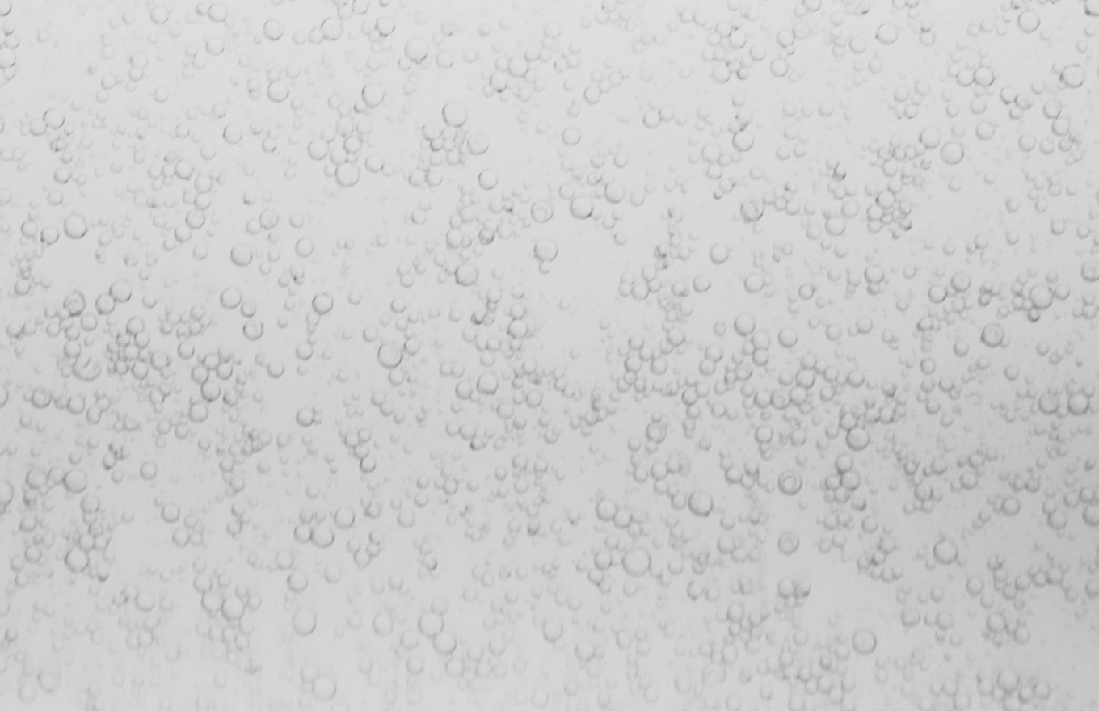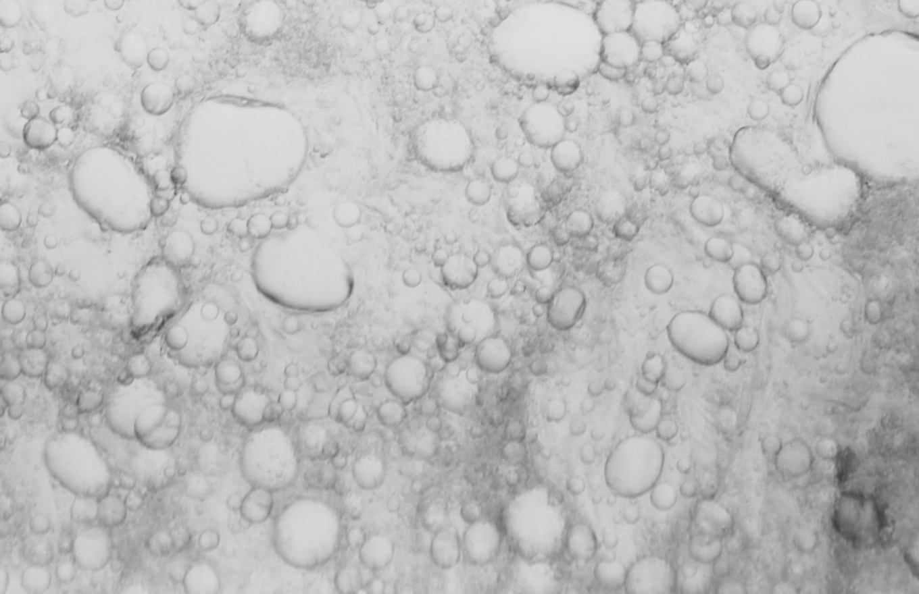

Slide 13
What is an emulsifier?
Water loving
head
Oil loving
tail
'Hydrophilic'
'Lipophobic'
'Lipophilic'
'Hydrophobic'

Slide 14
An emulsifier is a surface active agent with an affinity for both the oil and the water phases on the same molecule
An emulsifier reduces the surface tension at the oil / water interface and protects the newly formed droplet interfaces from immediate coalescence

Slide 15
- Within a droplet structure the emulsifier forms a monomolecular layer on the surface of the droplet;
- The orientation of the emulsifier depends on the type of emulsion formed.
Water - in - oil
Oil - in - water

Slide 16
Improving emulsion stability
Clearly the ability of the emulsifier to completely cover the surface area of the droplet will be dependent on:
  - The concentration of emulsifier in the formulation
  - The molar mass of the emulsifier
  - The size of the droplet
- Good coverage lead to longer term stability

Slide 17
Types of emulsifiers
Anionics
The emulsifier carries a negative charge e.g. Sodium Stearate soap
C H COO Na
35
17
-
+

Slide 18

Pros and Cons used emulsifiers
  - Were very common
  - Old fashioned
  - Cheap
  - Limitations for actives due to high pH
  - Give negative charge to the oil droplet

Slide 19
Cationic
The emulsifier carries a positive charge e.g. Palmitamidopropyl Trimonium Chloride
_
Cl
CH₃(CH₂)₁₄C
NH(CH₂)₃
O
CH₃
CH₃
N
CH₃
+

Slide 20
Non-ionic
Emulsifier carries no overall charge and can be made to form both Water-in-oil or Oil-in-water emulsifiers e.g. Steareth-2
CH₃ (CH₂ )₁₆ CH₂ (OCH₂ CH₂)₂ OH

Slide 21
HLB
Hydrophile / Lipophile Balance

0
10
20
Lipophilic
Oil loving
Non polar
Oil soluble

Hydrophilic
Water loving
Polar
Water soluble

Slide 22

Emulsifier HLB 5
Emulsifier HLB 10
Emulsifier HLB 15
Oil
phase
Water
phase

Slide 23
Determining HLB value
Calculate the water loving portion of the surfactant on a molecular weight percent basis and then divide that number by 5
Dividing by 5 keeps the HLB number scale limited to a maximum of 20 which makes the scale smaller
Once calculated assign this number to the non-ionic surfactant
  - This assigned number is the HLB VALUE

Slide 24
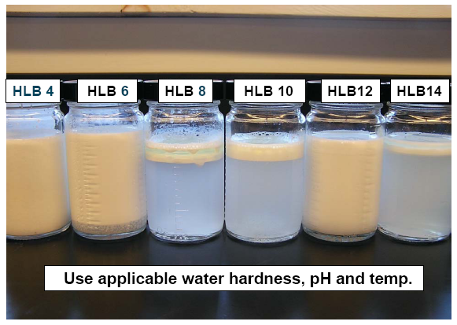

Slide 25
Look at your formula
Determine which are the oil soluble ingredients
this does not include the emulsifiers
Weigh each of the weight percents of the oil phase ingredients together and divide each by the total
Multiply these answers times the required HLB of the individual oils
Add these together to get the required HLB of your unique blend
Slide 26

Slide 27
Emulsifier selection using HLB
Oil phase components can be given required HLB values
Required HLB and emulsifier HLB are matched up
Each oil will have 2 required HLB’s, one for oil-in-water emulsions, the other for water-in-oil emulsions
The required HLB is published for some oils

Slide 28

Required HLB for oil-in-water emulsion
- Benzophenone-3 7
- Mineral oil 10 - 11
- Caprylic/Capric triglyceride 5
- Cetyl alcohol 15 - 16
- Vitamin E 6
Required HLB for water-in-oil emulsion
Mineral oil

Slide 29
Emulsions are thermodynamically unstable
This means that their natural tendency is to revert to a state of least energy i.e. separated into two layers
The process of emulsification is to produce droplets but also to maintain them in this state over a reasonable shelf life

Slide 30
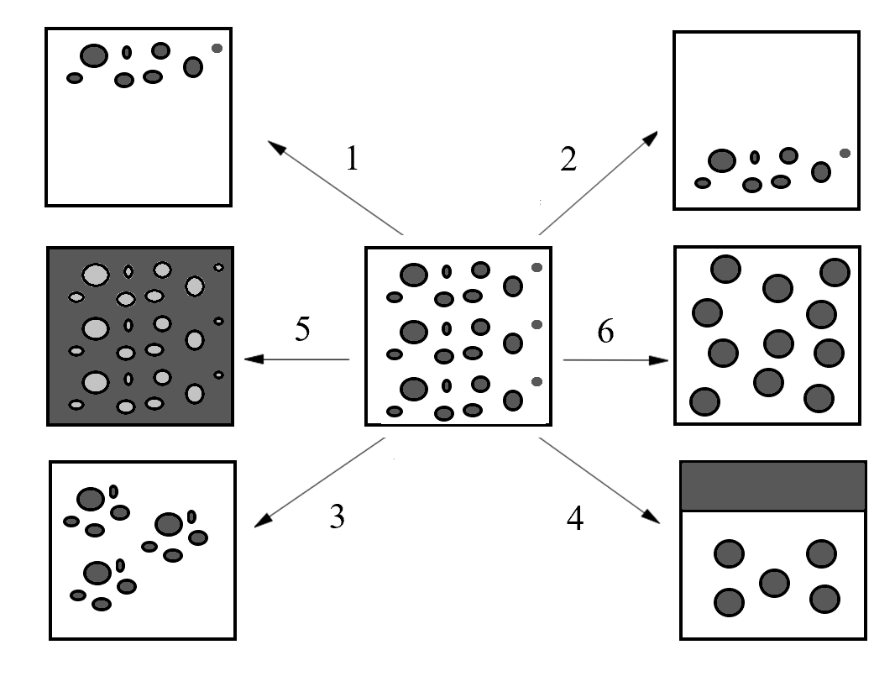
Slide 31
Creaming / Sedimentation
No change in droplet size
Not reversible
Driven by density difference
Usually results from gravitational forces
Sedimentation
Creaming

Slide 32

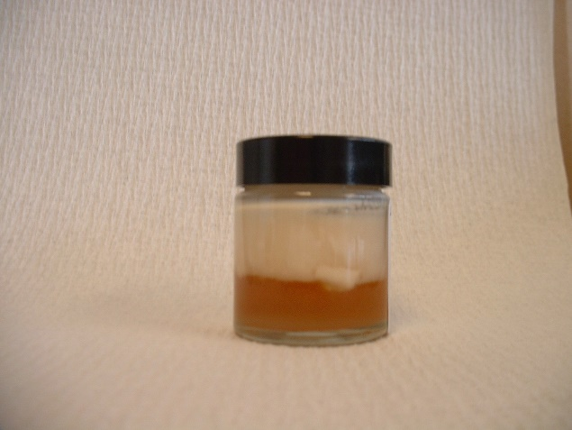

Slide 33
Coalescence
Not reversible
May lead from flocculation, creaming / sedimentation or Brownian motion
Involves 2 drops coming together
May lead to complete separation

Slide 34
Charge stabilisation
-
-
-
-
-
-
-
-
-
-
-
-
-
-
-
-
-
-
-
-
-
-
-
-
-
-
-
-
-
-
-
-
-
-
-
-
-
-
-
-
-
-
-
-
-
-
-
-
-
-
-
-
-
-
-
-
-
-
-
-
-
-
-
+
+
+
+
+
+
+
+
+
+
+
+
+
+
+
+
+
+
+
+
+
+
+
+
+
+
+
+
+
+
+
+
+
+
+
+
+
+
+
+
+
+

Negatively charged oil droplets repel each other
Stability affected by quantity of electrolyte and whether M+ or M++

Slide 35
- In this system
  - The negatively charged Stearate groups migrate to the interface
  - The positively charged Sodium ions in solution (counter ions) are attracted to these now charged droplets
  - A layer is formed where the impact of the charge is reduced
  - This layer, called the Helmholtz double layer, can reduce the repulsive effect and so stability

Slide 36
Helmholtz double layer effect

+
-
-
-
-
-
-
-
-
-
-
-
-
+
+
+
+
+
+
+
+
+
+
+
+
-
-
-
-
-
-
-
-
-
-
-
+
+
+
+
+
+
+
+
+
+
-
-
-
-
-
-
-
Oil droplet
Water phase
Electrical double layer

Slide 37
- The double layer is likely to be more diffuse the further away from the droplet you go (Gouy and Chapman and Stern)
- Can the same happen for cationic and non-ionic emulsifiers?
- The effect is impacted by the presence of electrolytes
  - Adding electrolyte increases instability by reducing the shielding effect
  - The extent of this depends on the amount of electrolyte added and the valency of the electrolyte

Slide 38
Improving emulsion stability
Continuous phase viscosity
  - Thickening the water phase restricts movement of oil droplets
  - Thickeners with yield points are most effective
- Droplet size
Increasing stability

Slide 39
Foam is made in by injection of air bubbles or by beating, Figure 5.1. Foam bubbles are fairly large and they cream rapidly at a rate of 1mm/s or faster. They form a layer on top of the liquid. As soon as the layer is a few bubble diameters in thickness forces cause the bubbles to deform each other against their Laplace pressure further increasing the volume fraction of air in the layer. The bubble size distribution becomes fairly monodisperse because small bubbles disappear by Ostwald ripening: small bubbles have a high Laplace pressure so the air inside has an increased solubility in water and the air diffuses to larger bubbles.

Slide 40
The phenomena lead to formation of a polyhedral foam: the shape of the air cells approximates polyhedra. For cells of equal volume the shape would be about that of a regular dodecahedron (a body bounded by 12 regular pentagons) and the edge q then equals about 0.8r, where r is the radius of a sphere of equal volume. The structure is less regular because of polydispersity. Close packing of true dodecahedrons is not possible. In a ‘‘two-dimensional’’ foam see a layer of bubbles with hexagons as in a honeycomb.

Slide 41
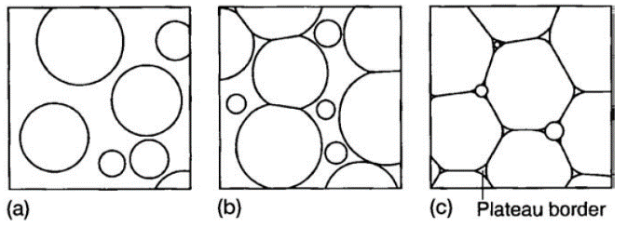
FIGURE 5.1 Subsequent stages, from (a) via (b) to (c), in the formation of a foam after bubbles have been made. The thickness of the films between bubbles is too small to be seen on this scale.

Slide 42
The thin films between bubbles meet at angles of 120⁰ assuming the surface tension to be constant. For angles of 120⁰ a balance of forces exists, Figure 5.2a. If the structure is not completely regular some of the films must be curved. This is illustrated in Figure 5.2b. The Laplace pressure in the central bubble depicted is higher than that in the four surrounding cells and the central one will disappear by Ostwald ripening. This leaves a configuration of four planes meeting at angles of 90⁰. In this case a balance of forces is also possible, the slightest deviation from 90⁰ causes an unstable configuration which will immediately lead to rearrangement.

Slide 43
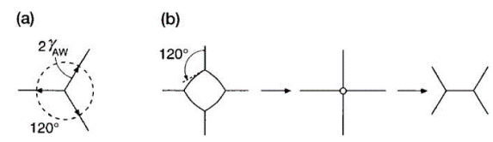
FIGURE 5.2 Cross sections through bubble configurations in foams. (a) Balance of forces where three flat films meet. (b) Change of configuration when a small bubble amidst four larger ones disappears.

Slide 44
An important structural element in a foam is the Plateau border, the channel having three cylindrical surfaces that is formed between any three adjacent bubbles. Similar channels are formed where two bubbles meet the wall of the vessel containing the foam. Figure 5.3a shows a cross section and it follows that the Laplace pressure inside the Plateau border is smaller than that in the adjacent films. This means that liquid is sucked from the films to the Plateau borders, whence it can flow drain because the Plateau borders form a connected network. The curvature in the Plateau border is determined by a balance of forces, Laplace pressure versus gravitational pressure.

Slide 45
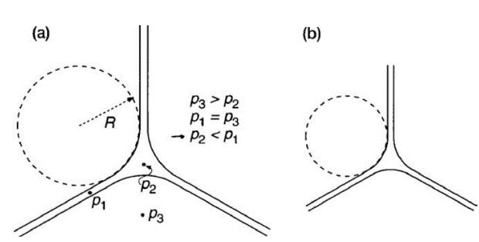
FIGURE 5.3 Cross sections through Plateau borders and films. (a) Illustration of the difference of the Laplace pressure between border and film. (b) Plateau border at a greater height in the foam.

Slide 46
It will take time to obtain a dry foam since the water has to drain from it and drainage is greatly hindered by the narrowness of the films and channels in the foam. The film has a thickness d, width q and height h.

Slide 47
Surfactant Concentration. The first requirement is that sufficient surfactant is present to cover the total air surface produced. Figure 5.4a gives some examples. A more practical situation overrun values of 400–1800 % have been obtained when beating 1% whey protein solutions.
Another point is that an optimum protein concentration for overrun is often observed. The decrease in overrun upon a further increase of concentration may be due to increased viscosity hence slower drainage a foam containing more liquid. Other possible effects of surfactant concentration are used.

Slide 48
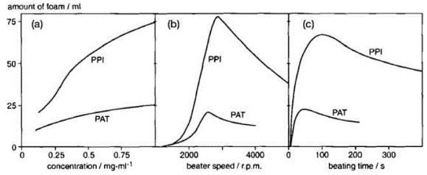
FIGURE 5.4 Amount of foam formed from dilute solutions of a potato protein isolate (PPI) and purified patatin (PAT); pH = 7.0, ionic strength = 0.05 molar. Foam was made on a small scale by beating. (a) Effect of protein concentration. (b) Effect of beater speed (revolutions per minute). (c) Effect of beating time.

Slide 49
Surfactant Type. The surfactant of choice for making food foams is nearly always protein in order to obtain sufficiently stable foams. Figure 5.4 shows the differences between two proteins. Figure 5.5 shows results of some proteins in relation to different surface tension. It is seen that ovalbumin and lysozyme give virtually no decrease in γ at a high expansion rate and short time scales, П ≈ 0. This then means that γ cannot form and drainage will be so fast as to prevent foam formation. The differences among the proteins shown cannot be due to a difference in the rate of protein transport to the surface.

Slide 50
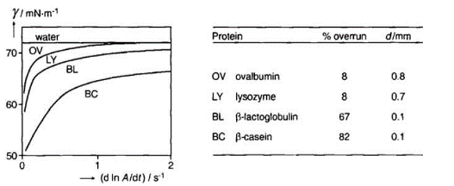
FIGURE 5.5 Foaming properties of some proteins (solution of 0.25 mg per ml) in
relation to the dynamic surface tension. γ is surface tension; d ln A/dt is the surface
expansion rate; d is the approximate average bubble diameter.

Slide 51
Another variable is the effective molar mass of the surfactant. Smaller molecules tend to give a higher molar surface load at the same mass concentration in solution and thereby higher П-values. Protein hydrolysates often have superior foaming properties where faster unfolding of smaller peptides may also play a part. The foam tends to be less stable against Ostwald ripening. Aggregation of proteins tends to decrease overrun because Г is much higher, implying that more protein is needed to cover a given surface area.

Slide 52
Beating conditions have considerable effect on overrun but few systematic studies have been done. During beating large bubbles are formed. Especially at high value fractions φ coalescence of bubbles is observed. Coalescence is due to destroyed of the film. This also means that the film becomes thinner.
Beating Time. Figure 5.4c illustrates that addition of high quantity surfactant at first increases during beating—as is only to be expected—but then decreases. Since such ‘‘overbeating’’ is typical for globular proteins as a surfactant the most likely explanation is surface denaturation leading to protein aggregation. During beating frequent expansion and compression of film surfaces occurs and this may readily cause strong unfolding and subsequent aggregation of globular proteins.

Slide 53
Some different regimes can be derived that predict parameters like drop size and time scales. The main factors determining what the regime is are the type of force and the flow type.
Flow Types. The main distinction is between:
Laminar flow, occurring if Re < ~ 2000.
Turbulent flow for Re > ~ 2500.
These variables give rise to three regimes for droplet (or bubble) breakup:
1. Laminar/viscous forces (LV), breakup by viscous forces in a laminar flow field
2. Turbulent/viscous forces (TV)
3. Turbulent/inertial forces (TI)

Slide 54
Two of the various types of laminar flow, and the effects such flows have on drops, are depicted in Figure 5.6. It also gives the definitions of the velocity gradient.
Simple shear flow causes rotation, and also the liquid inside a drop subjected to shear flow does rotate. The drop is also deformed, and the relative deformation (the strain) is defined as D = (L – B)/(L + B); see Figure 5.6a for definition of L and B. For small Weber numbers, we simply have D = We. For larger values of We, the drop is further deformed as Depicted.

Slide 55
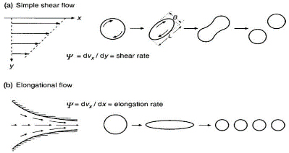
FIGURE 5.6 Two types of laminar flow, and the effect on deformation and breakup of drops at increasing velocity gradient (ψ). The flow is two-dimensional, it does not vary in the z-direction. More precisely, the flow type in (b) is ‘‘plane hyperbolic flow.’’

Slide 56
In elongational flow, there is no internal rotation in the drop, and it becomes elongated, irrespective of the viscosity ratio. If We is high enough, the drop attains a slender shape (see Figure 5.6b), in which it is subject to Rayleigh instability and thereby breaks into a number of small drops.

Slide 57
Turbulent flow is characterized by the presence of eddies (vortices, whirls), which means that the local flow velocity u generally differs from its timeaverage value u. The local velocity fluctuates in a chaotic manner, and the average difference between u and u equals zero.
Disruption probably occurs via the sudden formation of a local protrusion on a drop, which then breaks off. This would mean that fairly wide droplet size distributions result, as is indeed observed: see Figure 5.7a.

Slide 58
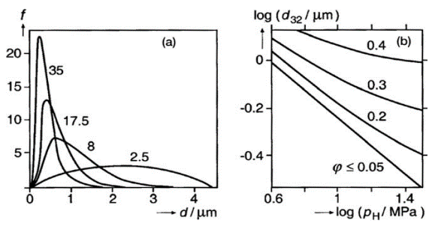
FIGURE 5.7 Examples of the droplet size (distribution) in O–W emulsions resulting from treatment in a high-pressure homogenizer, at various homogenizing pressures pH. (a) Volume frequency distributions (f) in % of the oil per 0.1 mm class width versus droplet diameter d; pH indicated in MPa. (b) Average diameter d32 as a function of pH for various oil volume fractions φ (indicated); the aqueous phase was a solution containing about 3% protein.

Slide 59
Colloidal interaction forces act primarily in a direction perpendicular to the particle surface. Consider two particles in a liquid a large distance apart. Colloid scientists try to predict the free energy needed to bring these particles from infinite distance to a close distance between the particles’ surfaces h. If that energy is positive it means that the particles repel each other. If it is negative they attract each other. For particles of a size of the order of 1 μm the distance between the surfaces over which interaction forces are significant is nearly always much smaller than the particle size.

Slide 60
Interaction Curves. Figure 5.8 gives a hypothetical example of such a curve. At very close distance (< 0.5 nm), the interaction free energy is always (large and) positive due to hard-core repulsion but at longer distances the shape of the curves can vary widely. In the drawn curve a primary minimum is shown at A a maximum at B and a secondary minimum at C. Starting at large h distance the particles will at some time reach position C. If it is a minimum the particles can diffuse away from each other. If the minimum is deeper they may stay aggregated without actually touching each other. If the maximum at B is substantial the particles will not pass it. The maximum can be seen as a free energy barrier retarding or even preventing close approach.

Slide 61
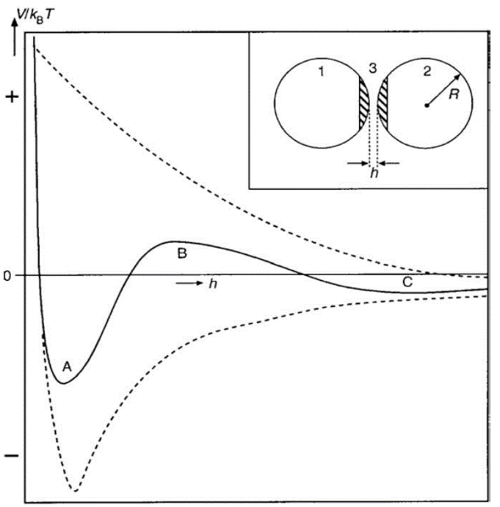
FIGURE 5.8 Hypothetical example (solid curve) of the colloidal interaction free energy V divided by kBT, as a function of interparticle distance h. The insert defines the geometry involved for the case of two spheres of radius R. The broken lines give two other examples of interaction curves.

Slide 62
Importance. Some situations in which colloidal interaction forces play an essential role are the following: aggregation of particles does it occur and if so at what rate?
The rheological properties of particle gels greatly depend on the strength of the interaction forces between the particles.
The stability of thin films against rupture .
In understanding the last case the interaction between two flat plates or surfaces is needed. Assuming the dimensions of the film to be much larger than its thickness δ, the interaction free energy V then should be given per unit surface area of the film, in J m⁻².

Slide 63
Polymers can strongly affect colloid stability. Many polymers can adsorb onto particles and then cause steric interaction which is often repulsive and stabilizing attractive interactions. If polymer molecules adsorb on two particles at the same time they cause bridging hence aggregation. Polymers in solution can also cause aggregation via depletion interaction or they can stabilize a dispersion by immobilizing the particles in a gel network.

Slide 64
The adsorption of various polymers is illustrated in Figure 5.9. Polymers can also be ‘‘grafted’’ onto a particle which means that one end of each molecule is strongly attached to the surface. The conformation and the thickness of a layer of adsorbed or grafted polymer molecules will depend on:
- the number density of the layer, the number of molecules attached or adsorbed per unit surface area (one per 10 nm²);
(b) the length (degree of polymerization) of the molecules;
(c) the number and distribution of segments that have affinity for the particle surface;
(d) the solvent quality.
It is difficult to define unambiguously the thickness δ of a polymer layer.
Figure 5.18 gives examples for one polymer length.
The ‘‘mushroom’’ type is typical for grafted polymers, if solvent quality is good.
Slide 65
FIGURE 5.9 Various conformations adapted by grafted polymer molecules sticking out in a liquid. Grafting is depicted by a dot. The local polymer segment density φ is indicated as a function of distance from the surface x. The approximate thickness of the polymer layer δ is also indicated.

Slide 66
A polymer layer adsorbed or grafted can cause so-called steric repulsion. Two mechanisms can be distinguished, Figure 5.10. If the proximity of a second particle restricts the volume in which the protruding polymer chains can be means that the number of conformations a chain can assume is restricted.

Slide 67
FIGURE 5.10 Two mechanisms involved in steric repulsion due to grafted (or adsorbed) polymer chains (heavy lines). The dotted lines indicate possible conformations of the polymer chain in the absence of volume restriction.

Slide 68
Proteins. As an illustrative example it is briefly discuss some aspects of the colloidal stability of casein micelles. These are particles to be found in milk with mean diameter about 120 nm. They consist predominantly of caseins calcium phosphate and water. One of the caseins present, called k-casein has a very hydrophilic C-terminal part of 64 amino acid residues containing some acidic sugar groups. k-casein is at the outside of the micelles and the C-terminals stick out into the solvent forming a ‘‘hairy’’ layer.

Slide 69
Consider two particles with an adsorbed layer of a homopolymer where part of the chains protrude from the particle surface. When these particles are brought close together theory predicts that at equilibrium some of the polymer molecules will become adsorbed onto both particles forming a bridge. Such bridging by adsorption is depicted in Figure 5.11a. The particles are aggregated. The same situation may occur with several kinds of copolymers.
The predicted bridging may not happen because thermodynamic equilibrium is not reached. When two particles meet by Brownian motion they will be close together and it will probably take a far longer time for the adsorbed layers to attain an equilibrium conformation. Hence the dispersion will appear stable. On the other hand, if the particles stay together for a long time they are sedimented.

Slide 70
FIGURE 5.11 Various modes of bridging two colloidal particles. Situation (c) can only occur for emulsion drops (or possibly gas bubbles) and (d) generally for solid particles. Not to scale: the number of polymer molecules involved in situations (a) and (b) would be very much larger than depicted.

