Example questions for Food Physical Chemistry

Part I
1. Divide in two groups intensive and extensive parameters: temperature, pressure, refractive index, mass density, dielectric constant, heat conductivity, pH, mass, volume, energy, electric charge, heat capacity.

Intensive parameters are independent of the amount of matter:

Extensive parameters are depend on the amount of matter:

2. Entropy (S) is a measure of disorder in thermodynamics; it is given by J K⁻¹mol⁻¹ in SI. Finished the equation:

S = ...................

3. A phase is defined as a (part of a) system that is (a) uniform throughout and (b) bounded by a closed surface, at which surface at least some of the …………………… change abruptly.

4. The Helmholtz (free) energy is given by: A =…….., J

Gibbs (free) energy is given by: G = ……., J. Finished the equations.

5. Chemical potential describe the change between Gibbs free energy and:

a) number of molls b) volume fraction c) mass density

at constant temperature and pressure.

6. Determination of activity is connected with ideal gas law. Please fill in the equation.

pV = ………..

7. The osmotic pressure (П) of a solution can be interpreted as the pressure that has to be applied to the solution to increase the chemical potential of the solvent to the value of the pure solvent at standard pressure.

П is ……………………. for a ……………………. solute concentration.

8. 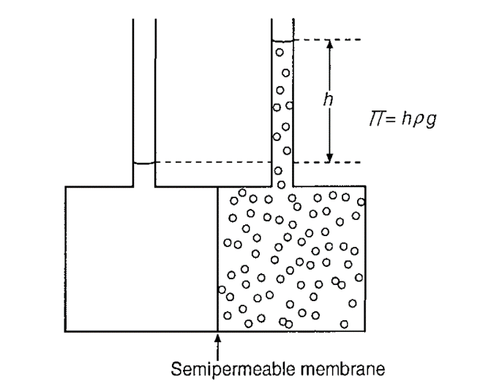

The figure presented measurement of osmotic pressure (П). Solvent and solution are separated by a semipermeable membrane. Which pass during membrane:

a) solvent b) solute c) both.

9. Several kinds of molecules can adsorb onto various surfaces or bind onto macromolecules. A surface active component naturally adsorbs onto many surfaces:
………………………., …………………………….. or ……………………………...

10. Langmuir type adsorption isotherm is presented with the following equation:
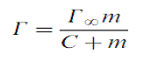
where: Г is …………………………………………………….. (in mol m⁻²), Г∞ its value if all adsorption sites are occupied and the constant C denotes the ………………… at which Г = 0.5 Г∞.

11. Atoms, groups of atoms, ions, molecules, macromolecules, and particles always are subject to forces between them.

Interaction forces = …………………………………….

12. If the solvent is water, solvation is called …………………. It is an intricate phenomenon, since water is such an intricate, not fully understood liquid.

13. The reaction rate is usually given as the change in concentration c, as either + or
- dA/dt. The following equation described it.
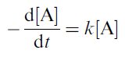
What is means "-" in a chemical reaction?

a) decrease of concentration of one of compound?
b) increase of concentration of one of compound?
c) negative value of reaction rate?
14. Activation energy is describing from Arrhenius equation:
What it means k in the equation:

a) rate constant b) Bolzman constant c) equilibrium constant

15. Reaction Heat. A reaction can only proceed if ΔG < 0. For most reactions - ΔH is larger than TΔS.
The reaction then is said to be …………………… and ……………………….. driven.

16. The flow may be laminar or turbulent.
Under below each figure specify the type of stream:

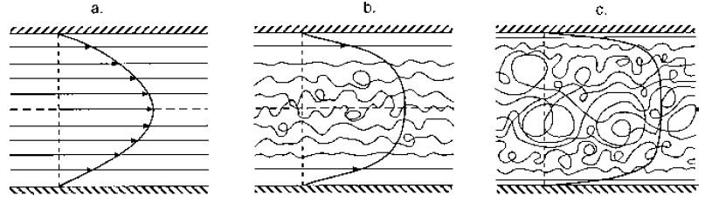
…………………… ………………… ………….........

17. Diffusion is caused by the thermal motion of molecules and small particles.
The molecules or particles can ………………… and …………………...

18. A very simple synthetic polymer is polyethylene, which is obtained by ………………………………….. of ethylene, CH2CH2, [– СH2 – СH2 –]n, a very long paraffin chain.

19. Stiffness of polymer connected with next bonds:

a) covalent bond
b) monomer–monomer bond
c) hydrogen bond
d) van der Waals forces.

20. The description on polymers connected with polydispersity.
What is mean polydespersity:

a) firmness of chain
b) degree of polymerization or high molar mass
c) increase of concentration in polymer solution.

21. Polysaccharides exhibit properties as:

a) solubility
b) conformation
c) firmness.

22. Donnan effect connected with:

a) electroneutrality a polyelectrolyte molecule accompanied by counterions
b) hydrophobic effect
c) dissolution.

23. Starch granules can be isolated from:

a) meet products
b) some plant oils
c) various plant materials.

Part II
24. Most foods are dispersed systems. They are physically:

a) homogeneous
b) heterogeneous
c) mixed systems.

25. Structural elements are particles, such as:

a) fruit products as juices and jams
b) foams
c) oil droplets and crystals.

26. A lyophilic heterogeneous system is more precisely, can be in thermodynamic equilibrium. Lyophobic systems, contain particles that do make up a new phase. It costs energy and they never form spontaneously. What is named the phase?

a) solid phase
b) continuous phase
c) liquid phase
d) gas phase

27.
Describe as follows:
Gas - Liquid -> ……………
Liquid - Gas -> …………...
Liquid – Liquid -> …………
Solid – Liquid -> …………..
Solid – Liquid -> ………….

28. When keeping a gelatinized starch solution or paste at ambient temperature, physical changes are observed, which are generally name ……………………….

29. Surface tension denote as symbol γ. In SI surface tension has two dimensions. Describe follows:

a) …….
b) ……..

30. The surface tension is the tension acting as between a liquid and …… (or another gas), or interfacial tension is the tension between liquid and ………..

31. Water has a surface tension γ = 0.072 N m⁻¹. This value compare with another liquids is:

a) highest
b) lowest
c) middle.

32. The surfactants generally consist of an aliphatic chain (‘‘tail’’) to which a polar ‘‘head’’ group is attached. The aliphatic part would readily dissolve in oil (if separated from the head group); the head group would readily dissolve in water.
In which system dissolve head group:

a) O/W interface
b) W/O interface
c) W/A interface.

33. Another variable of a surfactant is its HLB value, which is a measure of the balance of hydrophobic and hydrophilic parts of the molecule. What is means letters HLB:

H - ………….
L - ………….
B - ………….

34. Described Laplace equation:

P_{L} – …………….
γ – ……………..

35. Young equation is presented by following equation:

Which phases are described below:

AS – ……………
LS – …………...
AL – …………..

36. The emulsions are: milk and several milk products, creams, mayonnaise, dressings, soups, butter, margarine.
Divide emulsions on:

O–W emulsions - …….
W–O emulsions - …….

37. Several methods can be used to make emulsions or foams: ………………….., …………………., ……………………. and ………………………...

38. An emulsifier is a surface active agent with an affinity for both the …………… and the ………………. phases on the same molecule.

Part III

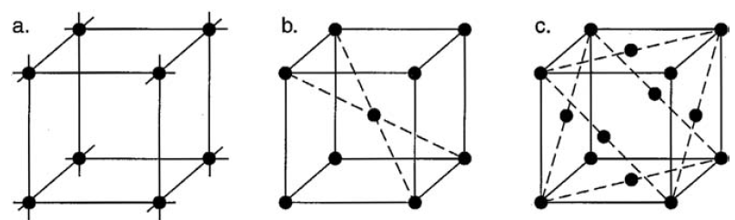

39. In the figure presented different cubic unit cells. Described the cells.

(a) ………..
(b) ………. (BCC)
(c) ………. (FCC).

40. The dimensions (lengths and angles) of the unit cell can be determined by:

a) x-ray diffraction
b) by absorbance
c) by optical methods.

41. Compound crystals are molecular crystals contain:

a) more than one component
b) contain one component
c) do not contain component.

42. Fat crystallization concerns, formation and sedimentation of:

a) crystals in oil
b) oiling in plastic fats and related products
c) coalescence of aqueous droplets and partial coalescence in some O–W emulsions.

43. Visual appearance of bloom on chocolate are tiny white fat crystals appearing on the surface, gloss of chocolate and margarine and turbidity in oils. All of these properties can:

a) change during produce of chocolate
b) change during storage
c) no change appeared

44. Polymorphism in crystallography is the property of some substances to form different crystalline structures changes at:

a) temperature and pressure
b) volume and mole fraction of elements
c) volume and temperature

45. Glassy foods - several dry foods are wholly or partly in a glassy state. A simple example is a high-boiled sweet. Which processes can be seen to obtain a food in a glassy state:
a) water generally has to be removed without crystallization of solutes
b) water stay inside in foods
c) water observed only in solution.

46. Many foods can be named soft solids: bread, cheese, margarine, peanut butter, meat, several fruits, jam, puddings, mousse, aspic, boiled potatoes. The term soft solid is defined as:

a) no solid
b) semisolid
c) full solid.

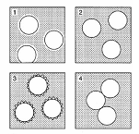

47. Described particles according the figure:

1) ………..
2) ………..
3) ………..
4) ………...

48. Most polyhedral foams are soft solids, as are some emulsions, like mayonnaise.
Agitation has to provide the forces needed to obtain permanently:

a) deformed droplets
b) droplets with right forms
c) no deformed droplets.

49. Cllular system is connected with:

a) deformation of system
b) mixing of system
c) melting of system

50. Gels consist for the:

a) greater part of liquid
b) small part of liquid
c) small part of crystals.

51. What is difference between absorption and adsorption?

Absorption is the process in …………………...

Adsorption is the process at …………………..

52. The Bouguer-Beer-Lambert law
expresses the relationship between the intensity of a light beam incident on an object containing …………………………….. and the intensity of the light beam transmitted through the object at a specific ……………………….

53. The spontaneous change in the concentration of a substance on the ………………….. of a phase boundary is called ………………………. An adsorbent is a substance that due to its large internal or external surface has the ability to adsorb other (liquid or gaseous) substances.

