Example questions for Food Physical Chemistry

**Part I**

**1.** Divide in two groups intensive and extensive parameters: temperature, pressure, refractive index, mass density, dielectric constant, heat conductivity, pH, mass, volume, energy, electric charge, heat capacity.

**Intensive parameters** are independent of the amount of matter:

**Extensive parameters** aredepend on the amount of matter:

**2.** Entropy (S) is a measure of disorder in thermodynamics; it is given by J K-1mol-1 in SI. Finished the equation:

S =

**3.** The Helmholtz (free) energy is given by: A =…….., J

Gibbs (free) energy is given by: G = ……., J. Finished the equations.

**4.** Chemical potential describe the change between Gibbs free energy and:

a) number of molls b) volume fraction c) mass density

at constant temperature and pressure.



**5.** 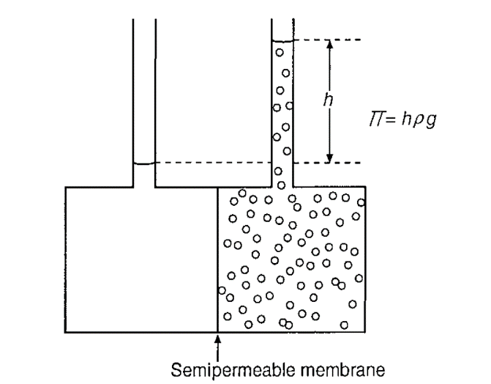

The figure presented measurement of osmotic pressure (П). Solvent and solution are separated by a semipermeable membrane. Which pass during membrane:

a) solvent b) solute c) both.

**6.** The reaction rate is usually given as the change in concentration c, as either + or

- dA/dt. The following equation described it.

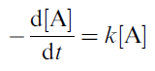

What is means "-" in a chemical reaction?

a) decrease of concentration of one of compound?

b) increase of concentration of one of compound?

c) negative value of reaction rate?



**7.** Activation energy is describe from Arrhenius equation:

What it mean k in the equation:

a) rate constant b) Bolzman constant c) equilibrium constant

**8.** The flow may be **laminar or turbulent.**

Under below each figure specify the type of stream:

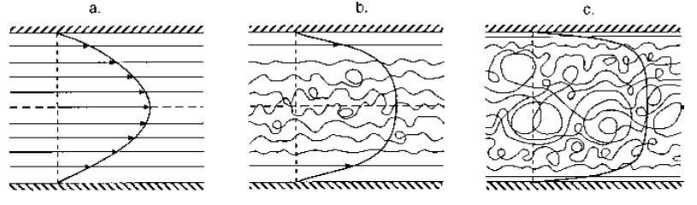

…………………… ………………… ………….........

**9.** Stiffness of polymer connected with next bonds:

a) covalent bond

b) monomer–monomer bond

c) hydrogen bond

d) van der Waals forces.

**10.** The description on polymers connected with **polydispersity.**

What is mean polydespersity:

a) firmness of chain

b) degree of polymerization or high molar mass

c) increase of concentration in polymer solution.

**11.** Polysaccharides exhibit properties as:

a) solubility

b) conformation

c) firmness.

**12.** Donnan effect connected with:

a) electroneutrality a polyelectrolyte molecule accompanied by counterions

b) hydrophobic effect

c) dissolution.

**13.** **Starch granules** can be isolated from:

a) meet products

b) some plant oils

c) various plant materials.

**Part II**

**14.** Most foods are dispersed systems. They are physically:

a) homogeneous

b) heterogeneous

c) mixed systems.

**15.** Structural elements are particles, such as:

a) fruit products as juices and jams

b) foams

c) oil droplets and crystals.

**16.** A lyophilic heterogeneous system is more precisely, can be in thermodynamic equilibrium. **Lyophobic systems**, contain particles that do make up a **new** phase. It costs energy and they never form spontaneously. What is named the phase?

a) solid phase

b) continuous phase

c) liquid phase

d) gas phase

**17.**



Describe as follows:

Gas - Liquid -> ……………

Liquid - Gas -> …………...

Liquid – Liquid -> …………

Solid – Liquid -> …………..

Solid – Liquid -> ………….

**18.** What is difference between absorption and adsorption?

Absorption is the process in …….

Adsorption is the process at …….. .

**19.** Surface tension denote as symbol γ. In SI surface tension has two dimensions. Describe follows:

a) …….

b) ……..

**20.** The **surface** tension is the tension acting as between a **liquid and ……** (or another gas), or interfacial **tension** is the tension between **liquid and ………..**

**21.** Water has a surface tension γ = 0.072 N m-1. This value compare with another liquids is:

a) highest

b) lowest

c) middle.

**22.** The surfactants generally consist of an aliphatic chain (‘‘tail’’) to which a polar **‘‘head’’** group is attached. The **aliphatic** part would readily dissolve in **oil** (if separated from the head group); the **head group** would readily dissolve in **water**.

In which system dissolve head group:

a) O/W interface

b) W/O interface

c) W/A interface.

**23.** Another variable of a surfactant is its HLB value, which is a measure of the balance of hydrophobic and hydrophilic parts of the molecule. What is means letters HLB:

H - ………….

L - ………….

B - ………….

**24.** Described Laplace equation:



PL – …………….

γ – ……………..

**25.** Young equation is presented by following equation:



Which phases are described below:

AS – ……………

LS – …………...

AL – …………..

**26.** The emulsions are: milk and several milk products, creams, mayonnaise, dressings, soups, butter, margarine.

Divide emulsions on:

O–W emulsions - …….

W–O emulsions - …….

**Part III**

**27.** 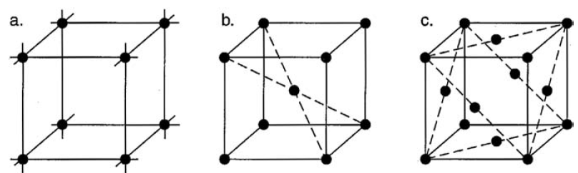

In the figure presented different cubic unit cells. Described the cells.

(a) ………..

(b) ………. (BCC)

(c) ………. (FCC).

**28.** The dimensions (lengths and angles) of the unit cell can be determined by:

a)x-ray diffraction

b) by absorbance

c) by optical methods.

**29.** Compound crystalsare molecular crystals contain:

a) more than one component

b) contain one component

c) do not contain component.

**30.** Fat crystallization concerns, formation and sedimentation of:

a) crystals in oil

b) oiling in plastic fats and related products

c) coalescence of aqueous droplets and partial coalescence in some O–W emulsions.

**31.** Visual appearance of **bloom on chocolate** are tiny white fat crystals appearing on the surface, gloss of chocolate and margarine and turbidity in oils. All of these properties can:

a) change during produce of chocolate

b) change during storage

c) no change appeared

**32.** **Polymorphism** in crystallography is the property of some substances to form different crystalline structures changes at:

a) temperature and pressure

b) volume and mole fraction of elements

c) volume and temperature

**33.** Glassy foods - several dry foods are wholly or partly in a glassy state. A simple example is a high-boiled sweet. Which processes can beseen to obtain a food in a glassy state:

a) water generally has to be removed without crystallization of solutes

b) water stay inside in foods

c) water observed only in solution.

**34.** Many foods can be named soft solids: bread, cheese, margarine, peanut butter, meat, several fruits, jam, puddings, mousse, aspic, boiled potatoes. The term soft solid is defined as:

a) no solid

b)semisolid

c) full solid.

**35**.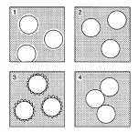

Described particles according the figure:

1) ………..

2) ………..

3) ………..

4) ………...

**36.** Most polyhedral foams are soft solids, as are some emulsions, like mayonnaise.

Agitation has to provide the forces needed to obtain permanently:

a) deformed droplets

b) droplets with right forms

c) no deformed droplets.

**37.** Cllular system is connected with:

a) deformation of system

b) mixing of system

c) melting of system

**38.** Gels consist for the:

a) greater part of liquid

b) small part of liquid

c) small part of crystals.