“Taking Woodstock “
“Taking Woodstock” is a film from Academy Award-winning director Ang Lee.

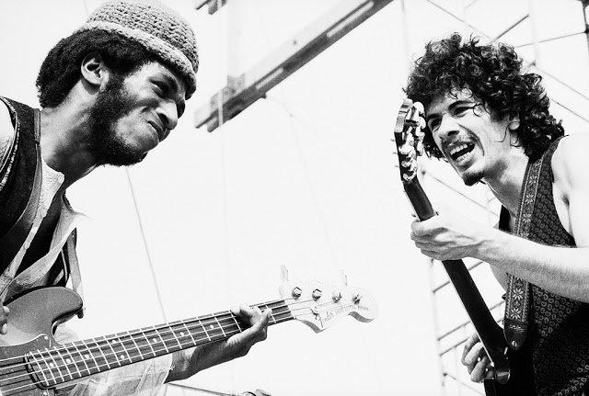
Based on the memories of Elliot Tiber, "Taking Woodstock" is a joyous voyage to a moment in time when everything seemed possible. The Woodstock Music and Arts Festival is the most famed happening it was.
Elliot is working as an interior designer in Greenwich Village and feels empowered by the gay rights movement. He also still thought the family business, the Catskill’s motel called, the El Monaco that is being run into the ground by his overbearing parents. In the summer of 1969, Elliot has to move back upstate to the El Monaco in order to help save the motel from being taken over by the bank.
Upon hearing that a planned music and arts festival has lost its permit from the neighboring town of Wallkill, NY, Elliot calls producer Michael Lang at Woodstock Ventures to offer his family’s motel to the promoters and generate some much-needed business. Elliot also introduces Lang to his neighbor Max Yasgur, who operates a 600-acre dairy farm down the road. Soon the Woodstock staff is moving into the El Monaco and half a million people are on their way to Yasgur’s farm for “3 days of Peace & Music in White Lake”.
With a little help from his friends, including theater troupe leader Devon, recently returned Vietnam veteran Billy, and cross-dressing ex-Marine Vilma, and with a little opposition from the local people, including Billy’s brother Dan, Elliot finds himself swept up in a generation-defining experience that would change his life and the popular culture forever.

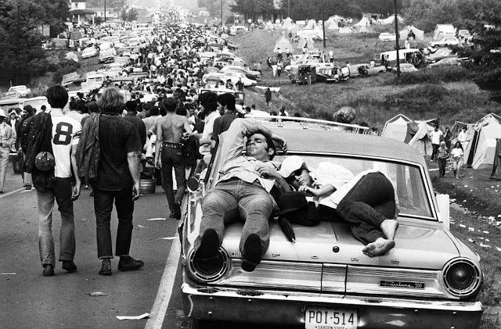
About the fest….
…49 years before, at 15th of August in 1969, in a corner of the planet, in Bethel suburb of N.Y., the biggest three day music Festival started, the Woodstock Festival or Woodstock Music & Art Fair. The music festival took place in a big farm of New York, in the suburb of Bethel and it was a reason for a lot of changes in global level. Famous artists of the era took part in this festival such as: Jimmy Hendrix, Janis Joplin, Carlos Santana etc.

Historical review:
In 1967, two rich businessmen published an advertisement asking for smart/ gainful investments. In this ad a music producer and an executive officer of a company were responded. They were the economic capital of the investment, the music festival of Woodstock, by giving 150.000$ on a public of 75.000 of young people. A ticket of 6$ for each day of the festival was the base for extremely high economical earnings. Before the inception of the festival, 186.000 tickets had already been sold and the total number of visitors surpassed the initial plan. Because of all these people there weren’t any ticket offices in the entries of the festival and they forced to announce the free entry of everyone. The traffic congestion was the main reason that 1 million of people who tried to reach in the festival area they finally couldn’t and only the half of them, 500.000 people, arrived.
The most important issue of Woodstock was the region where it took place. It was such a small place for so many people, because the planners and the organizers of the festival hadn’t predicted the reflection in the world. According to the initial planning, the festival was to take place in another region, near to Bethel, but the conservatives farmers threatening with “counter- revolution” and so the local police forbidden the conduction of Woodstock, the music festival. The fast move from the first area to the Bethel area more than doubled the initial budget of the organizers.
The Woodstock festival was the landmark of a whole era, “the flower children” who proclaimed the love, peace and drugs as the solution to all human’s problems. Easily, someone could say that the Woodstock changed the rock music and generally the history of Rock and Roll. The fans of triptych “Sex- Drugs and Rock & Roll” camped in the area of the festival and protesting, in this way, for global peace, for the American soldiers to return from Vietnam back to their homes and for the definitive end of all the racists’ distinctions in and out of the country.
The Woodstock was the ideal place for manifesting the generalized social outrage by American youth, who proclaimed a new way of life, full of love and far from personal interests.

Participants:
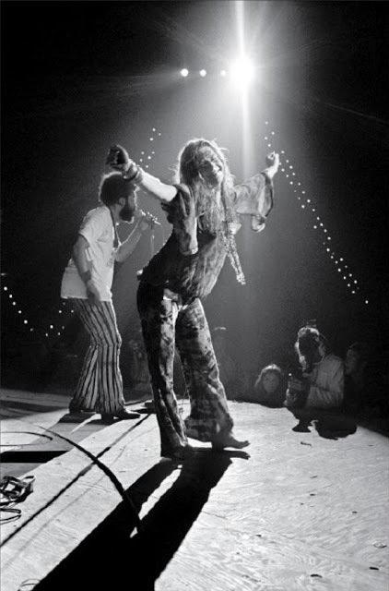
Richie Havens, Sweetwater, The Incredible String Band, Bert Sommer, Tim Hardin, Ravi Shankar, Melanie, Arlo Guthrie, Joan Baez, Quill, Keef Hartley Band, Country Joe McDonald, John Sebastian, Santana, Canned Heat, Mountain, Grateful Dead, Creedence Clearwater Revival, Janis Joplin και The Kozmic Blues Band, Sly & the Family Stone, The Who, Jefferson Airplane, Joe Cocker, Country Joe and the Fish, Τen Years After, The Band, Blood, Sweat & Tears, Johnny Winter & Edgar Winter, Crosby, Stills, Nash & Young, Neil Young, Paul Butterfield Blues Band, Sha-Na-Na, Jimi Hendrix.
The Beatles had denied participating in the Festival because John Lennon hadn't gathered them. The Led Zeppelin chose to sing in another music festival by a higher payment. Deny of participation had declared the band of Byrds too and Bob Dylan because he was opposed to the principles of the hippies movement. The Doors had denied because of the antipathy of Jim Morison in big outdoor concerts. Jethro Tull and Ian Anderson declared that they could not spend their weekend by playing for “unwashed hippies”.
For those who took part in the Festival had been paid and even quite good for that time. The “Who” band had threatening the organizers: “Double the payment or we'll disappear”, and in this way they received 12.500$. Jimmy Hendrix received 18.000$, the Blood, Sweat and Tears received 15.000$, Joan Baez and Greedence Clearwater Revival received from 10.000$. Janis Joplin and Jefferson Airplane received from 7.500$, Ritchie Havens 6.000$ and Carlos Santana was pleased with 750$.
Instead the lack of planning and infrastructures for the four day hospitality of thousands of people, the peaceful character was maintained from the common ideals of the gathered crowd. However, noted one death from overdose of drugs and one more as an agricultural vehicle had pressed a man at the time he was sleeping in his sleeping bag. Furthermore, two births were recorded and eight abortions, due to the existed living conditions. The security, health and the feeding of this crowd took over by the hippie community of “Hog Farm” from New Mexico. Totally 5.162 people needed medical care, with 797 of them due to the use of drugs. Finally, a lack of food was recorded and lots of people remained fasted for over 24 hours.
In the last 40 years, two attempts of revive took place, the first was in 1994 and the second in 1999. Both of these tries could be characterized as economically successful but they didn’t keep alive the character, the ideals and the ideology of the initial fact.

